**Sustainable Inclusion of The Girl-Child in TVET In Ilaro City, Ogun State, Nigeria.**

**Aluko, O**1**; Olapeju,O**2**; Soyemi B**3**, Banjo, O**4**; Irivboje O**5**.**

(Federal Polytechnic, Ilaro, Ogun State, Nigeria)

olasunkanmi.olapeju@federalpolyilaro.edu.ng(08061539556)

**Abstract**

The aim of this research is to assess the level of inclusion of the girl-child in TVET within Ilaro, a medium sized western Nigerian border region settlement within Ogun State, Nigeria, with the view to suggesting sustainable measures for including more girls in TVET based endeavors. The specific objectives are to: identify the schools where TVET related activities are taking place in the study area; investigate the level of inclusion of female students in TVET; investigate the reasons for the observed level of inclusion with a qualitative and participatory approach; and suggest ways of enhancing inclusion of female students in TVET in the study area. The study adopted the snowball technique in compiling the list of principals and two technology-based subjects’ teachers in each of the seven government owned schools within Ilaro community. The total number of participant stakeholders engaged is 21. The Focused Group Discussion’s modus operandi afforded exhaustive expressions for all the themes brought to the fore for discussion before consensus positions were adopted and recorded. The panel adduced numerous reasons to the disproportionate exclusion of female students from TVET based subjects, and accordingly classified them into four groups: Social Barriers, Challenges of Delivery, Policy and Governmental Factors, and the Border Region Factor. The study, among other, recommends orientation and enlightenment of parents, most especially those within the low income group, about the limitlessness of gender abilities, by sundry TVET interest groups.

Keywords: Girl-Child, Inclusion, Qualitative, Sustainable, TVET.

**1.0 INTRODUCTION**

Technical, Vocational Education and Training (TVET) is the aspect of education that is aimed at nurturing and applying relevant practical skills towards making changes within the society and essentially extricating individuals from economic backwaters (Abubakar, 2021). TVET is often deemed an efficacious means of empowering marginalized group, as access to skills training provided by formal technical and vocational training institutions is often limited for disadvantaged groups. Disadvantage, in the context being applied, could be along the dimension of gender, disability, purchasing power, regional access, and health status (for example, people living with HIV/AIDs). (UNESCO-UNEVOC, 2022).

Apart from the Sustainable Development Goal 4 that includes women among disadvantaged groups to be considered for inclusive quality education, the Goal 5 is specific about gender equality and empowerment of women and the girls. Target 5b is specific about the use of enabling technology, in particular information and communications technology, to promote the empowerment of women. Even as governments, world over, keep striving to domesticate the SDGs in their policy frameworks and national development plans, women are still disproportionately excluded from TVET. For instance, it is estimated that women, which account for about one half of the world’s population, represents two thirds of the world workers (Ngugi and Muthima, 2017) However, it is ironic that they earn a paltry one tenth of the world’s income and own a meager one hundredth of global properties (Adelakun, Oviawe, &Barfa, 2015. These inequalities can be linked to unequal access to training opportunities (Udeani, &Ejikeme, 2011).

The various barriers limiting access to TVET by disadvantaged groups include insufficient basic education qualifications, direct and indirect costs of enrolment, lack of understanding of the usefulness of [training](https://unevoc.unesco.org/home/training&context=), etc. But for women, many of the barriers to women’s empowerment are more specifically related with the socio-cultural traditions that have prescribed specific roles for women and men. Women have become socialized into sundry discriminatory social and cultural norms and practices, with boundaries, which confine movements, actions and opportunities, defined for them (Hussain, 2016). Women’s quotidian activities, including decisions on levels of education they can receive, places they can visit, how they can work, their sartorial outlook and social circles are placed under straitjackets The aim of this study is to assess inclusion of the girl-child in TVET, with the view to suggesting sustainable measures for including more girls in TVET based endeavors.

**2.0 PROBLEM AREA**

The Nigerian Bureau of Statistics recently put the absolute number of unemployed Nigerians to be about 21.7 million, out of which 12.2 million (56%) are female. (Durojaiye, 2020). Ironically, in the face of biting economic hardship and increasing unemployment, opportunities in engineering based vocations such as masonry, bricksmaking, tiling, automechanical artisanship, and  carpentry,  which are essentially stereotyped as not being feminine, are being taken over by foreign workers. Long-held gender based stereotypes partly due to perceived onerous nature of engineering vocations, among other issues that border on optics, steer girls and women away from the vocations and constrain the huge potential skills of a large pool of the female demographic, which could be leveraged for self-empowerment and economic development, from being unleashed. Few studies have validated the foregoing with some nuances. Mafa and Mohammed (2013) ascribe the lower participation of women in TVET activities to factors such as cultural bias and religion. Egun and Tibi (2010) had earlier adduced the lower enrollment of female students in TVET based cognitive activities to the level of education of parents, low presence of female teachers and the prohibitive costs of accessing TVET. In another study, eight factors precluding the female gender from proportionately participating in TVET activities were identified as interest, enrolment, masculine image of science, social barriers, role model, school factor, teacher factor and parental factor (Udeni, 2012). Moreover, Nwakego (2014) and Suleiman (2012) agree that the low enrollment of girls in technical activities is borne out of stereotypes that have been socially constructed against them.

It is worthy of note that the foregoing studies were carried out in typical urban settings. None of the researches had attempted to interrogate gender exclusion from TVET from the specific context of Western Nigerian border regions which are the melting pot of sundry Francophonic and Anglophonic tendencies and cultures. Further, the studies had adopted the quantitative or expository approach rather than relying on qualitative approaches to exacting wider contexts of the problems. These gaps, however, offer this research vista to adopt a qualitative approach in the assessment of the level of inclusion of the girl-child in TVET within a medium sized western Nigerian border region settlement, with the view to suggesting sustainable measures for including more girls in TVET based endeavors.

|  |  |
| --- | --- |
|  |  |

**3.0 OBJECTIVES**

The aim of this research is to assess the level of inclusion of the girl-child in TVET within Ilaro, a medium sized western Nigerian border region settlement within Ogun State, Nigeria, with the view to suggesting sustainable measures for including more girls in TVET based endeavors. The specific objectives are to:

1. Identify the schools where TVET related activities are taking place in the study area;
2. Investigate the level of inclusion of female students in TVET;
3. Investigate the reasons for the observed level of inclusion with a qualitative and participatory approach; and
4. Suggest ways of enhancing inclusion of female students in TVET in the study area.

**4.0 METHODOLOGY**

Ilaro is geographically located in Yewa South Local Government Area of Ogun State, South-Western Nigeria. It is located between latitude 6° 53' 0" North, 3° 1' 0" East of the meridian. Ilaro, Ogun State. Ilarois the headquarters of the [Yewa South Local government](https://en.wikipedia.org/wiki/Yewa_South" \o "Yewa South), a region that shares border with the Republic of Benin. It is located about 50 km from [Abeokuta](https://en.wikipedia.org/wiki/Abeokuta), the Ogun State capital, and about 100 km from [Ikeja](https://en.wikipedia.org/wiki/Ikeja), the capital city of [Lagos State](https://en.wikipedia.org/wiki/Lagos_State).

Figure 1: Map of Nigeria

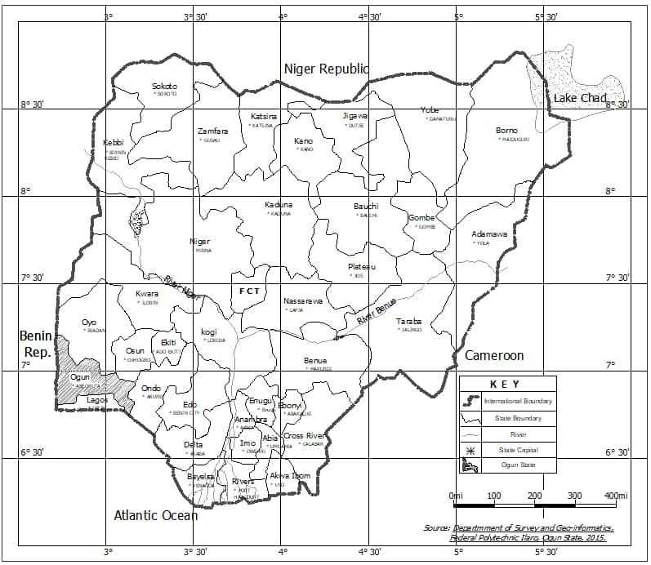

*Source: Department of survey and Geo Informatics, Federal polytechnic Ilaro, 2015*

Figure 2: Map Of Ogun State Showing Yewa South

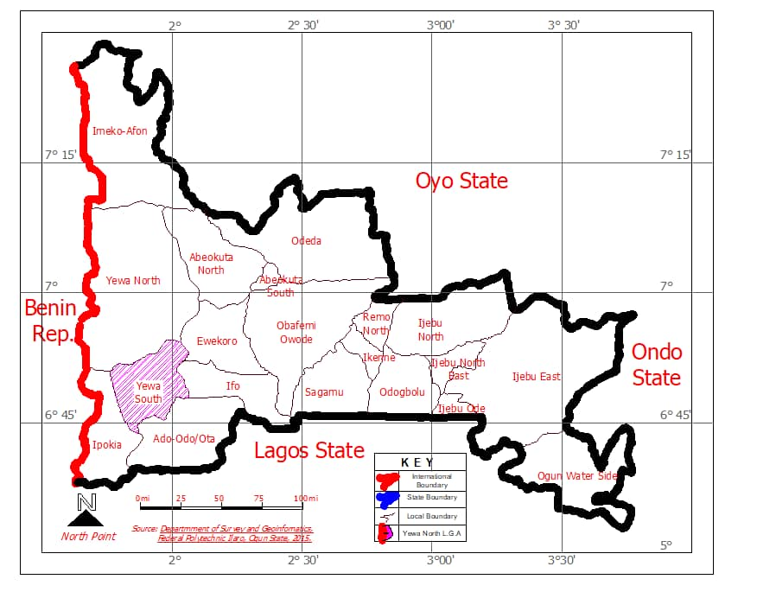

*Source: Department of survey and Geo Informatics, Federal polytechnic Ilaro, 2022*

Figure 3: Map of Ilaro Town

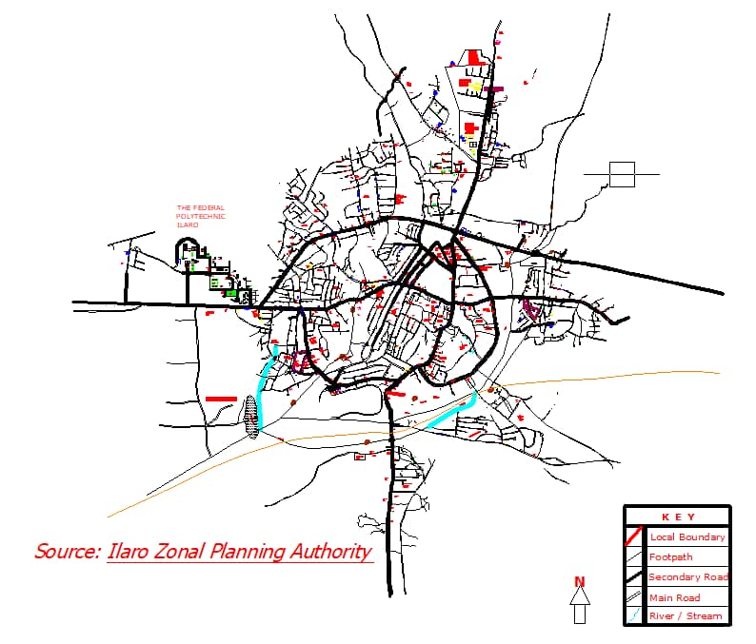*Source: Ilaro Zonal Planning Authority,2022.*

The study adopted the snowball technique in compiling the list of principals and two technology-based subjects teachers/instructors in each of the seven government owned schools within Ilaro community. The identified schools are: Baptist High School, Ilaro; Anglican Grammar School, Ilaro; Orona High School, Ilaro; Yewa College, Ilaro; Itolu Community High School, Ilaro; Emmanuel Grammar School; Ogun State Technical College, Ajegunle. The total number of participant stakeholders engaged is 21. The study adopted the focused group discussion in a participatory interrogation of the issues around female inclusion in TVET in Ilaro community. The qualitative approach adopted affords the vista of exacting wider contexts of the issues from the operators of the schools where TVET based subjects are taught, which quantitative approaches could only superficially elicit. The Focused Group Discussion was carried out within a period of three days and two-hours expended per day. The entire 5- member research team was involved throughout the three sessions spanning three days. The Focused Group Discussion’s modus operandi afforded exhaustive expressions for all the themes brought to the fore for discussion before consensus positions were adopted and recorded.

**5.0 DISCUSSION OF FINDINGS**

Foremost, the panel agrees that generally there is a gender inclusive disinterest to TVET based subjects in their schools. However, the female students are disproportionately excluded from the TVET based subjects that form the basis of important skilled vocations such as Technical Drawing, Metal Works, Wood Work, Plumbing, Electrical Works, etc. The panel adduced numerous reasons to the disproportionate exclusion of female students from TVET based subjects, and accordingly classified them into four groups: Social Barriers, Challenges of Delivery, Policy and Governmental Factors, and the Border Region Factor.

**5.1: Social Barriers**

There is the normalized perception about the onerous nature of TVET based subjects which females, who have been socially constructed, in the religious sense, as the ‘weaker vessels’, should not engage in. The religious dimensions of the social construct equally extend to sartorial outlook and the obscurity that should define the place of women in the society. For instance, there is the perception that most TVET based activities may require girls and women putting on trousers, a manner of dressing that is deemed unsuitable by the religiously minded. This, albeit with a more specific context, agrees with Mafa and Mohammed (2013) and Hussain (2016) which had ascribed the lower participation of women in TVET activities to factors such as cultural bias and religion. The foregoing aggregately forms the basis of stereotypes expressed against the female gender with respect to TVET. It explains why in the study area, limitations are still being placed on gender abilities by parents; with different gender nurtured and socialized into different careers and social roles. For instance, parents in the study area are still wont to buying dolls for their girls, teaching them culinary skills, while their boys are exposed to more arduous tasks. It should be noted, however, that exclusion of the female gender is disproportionately related to low income demographics. The female wards and children of the elites are observed to be more included in TVET.

**Challenges of Delivery**

The panel agreed on the numerous challenges constraining the delivery of TVET based subjects in a manner that makes girls to be disproportionately excluded. First, most of the schools where TVET based subject courses are taught do not have skilled teachers and adequate facilities and equipment to effectively deliver. Second, in schools where skilled and TVET inclined teachers are available, the female teachers who should serve as role models as canvassed in Udeni (2012) to teeming female students are poorly represented. Third, the skilled teachers are scarcely exposed to training and re-training exercises in order to keep them abreast of emerging trends and new technologies. Fourth, curriculum development, from secondary to tertiary level, is lacking in the mainstreaming of paradigm shifts that can enhance the gender inclusivity of TVET based subjects.

**Policy and Governmental Factors.**

The panel agreed that the current policy on education does not favour TVET, as most of the schools in the study area, judging from the lack of workshops, equipment and TVET based teachers, were essentially not built for the purpose of instructing TVET based courses. The panel also agreed that skilled teachers working within the schools are the ones that require more of training and re-training than civil servants working in regulatory offices that are seemingly prioritized by government with respect to training. The emphasis on certificates and dichotomy in the Nigeria’s tertiary sector and the attendant limitations in the upward mobility potentials of graduates of tertiary TVET institutions informs the disposition of the local community with respect to perceived inferiority of TVET based endeavors. This discourages most parents from socializing their children, most especially the female ones, into the world of TVET.

**Border Region Factor.**

The panel agreed that border regions are the melting pot of sundry negative tendencies occasioned by the porous nature of borders and the dynamics of cultural exchanges among migrating demographics within the larger context of an insufferable macro-economic environment, which is most underpinned by youth unemployment. The panel agrees that activities of smugglers within the border region, and the ostentatious showiness that comes with them, are a distraction to any form of erudition. Similarly, cyber criminals are known to lead a lifestyle that tend to deconstruct the essence of education. Teenage girls, from struggling homes, who are supposed to be undergoing vocational training or attending secondary schools where TVET based subjects are taught, are the most vulnerable to these tendencies. They mostly get enticed and entrapped with the tinsels of luxury, eventually become pregnant, with their educational dreams becoming truncated.

**6.0 CONCLUSION AND RECOMMENDATIONS.**

The paper began by making the case for the exclusion of girls in TVET. It adopted a qualitative approach in eliciting wider but more specific contexts of why females are disproportionally excluded from TVET in the study area. However, following exhaustive discussions, the panel adduced numerous reasons to the disproportionate exclusion of female students from TVET based subjects, and accordingly classified them into four groups: Social Barriers, Challenges of Delivery, Policy and Governmental Factors, and the Border Region Factor. Moreover, the panel unanimously agreed on the following recommendations for enhancing the inclusion of females in TVET within the study area. One, the panel recommends orientation and enlightenment of parents, most especially those within the low income group, about the limitlessness of gender abilities, by sundry TVET interest groups. The issue around cultural appropriateness of dresses can be resolved with dresses customized to suit what is culturally acceptable. Two, there is the need for curriculum development to integrate paradigms shift that favour the enhancement of female inclusion in TVET. Three, the government of Ogun State should prioritize females in the recruitment of skilled female teachers, as they can serve as role models to the teeming girls. The government should equally remodel the schools to mainstream TVET by providing adequate facilities as well as making resources available for the training and retraining of skilled TVET based teachers. Four, there is need for the schools to partner with external stakeholders like tertiary TVET institutions within their regions, community based organizations, and industries to help in the area of endowments that can manifest in the form of training of teachers, donation of facilities to help improve learning outcomes. Five, there has to be a deliberate effort to bringing accomplished TVET based role models from the industry or academia to engage female students and give practical meaning to the delayed gratification construct. This could represent a way of keeping them mentally insulated from the many environmental distractions that cut their aspirations short.

**REFERENCES**

Abubakar Adamu Njibulwa (2021) Factors Militating Against Female Participation in Technical Vocational Education and Training (TVET) in Government Girls Science and Technical Colleges. *Journal of Science Technology and Education 9(3), 58-64*.

Adelakun, O., Oviawe, J., &Barfa, G. (2015).Strategies for enhancing Female participation in Technical Vocational Education and Training. *Advances in Social Science Research Journal, 12(4). DoI:10.14738/assrj.24.1041.*

Afa F. U and Mohammed A.U (2013). Crisis in Women Education in Nigeria. *Potiskum Multidisciplinary Journal of Education. Federal College of Education (Technical) Potiskum, Yobe State. 1(1) 74-78.*

Durojaiye**, S.** (2020)21.7m *Nigerians are unemploye****d and 12.2m of them are female.*** Retrieved 10th July, 2022 from https://www.icirnigeria.org/21-7m-nigerians-are-unemployed-and-12-2m-of-them-are-female-nbs/*.*

Egun, A. C. & Tibi E. U (2010). The Gender Gap in Vocational Education: Increasing Girl Access in the 21st century in the Midwestern States of Nigeria*. International Journal of Vocational and Technical 2 (2) 12-19.*

Faheem,H (2016) Women’s Empowerment, SDGs and ICT. Retrieved 10th July, 2022 from <https://www.unapcict.org/sites/default/files/inline-files/Module_C1.pdf>.

Gusau A.W., Chagbe M.B.,& Achi T. T (2018). Challenges of women in technical and vocational education: A case study of federal college of education (technical), *International Journal of Vocational and Technical Education10(1): 7-13.*

Hyellaiya A. M. (2008). *The Challenges of Girl Education towards Achieving the Millennium Development Goals in Nigeria*. Paper presented at the (COEASU) North East Zone National conference on the Challenges of Teacher Education towards Achieving the Millennium Development Goals in Nigeria. Held at Federal College Education (Technical) Potiskum, Yobe State.

Ngugi M., and Muthima P (2017). Female Participation in Technical, Vocational Education and Training Institutions (TVET) Subsector: The Kenyan Experience. *Public Policy and Administration Research 7(4).*

Nwakego E. O. (2014). Social-Economic Development and the Girl-Child Education: a look at Jos North Local Government, Plateau State. *International Multidisciplinary Journal, Ethiopia 8(1).*

Oluniyi A. Itohan J.O & Garba B. (2015).Strategies for Enhancing Females Participation in Technical Vocational Education and Training (TVET) in Nigeria. *Journal of Advances in Social Science Research.2 (4).*

Suleiman R. B (2012). *Tackling Girl Child Education in Kano State*. Retrieved 10th July, 2022 from http//www.nationalmirrowonlin.net.

Udeani, U. (2012). Increasing Female Participation in Science and Technology Careers: Problems and suggested Interventions from Nigeria. Developing Country Studies 2(5): 1-9.

UN Women(2022) *SDG 5: Achieve gender equality and empower all women and girls.* Retrieved 10th July, 2022 fromhttps://www.unwomen.org/en/news/in-focus/women-and-the-sdgs/sdg-5-gender-equality.

UNESCO-UNEVOC(2022) *Gender Issues and TVE.*  Retrieved 10th July, 2022 from <https://unevoc.unesco.org/home/Gender+issues+and+TVET&context>=