OPEN DEFECATION AS A PLANNED BEHAVIOUR IN NIGERIAN TERTIARY INSTITUTIONS

**Olasunkanmi Olapeju, PhD, RTP, MNITP**

(Department of Urban and Regional Planning, Federal Polytechnic, Ilaro, Ogun state, Nigeria)

olasunkanmi.olapeju@federalpolyilaro.edu.ng(08061539556).

ABSTRACT

Open defecation is not limited to unorganized territories. It is equally a common practice in planned environments like the Nigerian tertiary institutions, where it is often expressed in a parlance popularly known as ‘throwing shotput’. This study adopts the RANT model (Risk, Attitude, Norm, and Toilet Management factors) in mainly investigating the psychology of open defecation being practiced by a minority of the students of the Federal Polytechnic Ilaro, Ogun State, as a planned behaviour, with a view to providing a comprehensive analytical premise, based on the assessment of several constructs and indicators, for planned improvement of the the Institution’s current sanitation situation. Using the multi-stage sampling technique, questionnaires were administered to a total of 184 students of the Federal Polytechnic Ilaro. In the logistic modelling of the psychological factors explaining why students defecate in the open, despite the availability of toilets within the Instituional premises, only indicators of the toilet space management construct- neatness of toilet and illumination of toilet spaces at nights- were significant. The study recommends the need to intensify on landscaping of open spaces,especially the locations profiled as open defecation spots, as a proactive way of pyschologially discouraging open defecation, among others.

**KEYWORDS:** Behaviour, Management, Planned Open-defecation, Sanitation, Sustainable.

# 

# introduction

With more than 58 million urban dwellers (67.2% of the population) living without access to a safe, private toilet, and over 46 million of its absolute population still defecating in the open, Nigeria’s sanitation profile is currently dire (WaterAid , 2015; Olapeju & Majid, 2020). Open defecation poses obvious economic, health, and social risks. Nigeria loses over 3 billion dollars to poor sanitation. This fact is corroborated by World Bank (2012) that persons practicing open defecation expend almost 2.5 days a year looking out for a private place to defecate, resulting in huge economic losses and production of unhealthy flies and pathogens. WHO (2017) reveals that diarrhoeal diseases related deaths in Nigeria reached 130,610 and accounted for 6.85% of total deaths. There is also the gender dimension to open defecation. Women and girls are disproportionately impacted by the rampant consciousness of toilet infections in the face of lack of access to clean water and adequate sanitation. In the quest to find private and cleaner alternative places to defecate, they stand the risk of exposure to rape and sexual harassment (WaterAid, 2013; Aung, 2017).

The foregoing had made Nigeria’s President Muhammadu Buhari  signed Executive Order 009 to tackle open defecation. Similarly, Nigeria’s Ministry of Water Resources¸ in collaboration with UNICEF and some other key agencies, launched the initiative tagged ‘Nigeria Open-Defecation-Free By 2025: A National Road Map’ in order to end a practice that has brought negative social stigma to Nigeria by 2025 (Akindayo, 2020) .

Strangely, open defecation is not limited to unorganised territories, it is equally a common practice in planned environments like the Nigerian tertiary institutions, where it is often expressed in a parlance popularly known as ‘throwing shotput’. Akoji (2021) had corroborated this in its assessment of the sanitary condition of toilets facilities in Nigerian tertiary institutions like Ahmadu Bello University Zaria (ABU), Usman Danfodio University Sokoto (UDUS), Bayero University Kano (BUK), Federal University Dutsinma Katsina (FUDMA) and Federal University Dutse (FUD).  The existence of this practice in these Nigeria’s tertiary institutions is essentially borne out of the unsanitary condition of available toilet facilities. However, just as in the case of households that still practice open defecation even with the availability of improved toilets (Olapeju&Majid, 2019), there are tertiary institutions where despite being afforded the luxury of improved toilets, open defecation is stil being practiced by a minority. In grappling with the paradox that this represents, the open defecation scourge in such environments have to be contextualised as a planned behaviour that can only be comprehensively studied via appropriate behavioural models. The Federal Polytechnic Ilaro, Federal Polytechnic, Ilaro, established in 1979 along with Six (6) other Federal Polytechnics in Nigeria, has continued to make giant strides in the management of a beautiful landscape conducive for effective learning, provision of adequate infrastructure, sanitary facilities and learning equipment. However, a minority of the students population, perhaps taking advantage of the enormous spatial size of the Institution(898 hecatares) that adequately afford private locations that are distant from activity areas, still practice open defecation either by way of urination or pasing out faeces in private locations aside the toilets. This is despite the practice being an offence that has been properly documented in the students’ handbook. Therefore, the aim of this study is to investigate the psychology of open defecation being practiced by a minority of the Federal Polytechnic Ilaro, Ogun State, as a planned behaviour, with a view to providing a comprehensive analytical premise, based on assessement of several constructs and indicators, for planned improvement of the the Institution’s current sanitation situation. The study slightly tweaks the Risk, Attitude, Norm, Ability, Self-regulation (RANAS), a planned behavioural model adopted by Graf *et al.* (2008), Inauen *et al.* (2010), and Alemu *et al.* (2018) to RANT (Risk, Attitude, Norm, and Toilet Management factors) in order to comprehensively expatiate on the psychological determinants of open defecation being practiced by the minority who take advantage of the expansiveness of space.

# methodology

As shown in Figures 1-3, the Federal Polytechnic Ogun State occupies the space of about 898 hectares within consecutively tracts of flat lands located within Ilaro Town, in the Ogun West Senatorial District of Ogun State, Nigeria.

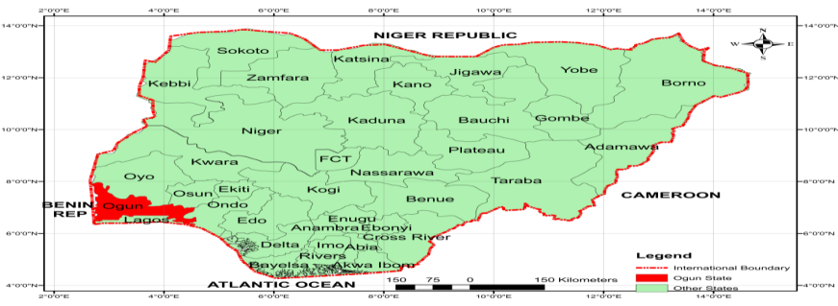

Figure 1: Map of Nigeria

Department of Urban and Regional Planning, Federal Polytechnic Ilaro (2017)

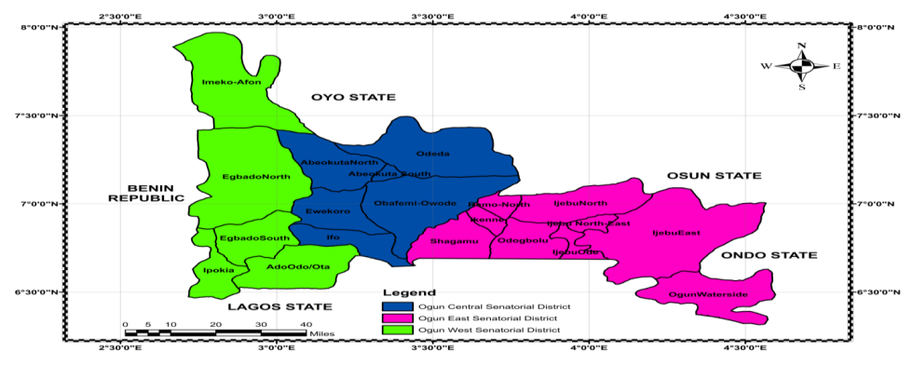

Figure 2: Map of Ogun State

Department of Urban and Regional Planning, Federal Polytechnic Ilaro (2017)

**Figure 3: Map of Yewa South showing Ilaro**

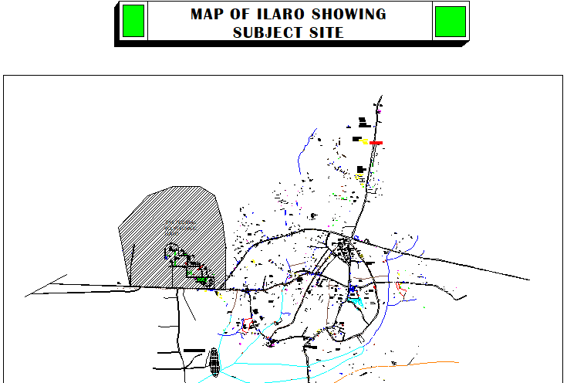

Figure 3: Map of Ilaro Town Showing the Federal Polytechnic Ilaro.

Source: Urban and Regional Planning Department, Federal Polytechnic, Ilaro 2021.

The study adopted the multistage approach. As shown in Table 1, the first stage involved the grouping of the research population, based on the existing faculties or schools: School of Environmental Studies, School of Pure and Applied Science, School of Communication and Information Technology, School of Engineering, School of Management Studies. Each school has a number of related departments grouped under it. In the School of Environmental Studies, there are 8 departments. 4 departments exist in the School of Communication and Information Technology; 7 departments in the School of Engineering; 7 departments in the School of Management Studies; and 8 departments in the School of Pure and Applied Science. All together, making a total number of 34 departments. Adopting the random sampling technique, a representative department was selected in each of the five schools, resulting in the selection of 5 departments altogether. These include: Department of Agricultural Technology with a total number of 115 students; Department of Insurance with a total number of 412 students, Department of Urban and Regional Planning with a total number of 99 students; Department of Agricultural and Bio-environmental Engineering with a total number of 126 students; and the Department of Library and Information Science with a total number of 412 students. As presented in Table 2, twenty percent (20%) of the total number of the students in the selected departments of about 910, out a total students population of about 12,091, was sampled. Based on this, a total of 184 students, representing about 1.5% of the total students’ population, were administered questionnaires in exacting the data that formed the analytical premise for the study. Missing data were adequately taken care of, as the face-to face questionnaire administration method adopted by the study through well trained survey assistants ensured the minimization of missing data. Missing cases only effectively existed in variables expecting responses from exclusive groups, for instance households that use a specific faecal waste management means. However, the exclude cases pair wise option adopted ensured that all observations to the extent that they have necessary information were included in the analyses. In the course of analysis, outliers not exceeding the 3-box lengths from the edge of the plot box were retained, while the values of the extreme cases were changed to less extreme values in a manner that does not distort the originality of the statistics. In the logistic regression of psychological factors of risk, attitudes, norms, and toilet space management (RANT) in households on the occurrence of open defecation, outliers with ZResid values above 2.0 were removed from the data as the initial output of the procedures suggested a problematic goodness of fit. Multicollinearity is indicated by lowness of tolerance values (less than 0.1) (Pallant, 2005). Such predictor variables showing low levels of tolerance were dropped to eliminate problems with model’s goodness of fit. However, after repetitive dropping of items for those with the highest tolerance levels, model’s goodness of fit was achieved, with some items showing significance. The adoption of logistic regression is premised on the fact that the outcomes to be predicted by the relevant constructs (RANT) are categorical outcomes with just two categories (whether students defecate in the open or not).

**Table 1: Selected Departments in the Study Area and Samples.**

|  |  |  |  |  |
| --- | --- | --- | --- | --- |
| **Schools** | **Departments** | **Selected Department** | **Number of Students** | **20% of identified students** |
| School of Communication and Information Technology | Library and Information Science | Library and Information Science |  |  |
| Mass Communication | 158 | 32 |
| Music Technology |  |  |
| Office Technology Management |
| School of Engineering | Agricultural and Bio-environmental Engineering | Agricultural and Bio-environmental Engineering |  |  |
| Civil Engineering | 126 | 26 |
| Computer Engineering |  |  |
| Electrical/Electronics Engineering |
| Mechanical Engineering |  |  |
| Mechatronics Engineering |  |  |
| Welding & Fabrication |  |  |
| School f Environmental Studies | Art and Design | Urban and Regional Planning |  |  |
| Architectural Technology |
| Building Technology |  |  |
| Estate Management and Valuation | 99 | 20 |
| Quantity Survey |  |  |
| Surveying and Geo-informatics |
| Transportation Planning |
| Urban and Regional Planning |
| School of Management Studies | Accountancy | Insurance |  |  |
| Banking and Finance |
| Insurance | 412 | 82 |
| Marketing |  |  |
| Public Administration |
| Taxation |
|  | Business Administration Management |  |  |  |
| School of Pure and Applied Science | Agricultural Technology | Agricultural Technology |  |  |
| Computer Science |
| Food Technology |
| Hospitality Management & Technology | 115 | 24 |
| Leisure and Tourism |  |  |
| Mathematics & Statistics |
| Nutrition & Dietetics |
| Science Laboratory Technology |
| **Total** | **34** | **5** | **910** | **184** |

***Source: Adapted from Examination, Records & Result Department(2021)***

## RESULTS AND DISCUSSION

Logistic regression of psychological factors of risk, attitudes, norms, and toilet space management was carried out on students. Risk, Attitude, Norm, Ability, Self-regulation (RANAS) model adopted by Inauen *et al*. (2010), Graf *et al.* (2008), and Alemu *et al*. (2018) to expatiate on the psychological variables for predicting Water, Hygiene and Sanitation (WASH) behaviours was modified to Risk, Attitude, Norms and Toilet Space Mnagement (RANT) in order to achieve a conceptual fit with the peculiar pragmatic realities of the study area, with respect to open defecation.

**Table 2 Descriptive Analysis for Risks**

|  |  |  |  |  |  |
| --- | --- | --- | --- | --- | --- |
| Risk | N | Minimum | Maximum | Mean | Std. Deviation |
| The high rate of contracting toilet disease (by females,most especially) | 184 | 1 | 5 | 3.89 | .977 |
| The possibility of been infected with diarrhea | 184 | 1 | 5 | 3.95 | .923 |
| The possibility of cholera infection | 184 | 1 | 5 | 3.87 | .959 |
| The perpetual feeling nausea each time the toilets are used | 184 | 1 | 5 | 3.87 | .852 |
| **Mean score** |  |  |  | **3.89** |  |

Source: Field Survey 2021

**Table 3: Descriptive Analysis for Attitudes**

|  |  |  |  |  |  |
| --- | --- | --- | --- | --- | --- |
| Attitudes | N | Minimum | Maximum | Mean | Std. Deviation |
| Whenever we are pressed and not in class | 184 | 1 | 5 | 3.54 | 1.167 |
| We do not bother to check whether there are public facilities in the environment at the point we get pressed | 184 | 1 | 5 | 2.93 | 1.333 |
| We enjoy defecating in the open even when we are aware clean toilets are available,whenever we are pressed,as there is fresh and odourless air to be enjoyed | 184 | 1 | 5 | 2.87 | 1.503 |
| **Mean score** |  |  |  | **3.11** |  |

Source: Field Survey 2021

|  |
| --- |
|  |

**Table 4: Descriptive Analysis for Norms**

|  |  |  |  |  |  |
| --- | --- | --- | --- | --- | --- |
| Norms | N | Minimum | Maximum | Mean | Std. Deviation |
| There usually no public toilets around those occasional critical moments especially when we are not in class. | 184 | 1 | 5 | 3.37 | 1.254 |
| The public toilets usually available whenever we get pressed outside the class are usually odorous and messed up. | 184 | 1 | 5 | 3.97 | 1.150 |
| We do not get cautioned by anyone for defecating in the open. | 184 | 1 | 5 | 3.23 | 1.315 |
| Most people also defecate in the open places where we defecate whenever we are pressed. | 184 | 1 | 5 | 3.40 | 1.276 |
| **Cluster mean score** |  |  |  | **3.49** |  |

Source: Field Survey 2021

**Table 5: Descriptive Analysis for Toilet Space Management**

|  |  |  |  |  |  |
| --- | --- | --- | --- | --- | --- |
| Toilet Spaces Management | N | Minimum | Maximum | Mean | Std. Deviation |
| There are usually queues whenever you want to make use of the toilet. | 184 | 1 | 5 | 1.94 | 1.203 |
| Neatness | 184 | 1 | 5 | 2.82 | 1.251 |
| The absence of water | 184 | 1 | 5 | 3.58 | 1.284 |
| Privacy not afforded | 184 | 1 | 5 | 3.14 | 1.236 |
| Toilets are not illuminated, especially at nights | 184 | 1 | 5 | 3.66 | 1.056 |
| No quick and easy accessibility of the toilets | 184 | 1 | 5 | 3.27 | 1.266 |
| **Mean score** |  |  |  | **3.07** |  |

Source: Field Survey 2021

The RANT constructs captured relevant psychological indicators for predicting households’ tendency for open defecation by students. Multicolinearity test was carried out to show that the predictor variables are not strongly related to each other. Multicollinearity is indicated by lowness of tolerance values (less than 0.1) (Pallant, 2005). Such variables showing low levels of tolerance are dropped to eliminate problems with model’s goodness of fit. The initial output of the logistic regression procedures suggest a problematic goodness of fit, even after cases with ZResidual values above 2.0 had been removed from the data. However, after repetitive dropping of items for those with the highest tolerance levels, model’s goodness of fit was achieved, with some items showing significance. The items or indicators that were retained in the final analysis are queues in toilet; neatness; absence of water; no privacy; toilets are not illuminated; no quick access; the possibility of contracting disease; possibility of being infected with diarrhea; possibility of being infected with cholera; fealing of nausea; and toilets are messed up.. The logistic regression of psychological factors of RANT on students on the occurrence of open defecation showed key statistics. The overall percentage of correctly classified cases is 93.4%. The Omnibus Tests of Model Coefficients, which suggests the goodness of performance of the model and equally known as the goodness of fit test, at a significance value of 0.00 (< 0.05) and chi-squared value of 34.948 with 16 degrees of freedom is significant. It indicates that the model is better than SPSS’s original guess that all households who share toilets still defecate in the open. Further, the Hosmer and Lemeshow Test, at a chi-squared value of 5.6 with a significance level of 0.065 (> 0.05) also corroborates the validity of the model. Cox & Snell R Square and Nagelkerke R Square values of .207 and .544 respectively, which are the pseudo R square statistics, suggest that between 20.7 % and 54.5% percent of the variability is explained by the model’s predictors. However, as evident in the sixth column of table Table 2, only two indicators are significant: Neatness of toilets and toilets are not illuminated at nights.

Table 6: Logistic Regression of the Psychological Factors of RANT on the Occurrence of Open Defecation by Students.

|  |
| --- |
|  |

|  |  |  |  |  |  |  |  |  |  |
| --- | --- | --- | --- | --- | --- | --- | --- | --- | --- |
|  | | B | S.E. | Wald | df | Sig. | Exp(B) | 95% C.I.for EXP(B) | |
| Lower | Upper |
| Step 1a | Queues in toilet. | .407 | .244 | 2.783 | 1 | .095 | 1.503 | .931 | 2.425 |
| Neatness. | .619 | .267 | 5.359 | 1 | .041 | .539 | .319 | .910 |
| Absence of water. | -.168 | .251 | .447 | 1 | .564 | .845 | .517 | 1.383 |
| No privacy. | -.038 | .270 | .020 | 1 | .887 | .962 | .567 | 1.634 |
| Toilets are not illuminated at night. | .588 | .324 | 3.302 | 1 | .019 | 1.801 | .955 | 3.397 |
| No quick access. | -.111 | .219 | .260 | 1 | .610 | .895 | .583 | 1.373 |
| High rate of contracting toilet diseases. | .015 | .329 | .002 | 1 | .963 | 1.016 | .532 | 1.937 |
| Possibility of being infected with diarrhea. | .071 | .418 | .029 | 1 | .865 | 1.074 | .474 | 2.434 |
| Possibility of Cholera Infection. | -.362 | .428 | .716 | 1 | .397 | .696 | .301 | 1.610 |
| Feeling of nausea. | -.444 | .376 | 1.394 | 1 | .238 | .642 | .307 | 1.340 |
| No toilet. | .083 | .235 | .123 | 1 | .726 | 1.086 | .685 | 1.723 |
| Toilets are messed up. | -.415 | .234 | 3.141 | 1 | .076 | .660 | .417 | 1.045 |
| Not cautioned by anyone. | -.185 | .233 | .628 | 1 | .428 | .831 | .526 | 1.313 |
| Constant | 4.607 | 2.017 | 5.219 | 1 | .022 | 100.233 |  |  |

The positive values of B in the indicator-Neatness of toilets implies that the more the perception by students that toilets are not neat whenever they want to make use of the toilet, the higher the probability for them to defecate in the open. Moreover, as shown in column Exp(B), of the Table 5, the odd ratio of 0.539 suggests that the likelihood for students to defecate in the open is 0.539 higher for students who have the perception that toilets are usually not neat whenever they want to make use of the toilets. Similarly, as shown in the last columns of Table 2, one can be 95% confident that the actual value of 0.539 odd ratio for lack of neatness lies between 0.319 and 0.910. That all the ranges exclude the value of 1 suggests that the results is statistically significant. Moreover, the positive value of B in toilets are not illuminated at nights implies that the more the perception that toilets are not illuminated at nights, the higher the propensity for them to defecate in the open. As shown in column Exp(B), of the table 4.2.11 above, the odd ratio of 1.801 suggests that the likelihood for students to defecate in the open is 1.801 higher for students who have the perception that toilets illumination makes toilets usage more convenient for them. As evident in the last columns of Table 2, one can be 95% confident that the actual value of 1.801 odd ratio for toilets are not illuminated at nights falls between .955 and 3.397. That all the ranges exclude the value of 1 suggests that the results is statistically significant.

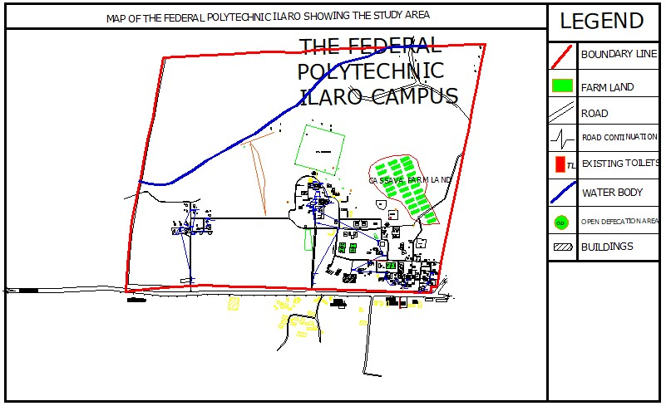Figure 4: Map of The Federal Polytechnic, Ilaro Showing the Distribution of Toilets and Spatial Profiling of Open Defecation Spots.

As evident in figure 4, nine isolated structures accomodating about 83 gender inclusive toilets , all of which are currently functional, are located within the study area, aside from toilets within office buildings, classrooms, and hostels. However, the available toilets are still below the acceptable standard in respect of toilets to population ratio that should be 1:125. On the basis of 125 people per toilet, 103 toilets ought to be made available for the entire school population of about 13,000. However, 85 toilets facilities are currently available.Moreover, 5 numbers of accidental open spaces were identified as open defecation spots. Their use as open defecation sites could be borne out of their bushy nature, as they afford privacy for those defecating on them; lack of illumination at nights owing to inadequate electricity supply; and unavailability of water. The unclean nature of toilets proximate to facilities most contiguous to the open defecation spots, borne out of the lack of constant cleaning, could also account for why some students defecate in the open.

**Conclusion/Recommendation**

In the RANT constructs developed to assess the open defecation practice as a planned behaviour, the significant indicators (dirtiness of toilets and the lack of illumination in toilets at nights) are all items of the toilet management construct. This implies that toilets management measures such as those that would ensure constant availability of water, intermittent cleaning of toilet spaces by toilet managers, and constant illumination of toilets at nights through reliance on alternative energy sources like solar would go a long way in enhancing students’ patronage of existing toilet facilities. Similarly, landscaping of open spaces,especially the locations profiled as open defecation spots, would go a long way, in pyschologially discouraging open defecation on them. There is also the need to install signposts warning against open defecation. Enlightenment campaigns against open defecation, with emphasis on the environmenal, health, and social risks, should be intensified upon by students’ advocacy groups on environmental sustainability. This can also be done by relying on public demonstrations, discussions and school-wide sanitation promotion clubs as well as posters, games and stories to illustrate that messages. School authorities have crucial roles to play in this directions.

**REFERENCES**

Akindayo,D.(2020).[Online].Tackling Open Defecation In Nigeria. Available at Https://Www.Ibanet.Org/Article/D4103b88-731b-4b2c-A24a-85f5ad005743[Accessed 27 March 2018]

Akoji, E. (2021). [Online] Investigation: Open Defecation Rife Amongst Top Universities In Northwest Nigeria. Available at <Https://Www.Icirnigeria.Org/Investigation-Open-Defecation-Rife-Amongst-Top-Universities-In-Northwest-Nigeria/>.[Accessed 27 March 2018]

Alemu1, F., Kumie, A., Medhin,. G., and Ga, J.(2018). The Role of Psychological Factors in Predicting Latrine Ownership and Consistent Latrine Use in Rural Ethiopia: a Cross-sectional Study. *BMC Public Health, 18, 229.*

Aung, T.T. (2017). Insufficient Toilets Pose Risk to Women and Girls [Online]. Retrieved10 November 2017 from: https://www.irrawaddy.com/news/burma/insufficient-toilets-pose-risk-women-girls.html

Graf, J., Meierhofer, R., Wegelin, M., & Mosler, H. J. (2008). Water Disinfection and Hygiene Behavior in an Urban Slum In Kenya: Impact On Childhood Diarrhoea And Influence Of Beliefs. *International Journal of Environmental Health Research, 18(5),335-355.*

Inauen, J., Hossain, M.M., Johnston, R.B., & Mosler H.J. (2010). *Acceptance and Use of Eight Arsenic-safe Drinking Water Options in Bangladesh:* Bibliothek derUniversitÃ¤t Konstanz.

Olapeju, O.O., & RafeeMajid, M. (2019). Rationalizing The Irrationality Of Open Defecation Practice Among Households With Toilets In Ogun State, Nigeria. *International Journal of Innovative Research and Advanced Studie, 6(6), 62-67*

Olapeju, O. O., & RafeeMajid M. (2020). Towards a Sustainable Incentive to Open Defecation Eradication, Journal of Sustainability Science and Management, 5(5), *215-235*

Pallant, J. (2005). SPSS Survival Manual: *A Step by Step Guide to Data Analysis using SPSS Windows*. 3rd ed. England: Open University Press McGraw-Hill Education.

Thompson, C.N. (2015). *The Epidemiology of Paediatric Diarrhoeal Disease and Shigella Infections in Ho Chi Minh City , Vietnam*. PhD Thesis London School of Hygiene & Tropical Medicine.

WaterAid (2013). *Women and WASH*[Online]. Available at: file:///C:/ Users /HP / Downloads/Briefing Note How can water sanitation and hygiene help realise womens rights and gender equality (1).pdf[Accessed 27 March 2018].

WaterAid (2015). *It’s No Joke: The State of the World’s Toilets 2015*[Online]. Available at: https://bit.ly/2EMOlQz [Accessed: 27 March 2018].

WHO (2017). *2.1 billion People Lack Safe Drinking Water at Home, More Than Twice as Many Lack Safe Sanitation*[Online]. Avaialble at: https://bit.ly/1m10zV0 [Accessed 22 March 2018].

World Bank (2012) *The Key Messages Sanitation Data from 18 Countries in Africa* < siteresources.worldbank.[Online] Available at: https://bit.ly/2YOvUlV [Accessed 12th October,2017]