TECHNOLOGICAL DEVELOPMENT IN THE USE OF HAND TOOLS FOR THE CONSTRUCTION OF A SAMPLED TRADITIONAL MUSICAL INSTRUMENT

By

Adegorioye Oluwole ADEYEYE
Department of Music Technology, The Federal Polytechnic Ilaro, Ogun State.
Email: adegorioye.adeyeye@federalpolyilaro.edu.ng
Contact: 07038197627
Author’s profile: Adegorioye is a music technologist & musicologist with ND Music Tech. from The Polytechnic, Ibadan, B.A. Music from O.A.U, and M.A in African Music from the Institute of African Studies, University of Ibadan.
&

Adegboyega Edesanya ADEYEYE
African High Arts Orchestra Company (AHAOC), Ibadan, Oyo State.
Email: adeyeyeadegboyega@gmail.com
Contact: 08076076543
Author’s profile: Adegboyega is a music technologist & musicologist with ND Music Tech. from The Polytechnic, Ibadan, B.A. Music from Obafemi Awolowo University (O.A.U), and M.A in view at O.A.U.

JUNE 2020
ABSTRACT
The construction of the Marimba involves various processes that engage the use of carpentry knowledge. Existing researches by scholars have focused on the usage of local tools and only a few modern machines for the construction of the Marimba. This research thus aims at providing solutions to challenges encountered during the construction process of the marimba by using modern machines and technology to make the work more accurate, easier, and faster, thereby examining machines and digital apps that can be used in the tuning process of the marimba, and identifying the nuances involved in the construction process of the marimba.This research was hinged on the theory of technology, and African High Art Orchestra Company was purposively sampled as the research field. The review of relevant literatures, participant observation, interview and pictorial analytical methods were employed during the period of this research. The outcome of the research reveals that different apps could be adopted in the construction process of the marimba as well as different machines replacing tools that are used for its construction. The paper concludes that modern technology improves the fabrication processes of the marimba, making the work more productive, faster, and easier to handle.

Keywords: Marimba, Modern Technology, Digital apps, Machines
Word Count: 196

INTRODUCTION
This paper examines the use of modern technology to fabricate and solve derive nuances as found in the construction process of a marimba. Hinged on technology theory, the paper notes
Music technology in the aspect of construction or fabrication of musical instruments involves the joining of raw materials to form or build a desired or an expected musical instrument. These processes not only include joining of woods together as found in marimba making and other musical instruments, but also involves cutting of felt, hammering woods or nails into woods, joining together using adhesive, screwing in and out of nuts and bolts, filing and sandpapering of rough edges, cutting of materials with a saw to desire size or length, seasoning of woods naturally and artificially, and more importantly tuning the musical instrument to bring the required sound.
Acoustics which is the scientific study of sound and the way it is being propagated is also an important aspect of constructing the Marimba, as this is what makes an instrument a musical instrument as it may concern individuals to be able to differentiate a musical instrument from a mere object. The marimba needs not only the resonators as amplifiers but also a good and hardwood that will resonate and project the sound. The entire structure of the marimba should be acoustically considered during the construction process, and this will be done using different techniques and technological equipment both manual, digital, electrical, and mechanical to bring out the desire and expected sound. The marimba as popularly called has different names which include balafon, ngelenge, gedegwu, xylorimba, likembe, illimba among other names.
Because of the hundreds of languages spoken in Africa, one instrument can have as many as ten names. The names Sanza, Mbira, Ubo aka, Ikpa, Mboto, Agidigbo, Kembe, refer to an instrument known by westerners as kaffir piano, hand piano, thumb piano or finger xylophone. (Akpabot1986:54).

The marimba, a type of xylophone is a tuned idiophone with graduated keys and resonators made from different materials which include, ivory, horn, bamboo, plastic to mention but a few. Nketia 1974 stated that “another important tuned idiophone played in many African societies is the xylophone.” This are evidence of its existence in Africa and its structural appearance in terms of shape and size. The marimba can be used as a solo instrument; can play in its ensemble of marimba family and also as an accompanying instrument. It can be used among other percussive instruments both traditional and western musical instruments and can serve as a melodic instrument among other musical instruments. The sound of a marimba is excited by either beating or striking it with a pair of mallets made of several materials like wood, fiber, plastic to mention but a few. As for dynamics, it could be played loud or soft. The timbre is many times dictated by the type of key slabs used as well as the materials used in the fabrication of the mallets.
In the Central African Republic, for example, the mbira can be played together with the marimba. In northern Mozambique, while one marimba player performs his instrument a second musician accompanies him by drumming with two sticks on the calabash resonator of the mbira. (Berliner 1978:15).

Music technology can be divided into two which are construction and repair of musical instruments and music production and engineering. The former will be the basis of this paper as we will be discussing modern tools and devices used in the construction process of the marimba is fabricated, the intricacies in its construction process, and the beauty of sound.
This research paper will be in a section of processes of how a marimba is constructed and thus explains how modern tools which may include both digital, manual and electrical machines are used for the construction process.

Statement of Problem

The western keyboard instrument is paramount and has gained a wide range of acceptance in the present time, less emphasis is on the Africa keyboard instrument which include the ubo aka, Ekwe Omaba, Ikon Eta, Gedegwu, Ngelenge, Agidigbo, Mbira, and marimba among other instruments of this type. The marimba as an African keyboard instrument thus needs to be produced more and commercialized for use in different musical concerts and for different performances. Its process should thus be documented to give individual and researchers to have the knowledge of how instruments of this categories should be constructed.
This cannot be achieved without taking note of different stages and challenges encountered during the process, and this is solved using technology to find solution to the existing problem as they appeared during the course of fabricating the instrument.
This process will increase the span of the instrument, giving it a wide range of acceptability among other instruments as found on the Africa soil. It is on this premise the researcher has chosen to extract facts and research further on the African marimba injecting scientific method to solve the nuances and intricacies encountered during the construction process of the marimba.
Research questions
The following research questions would be considered in this study
a. What are the machines that can replace the use of tools during the construction process of the marimba?
b. What software or apps are available for easy tuning of the Marimba.

Aim and objectives
The aim of this research work is to inject modern technology into the construction process of the marimba. The objectives of the study is:
a. To examine the varieties of machines that can be used to replace tools used in the construction of the Marimba.
b. Examining digital apps that can be used in the tuning process of the marimba

LITERATURE REVIEW
Different music and ethnomusicological scholars have researched into musical instrument, instrument making, and classifications. Scholars which include, Nketia(1974), Akpabot (1986) Lo-Bamijoko, Hornbostel, Curt Sach, Bruno Nettl among others, expressing their views based on research carried out.
“Musical instruments of the world have been classified as idiophones, like the rattle, membranophones, like the drum, aerophones, like the flute, chordophones, like the guitar and electrophones, like the modern instruments used to produce electronic music” (Akpabot 1986:2)

This we can relate to the marimba which is an idiophone which sound is excited by playing of the slabs by hitting or striking with the mallet. Membranophones, which are instruments that produce sound through the vibration of a stretched membrane, like the Djembe, the aerophones which includes the Ekutu, Opi, Oja, the chordophones which includes the Goje, Garaya, Alido and the electrophones which include different instruments of Africa which has been modernized. We now have instruments like the Agidigbo, Saperewa with a pickup machine that allows direct connection to an amplifier as opposed to the usual use of external mic to boost the sound during performances.

There is always a change in musical instrument look and sound which can be as a result of the material used for its construction, the choice of the instrument player or environmental and financial conditions. Instruments like the agbamole now has synthetic plastic used as its membrane as opposed to the usual animal skin used. The wood used might varies base on location and its availability or accessibility. Nketia (2016: 82) opined that “African craftsmen and technologists may naturally retrieve and remodel our traditional instruments and retune them and so forth”.

Theoretical framework.

This research is hinged on the “Technological determinism theory” believed to have originated from Thorstein Veblen, an American sociologist and economist. The theory is based on the assumption that a society’s technology determines the development of its social structure and cultural values. It endeavor to clarify the elements that shape mechanical development just as the effect of innovation on society and culture. Tools are developed into machines, communication media were also developed, and all facet of life is experiencing development using technology as a yardstick. We now have different devices machines, digital machines, computerized tools and equipment which not only make work easier and faster but also makes it valuable in terms of aesthetic or beauty. This development in technology affects all field of studies, type writers changed to the use of computers, hammer to hammer machine, manual jack plane to electric jack plane, hard copy books to e-books, these are products of technology.
This research aim at relying on existing phenomenon for a strong hold and foundation as far as technology is concern, exposing different tools used in the construction process of a marimba as they improve in efficiency and structural design over time. No doubt manual tools are still in use, for instance, using a sand paper to smoothen the surface of a slab as to use an electric grinding machine or sander to make it the surface smooth and neat. According to Karl Marx, “technology exemplifies the interaction between human beings and nature”.

Participant observation

The researcher was able to work with the key informant and other members of the company in deriving vital information on how a marimba is constructed and looking vividly into the nuances and intricacies during the process. Many places were visited during the process which includes the market where tools and machines were sold at Ogunpa, Ibadan. The researcher also visited the sawmill at Alaro Poly/Sango express way as well as saw-mill Bodija, popularly called Iso-pako Bodija, located at University Ibadan road, Bodija Ibadan.

Interview
Interviews were carried out by asking different relevant questions from the key informant, sellers of tools, machine, planks and also from different carpenters and musicians.

There are three major part of the marimba and these are:
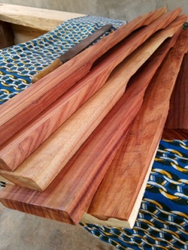
1.The key slab, 2. The stand and, 3. The resonators

The key slabs

The key slabs are tuned by scraping or chiseling out a portion at the middle of the wood, this is done by using the hack saw to cut the surface of the wood to at least 1cm-1.5cm deep, then use the chisel to and hammer to chop it of after which the rasp file is used to continually bruise the surface. This process lowers the pitch of the marimba, therefore a tuner, either a tuning fork, a pitch pipe, a keyboard, tuning apps or keyboard app which must have been tested must be readily available during this process so as to get the desire pitch of the slabs. Tuning are done to averagely a tone higher to give chance for re-tuning and rechecking of the pitch. Machines can be used to make this process faster and easier, machines like the band saw machine can be used instead of chiseling with a chisel and hammer, electric stone grinder replaces the use of rasp file and flat file. All these processes must be done carefully because a mistake can damage the slab thereby changing its form. This process is done for all the keys after which finishing touches and holes are drill at the node area using the pillar drill and bit.
The following tools and machines were used for the construction process of a key slab.The tape rule both digital and manual, the hacksaw (manual/electrical), the calculator (app or electrical), the band saw, the circular saw machine, the sandpaper machine, and the pillar drill machine.
Tool | Part of the tools | Usage | Average size of the tool | Material used in making the tool/machine
Hack saw | Nuts, blade and the frame | For cutting woods and iron rods/bars | 1 foot – 1 and half feet | Made from metal
Calculator  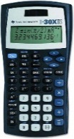 | Buttons, touch screen, numbers, symbols, battery, and cover. | To calculate the length and breadth of the key slab, to calculate the node point, calculate the frequency of each key | Pen size, more or lesser than 15cm | Often plastic and circuits with battery which may be li-on battery, AA size detachable battery etc.
Band saw  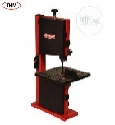 | Electric Motor, Blade adjuster, Dust container, Blade, table. | To cut curved woods, which might be sphere, circle, or irregular shapes | As designed by the manufacturer. Averagely 4 feet or more | Metal is the paramount material and plastics.
The circular saw machine  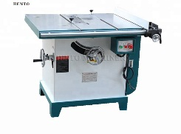 | Electric motor, circular blade, table, blade guide, coil, capacitor, fan and meter gauge. | To slice planks to desire length or breadth | Comes in different sizes, nut most often an average table size or as designed by the manufacturer. | Metal.
Sand paper machine  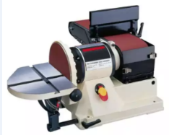 | Sand paper, motor, coil, belt, | To smoothen rough edges and for finishing | As designed by the manufacturer. It varies in sizes based on purpose | Metal, sand and paper, rubber
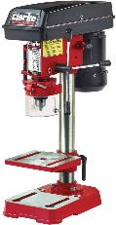  Pillar drill machine | Motor, belt, gauge, handle, bits, small table | For drilling holes at the node point of the key slab | Varies in size, and uses different sizes of bits, ranging from 1mm to 13mm or more | Metal.

APPS (Applications) and Devices
There are various apps made by apps developers used in tuning musical instruments generally including finding the voice range of the instrument and this has been used in the tuning of marimba amidst the conventional tuning fork, piano, electronic keyboard, or pitch pipe. These apps include: Da Tuner which has different functions like tuning meter which will allow you to know the pitch level of the key slab or resonator, green indicates perfectly tune, orange light level for slightly higher than the desired pitch, and yellow light level for slightly lower or lower than the desired pitch, the metronome is also available on this app for musicians to keep the beat when rehearsing.
The app is sensitive to sound and needs to be used in a noise-free environment like a studio for perfect and maximum use of it. Though there are limitations that occur during the process of tuning the marimba which include the app not responding as it should maybe due to overuse of the phone or battery level of the phone, other limitations are more from human, when the ear is filled with many sounds, getting the exact pitch or the causes of not being able to tune perfectly will be a dilemma. Then a break will help, this is psychological.

Interface of Da tuner app
The spirit level meter app is used to plum or balance objects or constructions, this can be done by placing the phone on the required wood, which might be any part of the marimba stand or key slabs to check for its accuracy, it functions as a protractor to get angles among other things it could work for. The app makes some sounds if surface found perfect.
The digital tape rule, very small in size is a device that makes you measure in centimeters and inches. This is done by just moving the device from a point to another and it reads the measurement in LED, just like the wristwatch.

The stand/frame
The marimba stand is also made from wood which can be Mahogany, Omo wood, Oro wood Manila wood among others. The first thing to do is to plane the plank and slice it to the desired breadth, then cut it to the desired length. Using the planner and the circular saw machine.
The following tools and machines aside from that mention above are used during the construction process of a marimba stand.
Tool | Part of the tools | Usage | Average size of the tool | Material used in making the tool/machine
Hammer | Handle and hammer head | To drive in nails | 1 and half feet | Ceramic, metal, wood, cast iron
Screw driver/screw driver machine | Battery, screw holder, screw, motor | To screw in screws into materials | Often gun shape and handy. | Plastic, metals, circuits
Spanner | Spanner head and middle joint | For tightening of Bolts and nuts | Depending on spanner size number | Metal/cast iron
Soldering iron | 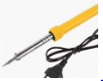  Insulator handle, filament, soldering iron nail point | To make holes in padded beams before using the drilling machine and also for connecting cables with lead. | 40-60cm depending on design | Wood, plastic, metals, copper.

Tools/devices picture comparison
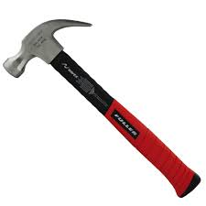  Hammer | 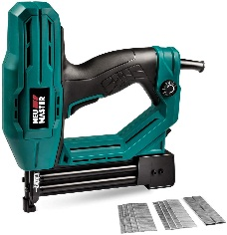  Electric hammer
Hacksaw  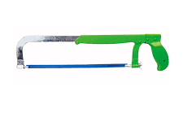 | Electric hand saw  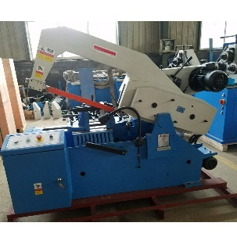
Fret saw machine  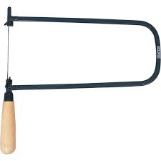 | Band saw  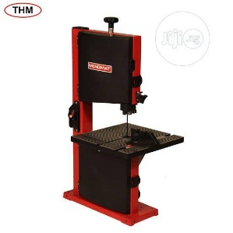
Measuring tape  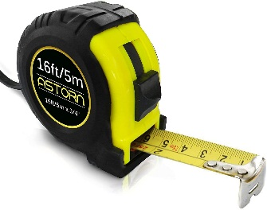 | Digital measuring tape  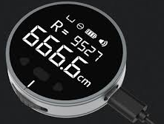
Brace and bit  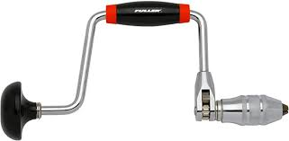 | Pillar drill  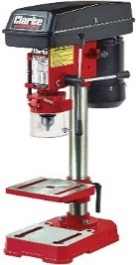
Screw driver  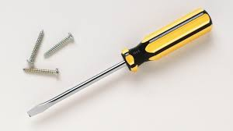 | 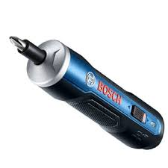  Electric screw driver machine
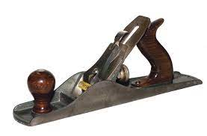  Jack plane | Electric planner  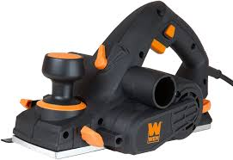
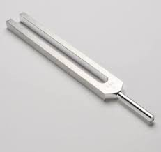  Tuning fork | Da tuner app

Nuances as found in the construction process of the marimba

The construction process of the marimba needs proper monitoring and care should be taking so as not to be at a loss after all the processes have been achieved. The tools used need proper care and maintenance for proper functioning as well as the wood being worked on. Failure to keep this in mind results in a stay down in the construction process. For instance, the wood which must be kept in a dry and enclosed room must not be exposed to the weather to avoid twisting. When a key is twisted, it will be a difficult task to correct it with the machine, though it can be reduced in size to reduce the length and this will allow for a little correction. It is better to keep planks and wood generally well than to anticipate correction after it has been dealt with by the weather.
The machine that can be used in straightening the bend or twisted wood includes the planer, and circular machine. This is done by using the try square, ruler, and markings with a pencil to re-shape the shape, but not all planks or wood can be corrected, the purpose can thus be diverted for another use.
A plank or seasoned wood should be used for the slabs to avoid dis-tuning after some time, the wood to be used must be well dried, the longer the years used by a plank the better it sounds and the better it gets seasoned. Artificial seasoning can be employed and this is done by putting the planks near the big oven for a while, to dry up the plank. A finished and well-furnished marimba must thus be covered with leather to keep it warm and moisture-free.
Why use the hardwood?
Hardwood is used to avoid dent and easy damage of key slab as opposed to softwood which surface gets dent easily and this reduces its sound production as well as tuning defects. Recommended hardwood includes rosewood, padauk, mahogany, oro, opepe, cedar among others. These are tested wood that has been used for the construction process of marimba and turn out to produce a very good sound, the rosewood is the highest rated among due to its hardness and beauty, it is used in making the best of musical instrument. Soft but mature wood can be used for mallets and some other part of the marimba, with good finishing.
The resonators
Resonators are amplifiers, they help in increasing the volume of the key slab, and this is done by tuning each and respective key resonator to the pitch of its key slabs. The resonator is made from different materials which are: horn, bamboo, plastic pipes, cardboards, ivory, and wood to mention but a few.
The resonator treatment depends on the required material or design. The wooden resonator must be preserved and protected against pest for it to last long and function properly, the cardboard resonators must be protected against contact with much water as well as the ivory or horn type resonator. The bamboo resonator must be boiled in very hot water to kill all the pests after which chemicals can be used to preserve it against further damages from pest and insect.
Machines, as used in the construction process of the marimba keys, are also used in the process of constructing a resonator. Resonator making thus involves, cutting, washing, putting a plug at one end, and tuning to the right pitch using devices like apps, electronic keyboard/keyboard app, tuning fork, or pitch pipe. Care must be taken to avoid any air leakage from the stop area of the resonator as this may affect its tuning process.
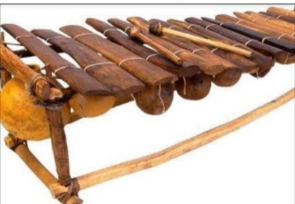
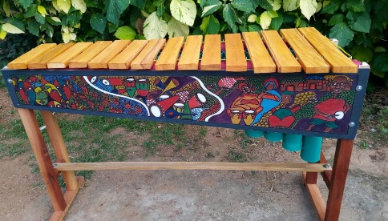

Plastic pipe resonator Gourd type resonator

CONCLUSION
Construction process of musical instrument involves having diverse knowledge of putting things together to bring out an output, an object that worth to be called musical instrument, with a good acoustic sound production. This is done with various raw materials as found in our environment but processed using modern technology, and by an expert in the require field. The technological space thus gives room for improvement in the production of musical instrument using available and improvised tools that suit a purpose in the production of musical instrument, this technology not only include hand tools but also mechanical machine as well as digital devices and apps on androids to make work easier and faster, challenges are encountered during the process but these tools, machines, devices and apps makes the work stress free and making the aesthetic value of the work appreciative.

Reference
Adeyeye A. and Faniyi K. Cultural and Creative Arts music, Drama and Dance, Nigeria:
Rocket and Rocker Publishing Company 2014

Adeyeye A. Technology of Sekere among the Yoruba. A project submitted to the Institute of African Studies, University of Ibadan. 1999
Akpabot, E.S. Foundation of Nigerian Traditional Music. Spectrum Books Limited, Sunshine House, Ibadan, Nigeria. 1986

Bruno Nettl and Timothy Rommen. Excursions in world music. Routledge Taylor and Francis Group, New York and London. 2012

Backus, J. The Acoustical Foundation of Music. California: University of Southern
W.W.Norton& company Inc. 1969
Brace, G. and Burton, I. Sounds, Signs and Language. Listen! Music and Nature. Cambridge: Cambridge University Press.1979
Chris H. G General Woodworking. Glencoe/McGraw-Hill, Mission Hills. 1952.
Journal of the association of Nigerian musicologist No. 4. Published by association of Nigerian Musicologists 2010

Nketia, J.H.K..The music of Africa. W.W. Norton and company, New York, London.1974
Paul F.B The Soul of Mbira University of California press, Berkeley and Los Angeles, California. 1978.
Smith & Marx, Merrit Roe & Leo. Does Technology Drive History? The Dilemma of Technological Determinism. The MIT Press. ISBN 978-0262691673. 1994.
Terry E. Miller and Andrew Shahriari World Music A Global Journey. Routledge Taylor and Francis group, New York and London. 2012.

