THE TECHNOLOGY OF THE BASS MARIMBA: A MEANS TOWARDS NATIONAL DEVELOPMENT.

By

ADEYEYE, Adegorioye Oluwole
Department of Music Technology, The Federal Polytechnic Ilaro, Ogun State.
Email: adegorioye.adeyeye@federalpolyilaro.edu.ng
Contact: 07038197627

&

ADEWUNMI, Olumayowa Oluwayomi
African High Arts Orchestra Company (AHAOC), Ibadan, Oyo State.
Email: adewunmiolumayowa50@gmail.com
Contact: 08153838640

SEPTEMBER 2020

ABSTRACT
The Marimba is an African traditional musical instrument of the idiophone family with graduated wooden slabs which are laid on a beam while being played with the aid of mallets. It is of different types which includes; soprano, tenor, baritone and bass marimbas among others. Existing researches have focused on less details about the technology of few out of the diverse designs of the Marimba. To this end, this research therefore examined the systematic process of constructing the Baritone Marimba as fabricated by the Institute of African Arts Technology, a musical instrument producing company in Ibadan. This research was hinged on the theory of continuity and change. And a manufacturing company was purposively sampled as the research field. Key informant interview was conducted and data on the construction details were collected through interviews, participant observation method and literatures among other ethnographic sources. Findings reveal that Musical instrument technology can aid national development as there are local musical instrument which when constructed could accrue international recognition and sales which translates to a better economy. Conclusively, the knowledge gained from this research which explores the step by step construction process of the Baritone marimba is therefore of paramount help to our nation at this time of serious economic recession as music technologist and interested individuals can make use of it.
Keywords: National development, Marimba, Music Technology, International recognition, Continuity and change.

INTRODUCTION
African musical instruments are symbolic part of the African heritage as they play vital roles in its social-cultural environment. They are used for different occasions, rites of passages, and worship of deities to mention just a few. This notion was supported by Omibiyi (1979) who described Yoruba traditional Music as “music performed in the courts of kings, at various religious ceremonies and festivals and also to instrumental ensembles”. Aside the socio-cultural usage of African musical instruments, they also serve as major tools to communicate values, societal norms, pass knowledge and reiterate history and historical events. An example of this could be found among African griots who perform by singing and relating historical events through story telling as they play their musical instrument which also voices out rhythmic sounds. Nketia (1974).
The African marimba (xylophone) as a musical instrument of the African origin which was engaged in this study falls under the classification of tuned idiophones which as explained earlier is a musical instrument that has its main source of sound production from the vibration of graduated wooden bars (keys) motivated by a pair of mallets which may be wood, or other materials that are used by the player(s) to strike the keys to achieve melodic or rhythmic feats. Nketia (1974:81). The wooden bars of the Marimba are tuned according to a particular mode or key. The sound gotten from the striking of the marimba wooden bars are then further amplified with a resonator which is tuned and tied or hanged under each key. These resonators could be of diverse materials ranging from banana or plantain stumps, clay pot, bamboo, animal horns, poly-vinyl-chloride (PVC) pipes, gourd and trough of a chosen material to mention just a few. In Nigeria, the African marimba is commonly used among the Igbo and Ibibio of the south-eastern and south-south as well as other ethnic groups in the northern part of the country.
On the performance of African music, Nketia (1974) observed that:
“Musical performances are generally multidimensional in character, for it is customary to integrate music with other arts, with dance and drama, as well as with various forms of visual display such as masks”. (1974:244)
With the foregoing statement, it is noticeable that African music is encompassing in nature as it draws the attention of other arts to itself whenever exhibited. The presence of African music creates an immediate atmosphere for dance and acting, as it is not uncommon to find audience in experiencing African music performance break into sectional dances when the inspiration of the music hit them.
Akpabot (1986) opined that:
“Nigeria is rich with a wide variety of xylophones which can have anything from two to fifteen slabs. The Gedegwu xylophone of the Ibos has only two slabs tuned a major second apart; it is constructed by placing the two tuned slabs over a pitcher. There are also the four-note xylophones of the Ibos known as the Ekwe Omaba; the eight –note xylophone of the Ibiobios called Ikon Eto and the fifteen-note xylophone of the Hausa/Fulanis called kundun”. (1986:14)
Akpabot (1986) further discussed the xylophones in the Northern part of the country which are usually supported by gourd resonators and hung around the neck during performance.
While discussing the history of the African Marimba, Babarinsa (1997) noted that the marimba as an African musical instrument assumes diverse names in relation to difference in ethnicity and language. “Among these names we have Marimba, Belinga, Balafon, Timbila, Mbila, Ngedegwu, Kundung, Ikon-Eto, Elawo-omoba, to mention (but) few” Babarinsa (1997:2). While discussing the early players of the marimba who were generally women, Babarinsa noted that:
“The players of this instrument in the period of antiquity were generally women. They usually sit on the ground, place two or three rough slabs of wood across their legs, then use two clubs to strike the slabs on their legs in turns to give the desired sound”.
The above shows that the marimba (xylophone) would not be classed as part of the musical instruments women are forbidden to play in Africa, owing to the fact that women are the earliest performer of the musical instrument. Having discussed details about the marimba, this research is set to solve the problem of how the bass marimba could be fabricated, so as to prevent the musical instrument from losing its place among other African traditional musical instruments.
Aim and Objectives
The aim of this study is to explore the technology of the bass marimba: a means towards national development. The objectives of the study are:
- To make a systematic documentation of the process of constructing the Bass Marimba.
- To discuss the acoustic consideration of the Marimba available in production in Ibadan.
- To examine the importance of resonator, types, sizes and specifications that exist in this case study.
- To investigate into the varieties of wood materials that could be used in constructing the marimba.
- To examine how knowing musical instrument technology can help to develop a nation.
Methodology
The ethnographic method of collecting data was used to gather vital facts, and this was done through interviewing of key informants, participant observation method where the researcher experienced the making of the musical instrument (Bass marimba), and consultation of books and library sources as the secondary data sourcing method.
Marimba designs
It would be important to note that marimba designs to be discussed in this project would be the ones as fabricated by a versatile music technologist in person of Mr. Adesanya Adeyeye, the director of Institute of African Arts Technology, a division of High Arts Orchestra Company, which is located in the heart of Ibadan Oyo State, Nigeria. Therefore there exist other different prototypes and designs of marimbas that exist all over the world, as they are all subject to the most commonly used designs peculiar to a particular culture or ethnic group, the manufacturer’s choice of design as well as customized designs based on marimba players or composers specification.
The various designs he has for marimbas include the Soprano Marimba, Tenor marimba, Baritone marimba, Bass marimba and Chromatic marimba. All these marimba designs have their names majorly based on their voice range structure and are in various keys of C major diatonic or F major diatonic. This is not to say that the marimba can’t be constructed in keys other than the ones mentioned.

Acoustic consideration of the Marimba
Acoustic is the study of the effect of sound based on material or environmental concepts or the way materials affect sound production. According to Oxford English dictionary, acoustics is the science of sounds teaching their nature, phenomena and laws. Every material used in the construction of the marimba has a way of affecting its overall sound production. There are materials that brings about greater changes in the acoustic of the marimba. Examples of such material are: The wood used for the keys, and the resonator prototype which may be materials from bamboo, poly-vinyl-chloride (PVC) pipes, horns, gourds among other materials. Aside these two major materials, (that is wooden key and resonators), other materials like the wooden stand, foam-padded beams, board use to cover the sides among others also have impact on the sound of the marimba.
According to Rager, the sound of the early instrument varies depending upon where it was made as the materials that make the resonated sound are of different sizes and composition. He observed further that:
“The pitch of the wooden bars is governed by several factors. Firstly, the material (type of wood), its length, width and depth all determine the timbre of the instrument. For example, if a wooden bar is thinned (sanded down) in the centre in the shape of an arch, the pitch will become lower. The more wood that is filed away from the middle of the bar, the lower the pitch will be.”
Wood type
The type of wood used in fabricating the marimba goes a long way in determining its sound production. For example, the sound production of rose wood is different from that of opepe or cam wood. Therefore it is good to understand the timbre of wood to be used in constructing the marimba as this is what translates to the uniqueness of sound that will be experienced during performance of the instrument.
Wood size
The size of the wood used in making the keys of the marimba, determines the pitch (frequency) of the marimba. The longer, wider and flatter the wooden bar used, the lower the frequency. And on the other hand, the shorter, thinner and thicker a wooden bar, the higher the frequency. This is one of the reasons why reduction of the wood through shaving it at the bottom part lowers the pitch of the marimba keys. Therefore the marimba keys are usually sized in a way that its working size has pitches higher than the actual pitches. Work is then done on each of the keys to lower the pitch until it reaches its intended actual pitch sound.
The frequency chart for the musical keys are as shown in the diagram below.
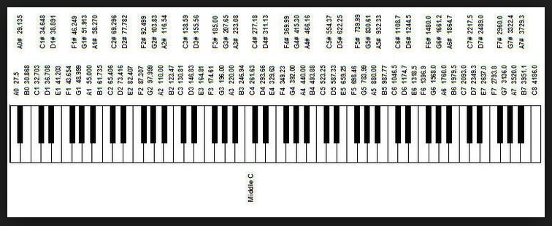
Resonator prototypes
Resonator simply means sound booster/enhancer. It could be likened to a chamber that amplifies the sound of another vibrating body which when excited at equal or very close frequency with the resonating chamber produces a louder or more amplified sound effect. Musical instruments (African and western) in general have an acoustic body or an attachment which helps them to have a clear and precise sound production. The Marimba which is being studied in this case makes use of the attached type of resonator, which is the fitting of extra hollowed out and graduated objects/materials under each of its wooden slabs/keys which thereby helps the projection of its sound. The resonators of the Marimba are usually graduated according to the size of its wooden keys which are also graduated according to the scale pattern employed in the construction of the instrument. The various resonator material types used in the construction of the African marimba includes; horn/tusk, Bamboo, Gourd \Calabash, and Poly-vinyl-chloride (PVC) resonators among many other materials that are used across Africa.

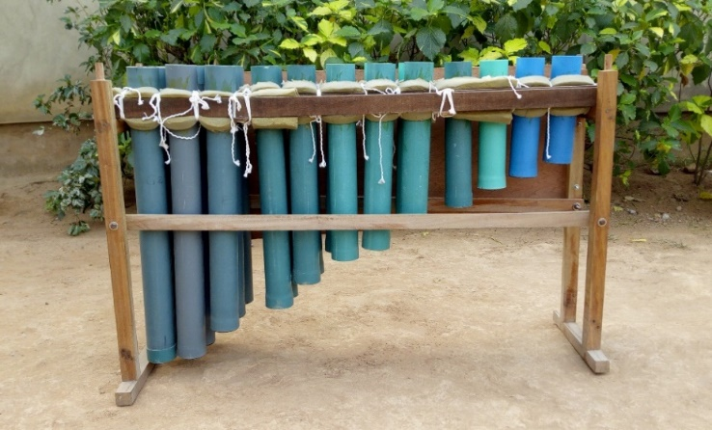

Plate 6: Poly-Vinyl-Chloride resonator for the bass marimba prototype of Mr. Adesanya Adeyeye (field work 2009)

WORKSHOP TOOLS AND MACHINES

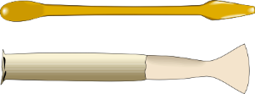

Hand Saw Chisel Spanner
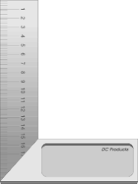

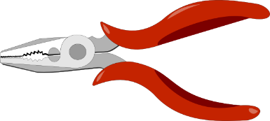

Tri square Star screw driver Plier
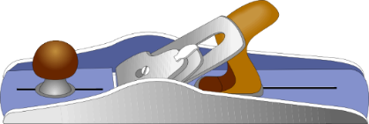

Jack plane Hack saw Pinches
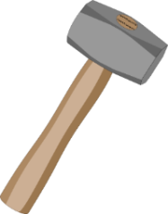
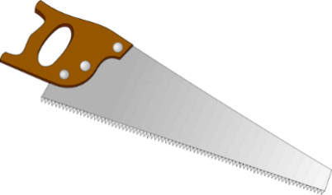
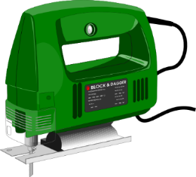

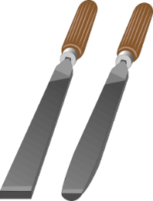
Sledge hammer Jig saw Panel saw
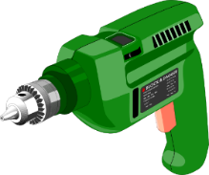

Flat file Chisel Electric hand
Drilling machine

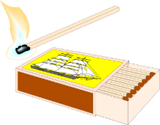
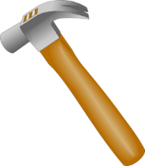
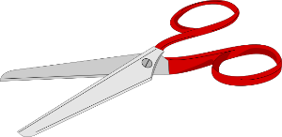

Hammer Scissors Matches
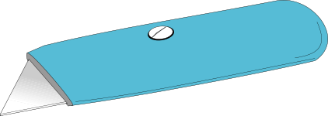
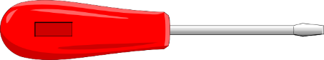

Brush Cutter Flat screw driver

FITTER’S VICE: This is a mechanical apparatus used to hold or secure an object to allow work to be performed on it.
VARNISH: This is a liquid material used for polishing surfaces. And it can also prevent ant from destroying the material.
BRACE: It is a hand manual drilling tool used to create holes in materials.
SAND PAPER: It is an abrasive material used to smoothen, polish, or grind a surface.
HAND SAW: This is also known as panel saw, used to cut pieces of wood into different shapes. This is usually done in other to join the pieces together and carve a wooden object.
BLADE: It is used to cut ropes, peel up or remove the hair from animal skin and it is also used to cut the skin (awo) into strand to make osan, it can also be used generally for cutting during construction work.
FLAT FILE: This is a metal tool with fine grid, which helps to smoothen a surface or edge.
RASP FILE: Rasp file is a metal tool with rough teeth which helps to grind a surface or edge.
ROUND FILE: This is a round metal tool which helps to smoothen holes and edges.
KNIFE: The type of knife used for construction is specially made, it is different from the kitchen knife and it is always very sharp.

Other tools and materials are:
1. Varnish paint
2. Brush
3. Sand papers
4. Rope
5. Knife
6. Nails
7. Glue
8. Evostic gum
9. Pencil
10. Red pen
11. Bicycle Adjuster
12. Screw drivers
13. Spanners
14. Pliers
15. Nut and bolt
16. Foam
17. Leather

CONSTRUCTION PROCESS OF THE BASS MARIMBA
The bass Marimba is the marimba design bigger in size than the baritone Marimba. It has keys with lower-pitched notes than the baritone marimba. The bass Marimba just like the baritone Marimba, has longer, wider and flatter keys which helps it to easily achieve the depth for lower-pitched keys. Its wooden key measurement is width 8.60cm, thickness 1.90cm and varied length depending on the key. Just like the baritone Marimba, the bass Marimba also span for one and half octaves (12 keys) with no extra note. It ranges from G2 (97.999 hertz) to D4 (293.66hertz). The length of its longest key which is the lowest sounding note is G2= 65.0cm, while the length of its shortest key which is the highest sounding note is D4= 37.6cm. Talking of the playing position of the bass marimba, the lowest note is usually to the left of the marimba player who would usually stand in an upright or slightly bent position depending on the action the performance entails. The bass marimba is as shown in picture plate number 10 above. The range of the instrument is also as expressed on the musical staff below.
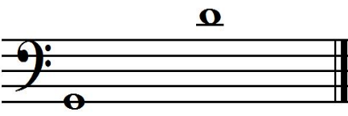

The bass marimba just like other marimba designs has different parts that are usually worked on separately and then assembled together to make a whole. In view of the foregoing, the different parts of the bass marimba to be worked on then includes majorly:
- The wooden Keys/slabs
- The resonator
- The stand
- The beam
- The hanger
- The brace and
- The side boards
The wooden key/slab
The keys of the marimba is usually made of hard wood which is cut and arranged according to the choice of key arrangement the manufacturer wants. The choice of hard wood is not behind considerations based on the strength the wooden key must have for it to survive being beaten (that is, played) with mallets without it getting damaged easily. This is not to say that all hard woods are good materials for making the marimba as one needs to consider the workability of the wood. When the wood is too strong, it won’t be easy to work on the wood which requires cutting, and shaving of the lower part during the tuning process. On this basis, there are diverse hard wood types that are therefore suitable for the purpose of constructing the marimba keys, among which is the Opepe, Rosewood and Cam wood, to mention just a few. Every wood has unique grain structure and this is what determines their strength or workability.
Working on the key: The first procedure to making a marimba key is choosing the right type of wood, which may be Opepe wood, Rose wood, or Cam wood among others as explained earlier. The quality of the wood should also be put to consideration. It must be that which does not have too much wood-knots, as wood knot tends to negatively affect the vibrational property and overall sound of a wooden key. Wood knots are node points (that is, the points with least or no vibration), and so dampens the sound production of the wooden slab.
Once the type and quality of wood have been rightly chosen the next thing is to cut and smoothen the wood to the desired dimension. It will be important to note the acoustic implication of any cut done to the wood at this point, and that is: The flatter, longer and wider the wood/key, the lower the frequency and on the other hand, the thicker, shorter and narrower the wood/key, the higher the frequency. The measurement of the wooden key of the Bass marimba according to Adesanya Adeyeye’s prototype is as shown in the diagram below:

After slicing of the wood plank to the desired measurement at the saw-mill, the next is to cut into usable pieces of wood which makes up the keys of the marimba. The measurement in terms of the length of the keys is determined by picking a first key length which will be used to calculate a constant for the measurement (length) of other keys. The first length for the Bass marimba according to Adesanya Adeyeye’s design is G= 65cm. And the calculation for other keys after it is as calculated below:
For the bass Marimba design, the tuning frequency used will be A = 440Hz as the standard for philharmonic tuning scale.
In a wooden bar of free ends$f α \frac{1}{l^{2}}$
$f= \frac{k}{l^{2}}$
Where f = frequency of bar,
l = length of bar,
k = Constant of proportionality.
$$\begin{matrix}k= & {fl}^{2}\end{matrix}$$
$$l^{2=}\frac{k}{f}$$
$$l=\sqrt{\frac{k}{f}}$$
To calculate length l (G_{l}), with a given frequency, from the formula above:
Taking a first length of wooden key G(98Hz)= 65cm, to calculate the constant (k) for other notes in the scale.
$\begin{matrix}k= & {fl}^{2}\end{matrix}$ (from above)
K = 98.0 $×65$²
K = 98.0 $×$4225
K = 414050
The constant above which was gotten by the chosen length of the first key, G, is what would be used to calculate the length of the other keys of the marimba, and the results analysed in the table below would be achieved. The node distance is also being calculated by multiplying the length of each keys by the node constant 0.224, which will result to the actual position of the nodes measured away from each ends of the wooden keys.

S/N | KEY/  NOTE | APPROXIMATE KEY LENGTH | NODE DISTANCE= NODE CONSTANT X KEY LENTH | APPROXIMATE NODE DISTANCE
1 | G | 65.0cm | 0.224 X 65.0cm=14.56cm | 14.6cm
2 | A | 61.4cm | 0.224 X 61.4cm=13.75cm | 13.8cm
3 | B | 57.9cm | 0.224 X 57.9cm=12.97cm | 13.0cm
4 | C | 56.3cm | 0.224 X 56.3cm= 12.61cm | 12.6cm
5 | D | 53.1cm | 0.224 X 53.1cm=11.89cm | 11.9cm
6 | E | 50.1cm | 0.224 X 50.1cm=11.22cm | 11.2cm
7 | F | 48.7cm | 0.224 X 48.7cm=10.91cm | 10.9cm
8 | G’ | 46.0cm | 0.224 X 46.0cm=10.30cm | 10.3cm
9 | A’ | 43.4cm | 0.224 X 43.4cm=9.72cm | 9.7cm
10 | B’ | 41.0cm | 0.224 X 41.0cm=9.18cm | 9.2cm
11 | C’ | 39.8cm | 0.224 X 39.8cm=8.92cm | 8.9cm
12 | D’ | 37.6cm | 0.224 X 37.6cm=8.42cm | 8.4cm
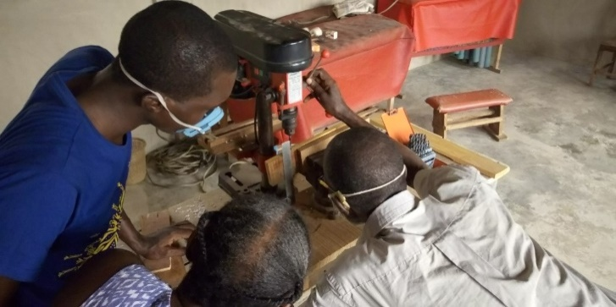
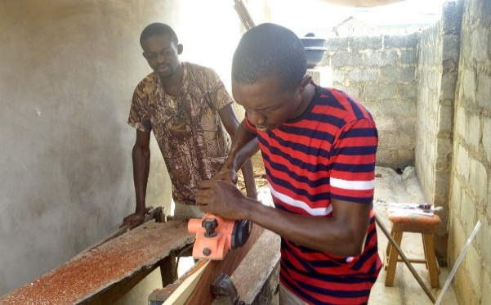

The researcher shaving a Marimba key with electric plainer machine.(field work 2019)
The Key informant and his wife teaching the researcher to drill the node hole of the wooden keys.(field work 2019)
The resonator
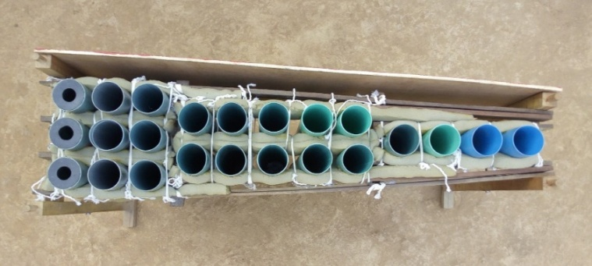
The resonator arrangement for the bass marimba according to Adesanya Adeyeye’s design is into three sections. That is, the first four wooden keys (keys G-B) have three resonators attached to each of the keys, the next five keys (C-G’) have two resonator attached to each of the keys, while the last four keys have just single resonator under each of its keys. The reason behind this arrangement is because of the lower part of the marimba which has long and wide keys. And these lower keys can only be best resonated by using more resonators to reinforce the sound of the keys. The diagram of the resonator arrangements under the bass marimba keys is as shown below.

Plate 23: The aerial view of the bass marimba resonator arrangement (Adesanya Adeyeye’s design) (field work 2019)
The resonators used for the construction of the bass marimba are usually close ended poly-vinyl-chloride pipes of 7.4cm diameter. The acoustic implication of it being close ended is that it reduces (lowers) the frequency of the pipe, thereby preventing too long resonator pipes which might have caused marimba players to stand on very high stools due to the height of the marimba which would have double or triple if the resonator pipes were to be open ended. To achieve a close ended pipe one would have to block one of the ends of the pipe with materials like pipe, wood, or other “stopper”. The stopper used for the bass marimba resonator is the PVC pipe stopper. It will be important to note that the resonators (group of three) meant for the first key of the bass marimba as constructed by Adesanya Adeyeye has stopper at both ends, only that the stopper that is at the upper part of the resonator that is directly under the keys is half closed. The reason for this is to further lower the pitch of the resonator pipe to correspond with the key it is meant to resonate while still maintaining a reasonable height of the marimba for ease in performance.
To fix the stopper, one would have to expose the lower part of the resonator to light heat source from kerosene stove or gas, then fix one of the pipe stoppers which must be removed within seconds because it is just meant to expand the pipe to accommodate stoppers as “evostic” gum must be applied before fixing the stopper permanently.
To construct the bass marimba resonators there must be a working length from which the resonators would then be tuned to the actual frequencies that correlates with the wooden key they are meant to amplify. The following measurement were employed for the construction process.

BASS MARIMBA RESONATOR MEASUREMENT
S/N | NOTE | WORKING LENGTH  OF THE PIPE RESONATORS | APPROXIMATE DEPTH  OF THE PIPE RESONATORS
1 | G | 81.0cm | 76.1cm
2 | A | 81.0cm | 76.8cm
3 | B | 73.0cm | 68.8cm
4 | C | 69.0cm | 64.3cm
5 | D | 62.0cm | 57.9cm
6 | E | 55.0cm | 51.6cm
7 | F | 53.0cm | 48.7cm
8 | G’ | 48.0cm | 43.5cm
9 | A’ | 43.0cm | 38.5cm
10 | B’ | 39.0cm | 34.1cm
11 | C’ | 35.0cm | 31.6cm
12 | D’ | 33.0cm | 28.0cm

The beam
The beam is the wood arrangement on which the marimba wooden keys are laid. The beam is usually padded by the use of foam, nylon, and then leather. The reason for the padding is to cushion the effect of the contact between the wooden key and the wooden beam. This helps the key to freely bounce while playing the marimba. This idea is as an improvement from how it has being in ancient times when banana stalk was used to carry marimba keys due to its softness and cushioning effect. The beam seats on the marimba stand with the help of a dowel joining, where holes of diameter 1.50cm are drilled at both ends of the long wooden brace. This hole fits into the “dowel head” of the stand. The oblique diagram of the beam showing the dimensions is as drawn below.

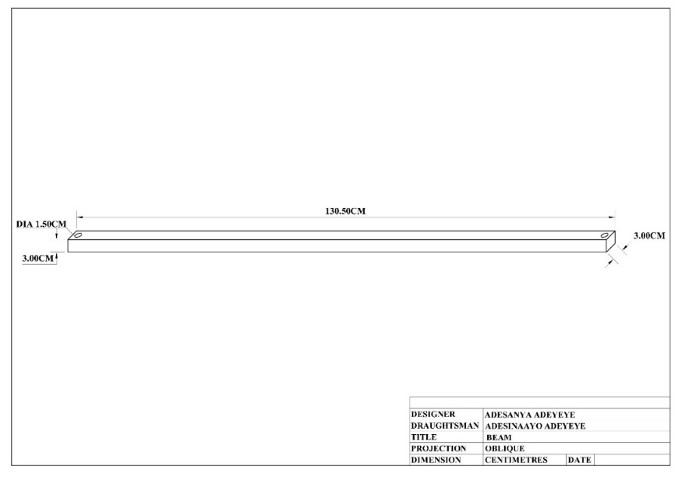

After cutting the wood for the beam to size and drilling the holes for dowel at both ends, the next is to pad by wrapping a thick foam of around one inch thickness around the wood using a transparent polythene nylon to tightly tie it down from one end to the other. It is after this process that leather can then be used to cloth it for a more cushioning effect.
There is always an arrangement of bicycle adjuster pinned down at intervals on the beam. This is done to hold down the keys from bouncing off or sideways away from its position. This bicycle adjusters have round holes which serves as passage for the strong thread/twine that helps to hold down the wooden key which also has holes drilled by the side and through its node points. The bicycle adjusters are pinned down by first marking the intervallic positions with a pen/marker on the beam, then use a hot soldering iron to centre punch each positions after which the drilling machine is then used to drill holes through the leather cushion to the wood so as to allow easy screwing of the bicycle adjusters.
The stand
Unlike the marimba keys which is made from specific hard woods as mentioned earlier, the marimba stand does not necessarily need hard wood for its own construction. Wood types that are suitable for the purpose of stand construction includes: Malina, Omo, and Oro to mention just a few.
In constructing the stand, there are factors that determines the size to use. The major factor being the size (length and width) of the longest and smallest marimba keys. The spacing of the wooden keys on the beam is another factor. The node points of each key also go a long in determining the setting of the beam (which is usually in v form due to its graduated keys) and the beam on the other hand dictates how wide the stand would be. The reason for this is that the marimba keys are laid on the beam (the beam lined at the node points) and the stand then carries the beam with the aid of a dowel joint arrangement. Due to the graduation of the marimba keys (from big to small) which is usually according to a scale structure, the marimba stand has two sizes of stand. One big-sized stand which carries the beam at the widest area (where there is the longest key) and the other small sized stand whose size is determined by the smallest key.

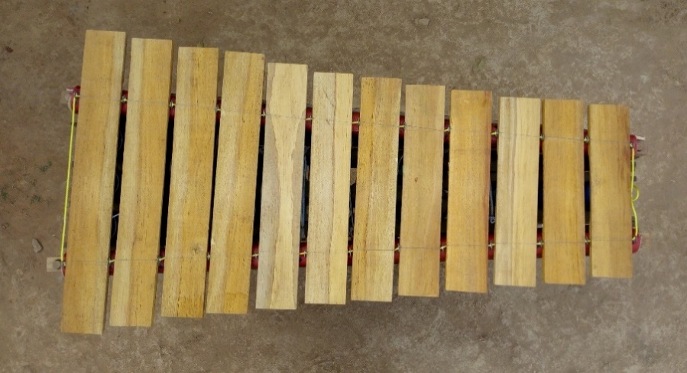

Plate 25: Arrangement of the Bass marimba keys on the beam, with the beam tracing through the node points of the wood. (field work 2019)
The Oblique diagram of the bass marimba’s small and big stands showing the various dimensions used for construction.
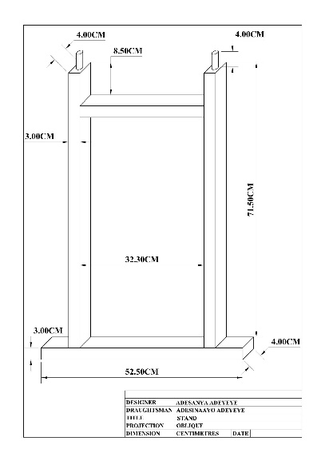
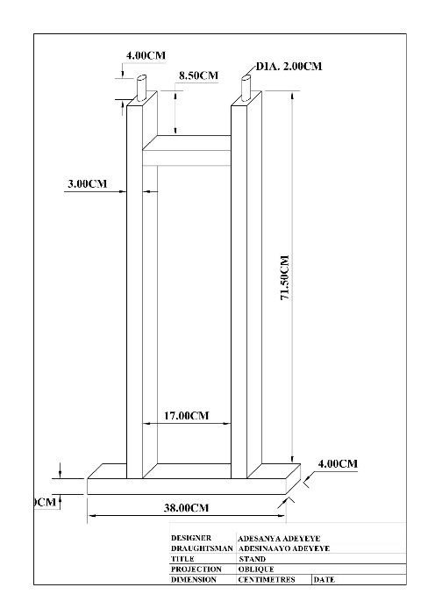

The brace
The brace is the wooden piece that connects the two marimba stands together and as well holds the lower part of the stand to the right position. Unlike the Soprano, tenor or baritone marimba that have their brace connecting the stands directly underneath the resonator pipes, the Bass marimba has its braces by the sides of the stands. One major factor for this is the length of the resonator pipe of the bass marimba which is usually very long thereby not leaving enough space for a brace to stay under it. Except there will be an increase in the height of the stand to accommodate the brace, but this would mean too much height for average performers of the instrument. The size of the brace is length 135.0cm, breadth 4.0cm and thickness 1.50cm.

The hanger
The hanger is the set of wood that holds the resonators of the marimba together. The hanger of the bass marimba is in three sets according to the settings of its resonators which is grouped in threes, twos, and singles (from the lowest note to high). The hanger rests its harms at both ends on the upper brace of each stand. The wooden hangers are usually padded with a foam of about one inch thickness so that every contact of the pipe is cushioned by the foam. This cushioning effect is necessary to prevent the resonator pipes from breaking due to the pressure from tightening it. The hangers guard both the external and internal part of the resonator, and they are arranged as shown in the diagram below
Tuning of the marimba keys
To tune the keys of the Marimba the middle of the inner (lower) part of the wood must be shaved off so as to gradually lower its frequency until the desired pitch has been achieved. While tuning the keys of the marimba the pencil was used to mark out the middle of the wooden slab, then the hack saw was used to cut the middle of the wood. This cutting with the hack saw was done so as to have easy access to using the chisel to remove a handful of the wood for a faster work done. The rasp file was then used to further shave the wood until it got to a semitone closer to its final pitch. The flat file was then used do the final tuning which was achieved with the aid of a phone software (fine tuner), and a keyboard (musical instrument) to double check the tuning of the wooden key.

SUMMARY AND CONCLUSION
This research has been able to discuss the method of fabricating the African bass Marimba, as it affects its constructional process by the African High Arts Orchestra Company in Ibadan. It has thus opened interested musical instrument technologists and other interested individuals to the making of an important African musical instrument that can bring economic and financial independence thereby a way towards national growth and development.
CONCLUSION
Conclusively, the task of preserving African musical instrument and heritage in terms of performance style is not an easy one, has there are lots of challenges musical instrument manufacturers face in terms of availability of materials, tedious work involved in the construction process and expensive machineries which would have made the work less tedious and interesting but impossible because of lack of adequate funding.
5.3 Recommendations for further study
Based on the findings gotten in the course of this research, the following recommendations could be made, as it would serve a basis for interested individual to further engage researches of this nature which has to do with the instrumental technology and performance of an African musical instrument.Firstly it would be important to note that the focus of this research is limited to Ibadan which is just a town in the South-west region of Nigeria. It would therefore be good to encourage other researchers to explore other regions where the marimba is being used, so has to have a proper documentation of the existence and performance practice of the marimba in these diverse regions.
Secondly it is evident with this research that the task of preventing the gradual extinction of our indigenous musical instrument is not an easy one, as the funds needed to buy the scarce materials as well as tools and machineries which could make the work easy to handle is a huge one that goes beyond the handling of an average technologist. It is therefore important that the government should intervene into the matter of preserving our musical heritage and practices by encouraging the technologists and artisans handling the construction of our indigenous musical instruments, through easy access to grants and loans/funds.
Lastly, it would be of great benefit if marimba performances could be made important at the primary, secondary and tertiary institutional levels. This will help to keep and preserve the performance practise of the marimba, therefore preventing the fade-off of our cultural standards.

REFERENCES
Adeyeye, A. Music Study Courses for Schools. Ibadan: Rocket & Rocker Publishing Co. 2006
Adeyeye, A. 2017. Technology of Marimba Construction- A case study of Adesanya Adeyeye’s
Marimba Design – A final year project, Obafemi Awolowo University, Ile-Ife, Osun State.
Adeyeye, A. 2011. Acoustic consideration in the Construction of African Traditional Instrument. The Nigerian Example. A journal of Association of Nigeria Musicologists.
Adeyeye, A. 1999. Technology of Sekere among the Yoruba.
Unpublished M.A. Thesis, Institute of African Studies, University of Ibadan.
Adkins, H.E. 1977. Treatise on the Military Band. Boosey & Hawkes Music Publishers Limited.
Akpabot, S.E. 1986. Foundation of Nigerian Traditional Music. Ibadan. Spectrum Books Limited, Nigeria.
Akpabot, S.E. 1998. Forms, Function and Style in African Music. Lagos/Ibadan. Macmillan Nigerian Publishers Limited.
Bebey, F. 1987. African Music A People’s Art, Lawrence Hill& Company, p. 84-85.
Charles, A. 1947. Musical Acoustics. The Blackiston Company, Philadelphia, Toronto.
Eyler, David Paul, "The History and Development of the Marimba Ensemble in the United States and Its Current Status in College and University Percussion Programs (Musser)." (1985). LSU Historical Dissertations and Theses. 4091.
Faniyi, K.O. 2017. Dynamics of Instrumental Technology and Performance of Bembe Music in Ibadan South-western Nigeria. Unpublished M.Phil. thesis, Institute of African Studies, University of Ibadan.
Grout, D.J. 1973. History of western music. New York: W.W. Norton
Garfias, R. 1983. “The Marimba of Mexico and Central America”. Latin American Music Review. University of Texas Press, p. 203-228
James, B. 1975. Percussion Instrument and Their History. Faber and Faber, London.
John, B. 1969. The acoustical foundation of music. University of Southern Califonia. W.W. Norton & company inc.
Miller, T.E. 2009. World Music-A global Journey; New York: Routledge.
Nketia, J.H.K. 1974. The music of Africa. W.W. Norton and company, New York, London.
Oluoma, O.L. 2010. Nelson Functional Physics. Nelson Publishers Limited, Jericho, Ibadan.
Omojola, B. 1995. Nigerian Art Music. Ibadan: Institute Francais de Recherche en Afrique (IFRA)
Omojola, B. 2006. Popular Music in Western Nigeria. Ibadan. Institute Francais de Recherche en Afrique (IFRA)
Olaniyan, O. 2011. “Yoruba musical technology”: An enhancement for dundun drums construction and ensemble organization. A Journal of Association of Nigerian Musicologists. (JANIM) No. 5. Pg 141-147.
Omibiyi-Obidike, M.A. 1979 “Islamic influence on Yoruba Music” African notes Volume viii, number 2, October 1979. Pg 39-41.
Rager, D. 2008. “The History of the Marimba”. Music Faculty Publications. Paper 1.
Samuel, K.M. 2009. Instrumental technology of dundun drum of the Yoruba. In Nigerian Art reflections: A Journal of the Society of Nigerian Artist, Oyo State. Vol.8
Samuel, K.M. 2009. The Art of Female Dundun drumming in South-western Nigeria. Unpublished Ph.D. Thesis, Institute of African Studies. University of Ibadan.

