Name: Ogunjimi M. O, Okedairo O. O
Title of Paper: Effects of Technology on Music Distribution During Covid 19 Lockdown
Details of Coference: A paper presented at the 2nd International Conference of The Federal Polytechnic Ilaro, Ogun State, Nigeria. Held at The Federal Polytechnic, Ilaro, Ogun State, from 10th to 11th November 2020.

EFFECTS OF TECHNOLOGY ON MUSIC DISTRIBUTION DURING COVID 19 LOCKDOWN
BY

OGUNJIMI MOBOLAJI OLARINRE
MUSIC TECHNOLOGY DEPT
0806018775
Mobolaji.ogunjimi@federalpolyilaro.edu.ng
OKEDAIRO OLUFEMI OLALEKAN
MUSIC TECHNOLOGY DEPT
08036129297
Okedairooluwafemi123@gmail.com

ABSTRACT
This paper examined the effects of technology on music distributions with emphasis on prospects that surrounds creation of online music streaming sites. It silhouetes the characteristics of covid 19 devastation and it negative effects to the economy. The review of the study is of great impact to the background of this study on technology of buildimg the economy as a way of fighting covid 19 pandemic. The study make findings based on the increase in number of music streamings online during pandemic and discussed how relevant and effective is the creation of music online streaming to the devastated economy caused by covid 19. The study was concluded on the note that, the technology of creation of online music streaming sites has indeed contributed to the economy and has aid tremendously in fighting against covid 19 downturn of the world economy.
Keywords: Technology, Music, Online streaming sites, Distributors, COVID 19

Introduction
Sahal (1981) views technology as ‘configuration’, observing that the transfer object (the technology) relies on a subjectively determined but specifiable set of processes and products.Today, technology is in the fore front of navigation in the world and we see constant technological changes within the local and international media industries. As technology grows and consumer preferences change, it is equally important for media companies (streaming sites to be precise) to differentiate themselves. The market is witnessing more customer-focused options with online streaming every day.
In the last few months, due to COVID 19 outbreak, the Internet users’ community has experienced huge patronage and therby increase changes in the way the web sites function and the services they offer. There is a new logic behind this evolution that goes beyond the data-based web structures of the near past. The new streaming trend invites users not as passive receivers of information, but as creators, or at least gatherers and redistributors.
Internet has penetrated into our everyday life in every possible way. As a result, not only the volume of users has increased, but also their familiarity with the World Wide Web. Media consumption has aided production and distribution of music especially during covid 19 lockdown. As Joshua Meyrowitz (1985) argues in No Sense of Place, the differential social spaces surrounding media consumption can impact social life in simultaneously subtler and more dramatic ways; as he puts it,

“Electronic media affect us…not primarily through their content, but by changing the ‘situational geography’ of social life”
As far as music is concerned, more users means larger potential volume of music information distributed, while more familiarized users means greater convenience and more distribution channels. At the same time, the contemporary Internet structure, combined with the revolution of social networks, led to the exhibition of many new artists. New music groups and independent artists do not target on the music labels for their promotion. In contrast, they use social networks and YouTube for their exposure. Music is everywhere in the web and can be found and consumed through numerous software and hardware (even portable) solutions. In addition, music is free for those who are not interested or informed about copyright issues and agreements.
The media industries should focus on factors that make music distribution easier and also factors that makes a consumer more likely to choose online streaming. Such factors may include cost, media options, usability, social trends and age. However, after a thorough review of past studies, the lack of recent research identifying the obvious variables in these consumer choices and mode of music distribution became evident. While there has been rigorous research into online streaming services, most of the previous studies concentrate on one aspect rather than multiple variables to reveal important correlations between online music distribution consumer preference. This paper presentation attempts to address this gap in the literature with an up-to-date investigation into the factors that makes music distribution much easier especially during covid 19 pandemic and why consumers chooses online streaming sites to other available means.
Statement of the Problem
Covid 19 pandemic is a major disaster to the workd economy. It has affected big and small scale enterprises in the world. The effects of covid 19 to the downturn economy of the world cannot be under emphasised. As countries of the world continue to battle with it, people are busy looking for possible means to build the shattered economy caused by covid 19 and technology is a major way out in this century. The major problems of music consumers and distributors on where to buy and how sell music is what this paper will address. To this effects, the paper will examine how effective is the creation of online music streaming sites to the problems of buying and selling of music and as solutions to economy downturn caused by covid 19 pandemic.
Paper Objectives
The objectives of this paper specifically are to:
1. Explore effects of technology on music distribution
2. Examine the problems associated with music distribution during covid 19 pandemic
3. Evaluate how effective is the online music distribution to solving the problems of covid 19 economy down turn
Research Questions
The following questions were formulated to guide the study:
1. In what way does technology affect music distribution?
2. What are the problems associated with music distribution during covid 19 pandemic?
3. How does online music distribution aid in solving the problems of covid 19 economy downturn?

Scope
The paper covers distribution of hip hop music both Nigerian hip hop and foreign hip hop music. The study explores 5 online streaming sites namely, Amazon, boomplay, spotify, itunes radio and Ahola.
Operational Definition of Terms
Technology: is the implication of scientific knowledge for practical purposes, especially in music industry.
Music: is the vocal or instrumental sounds (or both) combined in such a way as to produce beauty of form, harmony, and expression of emotion.
Online streaming sites: is the media content - live or recorded - delivered to computers and mobile devices via the internet and played back in real time.
COVID 19: is a disease caused by a new strain of coronavirus
Research Method
Data gathered for the presentation are found on music online streaming platforms for the basis of analysis in this presentation. Some music purposely uploaded to streaming sites to generate income was selected based on their numbers of streaming and popularity in the hip hop music industry. The study adopted simple random technique to select Nigeria music and USA music found on some popular streaming sites. To this effect, the music selected was analysed using content analysis. 10 music were randomly selected using simple random sampling technique. The selection consisted of 7 Nigerian songs and 3 yankee songs. 7 Nigerian hip hop songs were selected based on the note that, this paper looks at effects of technology on Covid 19 with a special focus to Nigerian economy. 3 yankee songs were selected to justify how effective is digital technology on music to both Nigerian music and yankee music. To this effect, 10 music uploaded to popular online streaming sites were selected and analysed.
LITERATURE REVIEW
Pattern of Music Flow before and during Covid 19
The fact is that, music used to follow a specific procedure for its production and distribution until a few months ago. This old procedure started from the idea’s capture (by the composer) and, after several stages, ended to the reproduction of the final recording by a device and distribution for cosumption by music listener. The procedure used to be the same without regard to the final recording medium (vinyl disks, tapes or even CDs). The music production process had several stages. Considering a song as a product, its production process begins with the writing of music by the music composer and the writing of lyrics by the lyrist (these two roles may belong to the same person). Automatically, they own this composition’s copyrights. Afterwards, the initial idea is processed by several artists: musicians, singers etc. The recording of the music piece takes place in a music studio, where sound engineers and computer programmers participate. After the recording, the production of copies (CDs, tapes etc.) follows as distribution processes begins. The product should be then packed in order to come out to market.
But recently, covid 19 has changed that traditional direction where most of recordings are done virtually and after several professionals worked in the next phase: photographers, commercial artists and publishers. The final stage involves a promotion company that takes over the product’s promotion in the market. The person in charge of the described whole process was a producer (usually representative of a record label). Although the recording usually took place in privately owned studios of the record label, the CDs production used to take place in third party facilities. The advent of information technologies in music industry brought several changes to the production chain. A crucial point of the new confused situation in music production is the entrance of several stakeholders from the field of computer science, who had no association to the music industry before. Online music distribution differs a lot from the traditional distribution of physical media, and saves a lot of money for the labels concerning the costs of manufacturing, packing, storing and delivering. There are obvious differences and additions from the traditional structure.
Covid 19 has merged two kinds of music consumers: those who buy the physical record products, and those who consume digital products (music files, streams etc.), it has also changed the tradition of patronising physical products through social distancing, use of facial mask and other measures.
Digital Music
In digital era, the traditional production process stops at recording, where the only engaged roles are: the producer, the artists and the record label. There is no need for hard copies and packages anymore. The digital form of music (bits) allows its cheap storing in a tiny disk. When the digital music file is ready, it is distributed to music websites and eshops. Music labels and producers authorize such sites for the legal retail to consumers. The third newly created channel has to do with the artists, who can now easily carry out the tasks of recording and production by themselves and peddle their songs directly to the Internet.
There are several reasons why people embraced digital music format. The user is able to download any songs anytime, without visiting a traditional music store. Any music piece can be downloaded in a few seconds thanks to the increase of network connection speeds. Another reason is the dramatic growth of Internet piracy. Songs are freely distributed over the Internet (in some cases even before their official market release).Thus, the users do not need to pay a price to buy a CD. Instead, they can simply click and download their favorite songs, without thinking about label contracts and copyright issues. A last advantage of this shift towards digital music is the ease of music storing and transferring. CDs and vinyl are concrete. Contrarily, downloaded music is simply bytes in our hard disk. Therefore, instead of filling our shelves with music media, we fill our hard disks with bytes of music. This serves for two reasons: it saves space and makes distribution easier.
Online Streaming and Online Access to Content
Online streaming is defined for the purposes of this paper as delivering content that is continuously received by, and displayed to, the end user virtually, while it is being delivered by the provider. Streaming media is multimedia data transferred in a stream of packets that are interpreted and rendered, in real time, by a software application as the packet arrives(klass 2003) . Continuity of transmission while the content is already being consulted and the lack of permanent transfer of data to the user computing device constitute distinctive features of streaming. Both elements differentiate streaming from downloading; although the distinction is increasingly blurred due to a shift in downloading services from traditional hardwareoriented data transfer and storage to ubiquitous solutions, such as acquiring rights to consult specific (acquired) content by the consumer through various devices, which are usually registered on a cloud computing platform and managed by an accounting system, electronic identification or digital identity, and by digital rights management.
Most streaming media systems operate on the client/server model. A client requests data from a server on a computer network, and the server delivers the data, which is interpreted by the client. In streaming media, audio and video data are encoded in a special format that shrinks the data to a manageable size. After the server delivers the data, the client renders the data and displays it as audio or visual information. Streaming technologies like Adobe Flash, Apple QuickTime, and Microsoft Windows Media and Silverlight all include certain common components in their solutions. These include a player to play the media on the viewer's computer or mobile device, a defined file format or formats that the player will play, and often a server component that offers features like digital rights management and live streaming. All streaming technologies use compression to shrink the size of the audio and video files so they can be retrieved and played by remote viewers in real time.
The trend towards the digitalisation of information flow leads to the transformation of initial e-commerce and e-government (both originally functioning as electronic windows for physically-performed transactions, e.g. goods delivered and forms sent by post) into advanced e-commerce and e-government (operating exclusively on an electronic basis, e.g. electronic downloading of digital goods and services, and electronic internal and external transactions in administration), and subsequently into ubiquitous commerce and ubiquitous government (where rights to pervasive, fixed and mobile access to connectivity and services are defined by and centred around electronic identification and digital identity; thereby placing the user, rather than technology, in the centre).
The shift from electronic to ubiquitous reflects the fact that the Internet is evolving into an ever more complex network, composed of highly-interactive and constantly-connected sensors, RFID tags (Radio Frequency Identification), processors and storage units that allow for the efficient, collaborative and interdependent exchange of information and content, involving citizens, businesses and administrations. In such a system, the possibility to download and “own” content on one's personal computer is much less important than the possibility to have multi-platform access to a constantly-updated flow of collaboratively-produced information and content, and to be able to contribute to it.
Technology Advancement and Covid 19 Devastation
Technological advances are another important factor influencing how consumers view entertainment in their homes. Cable companies and now streaming options are providing customers an easier way to access digital content and much more of it. As technology continues to evolve, the use of hand-held media devices is seeing a drastic increase. Hand-held devices improve the viewing experience of online streaming services. Social trends are playing a huge factor in how customers are adopting online media and what they watch. Social media mixed with technology allows users to connect more easily and see what everyone is watching. Research by Bondad-Brown et al. (2012) produced a statistically significant relationship between social trends of the current age and the factors of adoption. The data showed significant correlations between social trends and how the adoption of online media occurs. The social aspects of digital technology, mobile apps and social media are shown to impact this loss of viewership. (Feldman, 2016; Bautista et al., 2016).
Review of Previous Studies
Research by Lee, Choi, Cho, and Lee (2016) attempted to determine the relationship between digital products (online media streaming) and physical products, focusing specifically on music from both records/CDs and online streaming. Their objective was to identify the factor that impact such decisions. They collected data between March 2011 to July 2013, focusing on the top 200 songs of those years, as well as the sales figures of the Gaon Music Chart (http://gaonchart.co.kr). The Gaon Music Chart tabulates the relative weekly popularity of songs or albums in South Korea, which is similar to Billboard Chart in America. To supplement the basic data, the research team collected information about how often an artist performed, album specific characteristics, and album ratings. Upon initial examination of the data, the team found that the numbers were skewed due to the sales, and consequently created an algorithm to continue the analysis.
In addition to a correlation analysis model, they developed an econometric model to determine the impact of online music streaming and music record sales. The results show that there is a significant positive relationship between online streaming and record sales, but that price and album rating do not significantly impact record sales. Lee et. al. (2016) relates to our current research, as we are seeking to understand the effect on additional purchases when consumers look for online streaming or cable. Our research intent is to establish whether there are any significant relationships between these factors—that is, whether the choice between online streaming or cable services leads to more sales or the purchase of additional add-ons.
With growing media viewership from online sources, such as streaming services or websites, more recent studies have focused on the factors that drive this adoption. Bondad-Brown, Rice, and Pearce (2012) explored the motivations of users to access online media for content over traditional TV, and also considered age, generation, and contextual age (physical health, economic security, etc.). To gather the data, surveys were sent out through email and were able to identify 500 people as their sample size. The model looked into a number of independent variables which included media use, internet experience, online video use, age, generation, and audience activity. Among the independent variables, we will explore the media use and age variables in our research.
Research performed by Taneja, Webster, and Malthouse (2012) examines the wide range of platforms and content choices available to both cable and streaming customers, and how customers deal with the abundance of options. Factor analysis was used to identify what the authors called “user-defined repertoires” from data gathered by following 495 users through their daily use of cable/streaming, down to 10 second intervals. For this case study, a “repertoire” is considered to be a small subset of preferred media. Two general hypotheses were tested; the first indicates: “Structures, such as program schedules, shape media consumption.” The second hypothesis states: “People are active agents who make purposeful, rational choices when they consume media.” An interesting finding throughout the article was that consumers do not divide their time consuming all of the media made available to them but instead, create subsets of options and consume media from those smaller subsets. A similar, simpler study by Nielsen Company gave evidence that households used only 14% of the channels made available to them through cable, a leading reason for consumers switching to streaming services as the channel availability can be more fine-tuned to consumer preferences (Nielsen, 2009).
Reviewing the research performed by Cha and Chan-Olmsted (2012), there was some concern regarding whether online streaming would have a cannibalizing effect on traditional cable networks. As our technology and infrastructure of video streaming has evolved, many of the industry leaders questioned the effect this would have on television, some even suggesting it would replace it altogether. Cha and Chan-Olmsted’s (2012) study was focused on this issue, intending to determine if the new medium (digital media) would either replace or complement the older one (cable). Some of the questions they asked were: “What motivations do consumers have to watch video content?”, “Are there differences between users and non-users of online video platforms with respect to motivations for watching video content?”
The researchers collected survey data from 1500 adult internet users in 2009. They used a Likert Scale to gauge the respondent’s motives for video content, which included music videos, TV programs, movies, and videos. The primary method was principal components exploratory factor analysis, in addition to ANOVA. The results varied but did provide some insights, for instance, learning motives differentiate online streaming and television in terms of customer satisfaction. As well, the study revealed that non-users are more likely to view online video platforms as a substitute for cable television. Cha and Chan-Olmsted’s (2012) research was important for demonstrating the “fundamental functional similarities” between online streaming and cable, as well as the relationships that stem from each. Different from the findings of previous studies reviewed in this paper, this present study attempts to examine the effects of technology of online music streaming as a positive response to negative effects of covid 19 pandemic.
Data Presentation and Analysis
Data presented for analysis in this study were gathered from the online streaming sites. The data presented focuses on the technology of streaming songs and how effective it is to artist, consumers, distributors and online streaming creators. Ten songs were gathered and presented for the purpose of analysis in this study. Analysis and discussion of findings were carried out in the second phase of this section.
S/N Artists/Music Streaming Sites No of Streams Artists % online sites %
1. Wande coal (Again) Sportify 745,000 70% 30%

2. Fire boy (Apollo) Boomplay 6.6 million 70% 30%
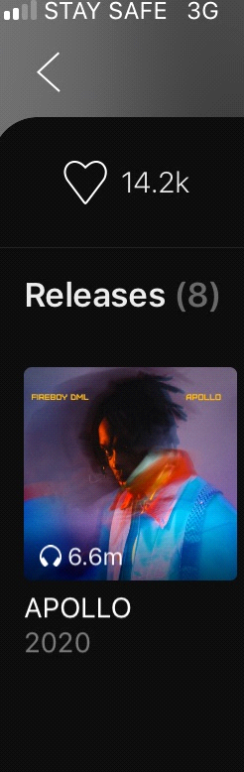
3. John legend (Love me now) Ahola 13.2m 70% 30%
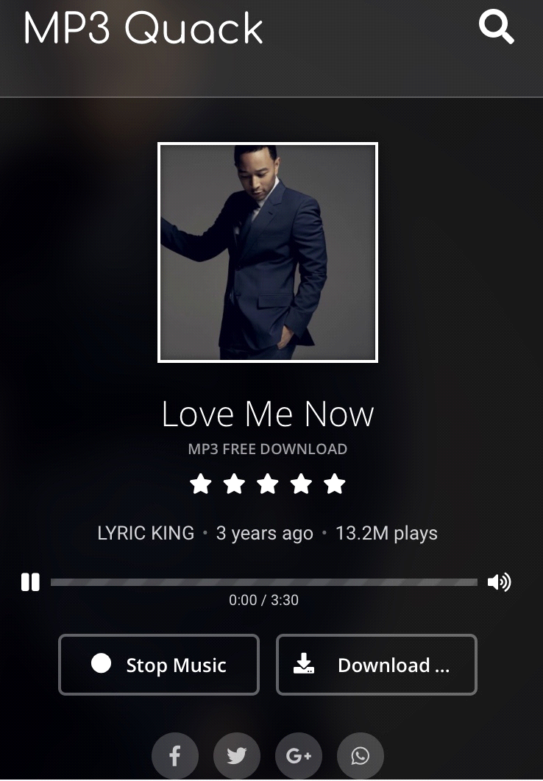

4. Davido (Aye) Boomplay 800,0000 70% 30%


5. Wizkid (Joy) Amazon 1.2million 70% 30%
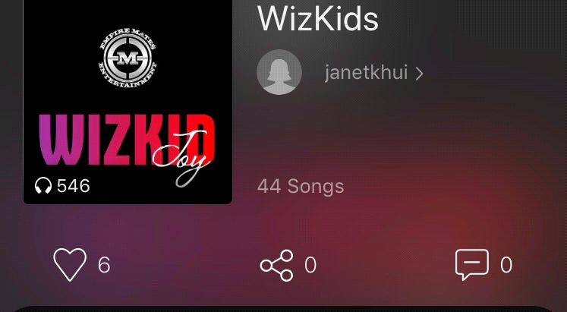

6. Burna boy (Wonderful) Boomplay 2.5million 70% 30%


7. Wizkhalifa (Roll up) Itunes 6.8million 70% 30%


8. Joe boy (Nobody ft Mr Easy) Boomplay 3.7million 70% 30%
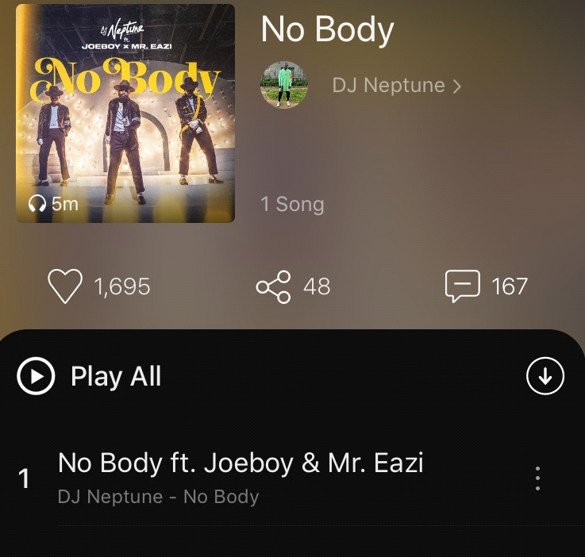

9. Fire Boy DML (New York City Girl) Ahola 2.3million 70% 30%
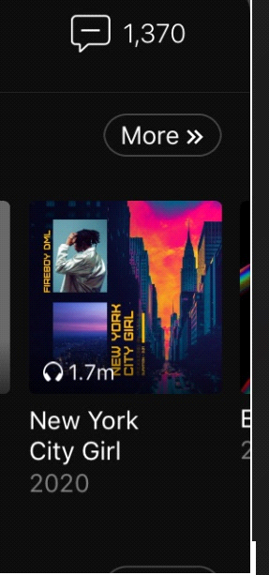
10. Brian Free (Acapella) Ahola 150,000 70% 30%
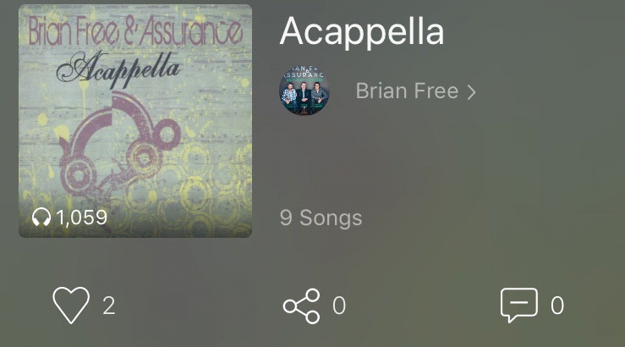
Analysis
From findings, the study discovered that, some online distribution platforms who are third party or intermediary between artist and streaming sites on music distribution receive their charges directly from artists before they distribute their work to the online streaming sites. Therefore, money made on streaming songs are shared between artists and online streaming sites. In some cases, where distribution companies don't get to charge artist before distribution, percentages are shared among the three key players who are the artists, distributors and online streaming services. But in this study, the percentages of the song gathered on the selected streaming sites are shared between artists and online streaming services with artists having 70% of the streaming and streaming sites creators having 30%.
From the findings it was evident that online music distribution has a significant contribution to music sales in Nigeria and abnroad. To start with, Wande coal (Again) on Sportify online streaming site has 745,000. Fire boy (Apollo) Boomplay 6.6 million, Burna boy (Wonderful) on Boomplay has 2.5million, John legend who is a foreign artist in (Love me now) on Ahola streaming site has the highest stream 13.2m, Davido (Aye) on blooplay has 800,000, Wizkid (Joy) on Amazon site has 1.2million, Wizkhalifa (Roll up) on Itunes has 6.8million streams, Joe boy (Nobody ft Mr Easy) on Boomplay has 3.7million streams, Fire Boy DML (New York City Girl) on Ahola has 2.3million while Brian Free (Acapella) on Ahola has 150,000 streams.
From the above findings, it was revealed that foreign songs still have more streams than Nigerian songs but there have been a great improvement in the waves Nigerian songs are now making online too. The total sum of stream from the ten selected songs in this paper is 37.995million and this made us to understand the fact that artist and online streaming sites makes more money with the artists getting 70% of the total streams and the online streaming sites 30%. However, the charges of the distribution conpany and some other online streaming sites differs depends on terms and condition but the total percentage of this study was based on the streaming sites under survey.
Conclusion
The results from this study reveal how effective the technology of music online streaming to covid 19 devastation is. During covid 19, consumers are more open to the idea of purchasing online streaming services. This is significant as online streaming companies can focus their efforts on expanding more data base for consumers because of the propensity to buy online than physical. It is equally important to conclude the rate at which people patronise online streaming sites to get their desire music is on the high and is of positive impact to boosting the economy that has been downturn by covid 19. Unlike before when music consumers tend to patronise CDs, millions of music consumers have now turned to the idea of streaming their favorite songs online and this makes music patronage and money making processes much easier for key players in music making and distributions. We also found that online streaming services must keep prices competitive, since they are a critical driver in the purchase decision. Online streaming has aided in fighting the problems of covid 19 devastation as it pave ways to maximum music delivery to consumers.
Recommendations
In line with Taneja, Webster, and Malthouse (2012) who examines the wide range of platforms and content choices available to both cable and streaming customers, and how customers deal with the abundance of options, this paper recommends the following:

The paper recommends the following:
1. Future research should examine the impact of how consumers stream music online and explore the different ways that streaming services are used
2. Upcoming artist should source online means for distribution of their music.
3. Attention should be paid to online distribution of goods and services.
4. Music lovers can get their favorite songs online rather than patronising cds.
5. Government should explore the prospects in technology than rebuking it.

References
Bondad-Brown, Beverly A., Rice, Ronald E. & Pearce, Katy E. (2012) Influences on TV viewing and online user-shared video use: Demographics,
Cha, J., & Chan-Olmsted, S. (2012) Substitutability between online video platforms and television. Journalism & Mass Communication Quarterly, 89(2), 261-278.
Chang, B., & Chan-Olmsted, S. M. (2010) Success Factors of Cable Network Brand Extension: Focusing on the Parent Network, Composition, Fit, Consumer Characteristics, and Viewing Habits. Journal of Broadcasting & Electronic Media, 54(4), 641-656.
Elisabeth Jones, (April 26, 2009) Network Television Streaming Technologies and the Shifting Television Social Sphere Media in Transition 6: Stone and Papyrus, Storage and Transmission Cambridge, MA, The Information School, University of Washington
Feldman, J. (2016) How we watch football. Sports Illustrated, 125(18), 36-40.
Lee, M., Choi, H., Cho, D., & Lee, H. (2016) Cannibalizing or complementing? The impact of online streaming services on music record sales. Procedia Computer Science, 91, 662-671.
Meyrowitz, Joshua. (1985) No Sense of Place: The Impact of Electronic Media on Social Behavior. New York: Oxford University Press.
Nielsen (2009, July 17). Television audience 2008 The Nielsen Company. Retrieved October 30, 2017, from http://blog.nielsen.com/nielsenwire/wpcontent/./tva_2008_071709.pdf
Rainie, L. (2017, September 13) About 6 in 10 young adults in U.S. primarily use online streaming to watch TV. Retrieved October 28, 2017, from <http://www.pewresearch.org/fact- tank/2017/09/13/About-6-in-10-youngadults-in-U-S-primarily-use-online-streaming-towatch-TV/>
Taneja, H., Webster, J. G., & Malthouse, E. C.(2012) Media consumption across platforms: Identifying user- defined repertoires. New Media & Society, 14(6), 952-968.

