THE PERFORMANCE CONTEXTS OF YORUBA TRADITIONAL MUSICAL FORMS

OLALEYE, OLUFEMI AKANJI PhD
olufemi.olaleye@federalpolyilaro.edu.ng.com
08035745380
FEDERAL POLYTECHNIC ILARO,
OGUN STATE

Olaleye, O.A. (2012). The Performance Contexts of Yoruba Traditional Musical Forms. A Paper Presented at the 11th National Annual Conference of the Association of Nigerian Musicologists (ANIM), held at the Department of Music, University of Nigeria, Nsukka, Enugu State, between 13th – 18th August, 2012.

Abstract
This paper investigates the performance contexts of selected Yoruba traditional musical forms and identified hidden and neglected cultural facts about the design and organization of their musical forms. The form which a Yoruba song performance takes is determined by the structure of the social ceremony and therefore, the actual form of a song depends on the particular context from which it is derived. Through music, the Yoruba people express their world views, philosophies, and show reverence to their various deities. Against this background, this study traces the performance contexts as factors that determine the forms of Yoruba festival song forms. Descriptive textual and structural analysis of data revealed the significant and objectives of the study. The implication of the findings for policy and practice were also discussed. The included among others that the contextual and structural analysis should be adopted and form the basis of theories and forms in Nigerian art musical compositions and analysis. The study concluded that performance contexts are the determinant factor of musical forms therefore brings to lime light one of the yardstick of theoretical analysis of Yoruba musicological studies.

Keywords: Forms, Cultural facts, performance, social ceremonies

Olaleye, O.A. (2012). The Performance Contexts of Yoruba Traditional Musical Forms. A Paper Presented at the 11th National Annual Conference of the Association of Nigerian Musicologists (ANIM), held at the Department of Music, University of Nigeria, Nsukka, Enugu State, between 13th – 18th August, 2012.

Introduction
This study explores the performance contexts of the Yoruba traditional music as factors that determine their musical forms. Traditional music is the indigenous music which has been practiced from time immemorial and it is usually realized within the context of social events. From this point of view, the form which a given musical performance takes is determined by the structure of the social ceremony. Moreover, the actual structure of a song depends on the performance context from which it is derived. Music is an important art that is used in the daily activities of the Yoruba people. Through music, the Yoruba people express their world views, philosophies, and show reverence to their various deities. Nzewi (1985) observed that “it is a society that ascribes meanings to music” in terms of its sound implications and non – musical essence’’. Omojola (1999) in Idolor (2002) remarks that an understanding of the conception of music among African would have to be derived from a combination of factors such as the words… the contexts of performance…organized procedures…the nature and meaning intended in a musical performance. The conceptual background to this study is hinged on the notion that every art is an accurate representation of social realities: Kennedy (1980:12) submitted that art must depict its subject truly.
Renowned Musicologist, within the framework of Yoruba culture had contributed various musicological discourse and analysis which had led to greater understanding of Yoruba traditional music. However, after several decades of research in Yoruba traditional music, the question of whether the study actually reflects the performance contexts which birthed the musical forms, poses a challenges. It has been observed that while scholarly attention concentrated on analysis of recorded sound, the performance contexts of musical forms received far less scholarly attention. This therefore provides the premise for this study. This problem was vividly noted by Akpabot (1993:13) who opined that
There have been, in many studies in African music; too much of a hurry to analyzed a piece of recorded music and not enough attention to the social structures that influence the music sound. This total reliance on music alone has resulted in some debatable theories by … scholars.
The dilemma that arises in such a process tends to create a dichotomy between the foundation of Yoruba music and the processes of its forms. Therefore, the preoccupation of this paper is on the performance contexts, which is a precursor to the development of Yoruba traditional musical forms. Therefore, this study focuses on the performance contexts of selected Yoruba traditional musical forms such as; Orin Igbala (Burial processional song), Orin Oro (Traditional festival song), Ekun Iyawo (Bridal cry song) and Ere Osupa (Moonlight play song).
Form, in the context of this study, is the intelligible organization of sound in a way that gives meanings to music for communication to take place. However, the analysis of musical forms without reference to performance contexts makes it impossible to fully realize the musical meanings. Hence, Schoenberg (1937:11) declared that ‘form means that a piece of music is organized’. No doubt, a lot of Yoruba art music have been collected and analyzed since the pioneering works of Ulli Beier and William bascon (1970). Invariably, the need for this study is the near absence of performance contexts and internalized value system of Yoruba culture into Yoruba music analysis. The aforementioned are the main focus on the study.
Theoretical Framework
The theoretical framework for this study is hinged on Aristotle’s’ theory of art as an imitation of life. Aristotle, (384 – 322BC?) the Greek philosopher, was the first to introduce the theory that art imitates nature and he considered the origin of art as a basis for his argument. He attributed the origin of art to the human affinity for imitation of nature. According to the theory, imitation is the primary method of learning and that it is natural for humans to take delight in work of imitation. Aristotle in politics (1409 17-21) states that ‘musical times and tunes provide us with images’ (homoiomata, likenesses) of states of character’. According to Plato, as quoted by David 1999 ‘all artistic creation is a form of imitation of life’. Therefore, Aristotle’s’ theories which interpret art as an attempt to provide an accurate representation of the object, social reality, and experience of life are undoubtedly the core theoretical framework for this study.
Performance as a Concept
The concept of ‘performance’ practice is taken over from the German word ‘Aufuhrungsprazis’, coined in the 19th century, and may be said to cover the mechanics of a performance that defined its style. The serious scholastic study of performance practice belongs to the 20th century, pioneered in England by Arnold Dolmetsch but gathered real momentum only quite recently, especially in African music studies.
The study of performance practice aims to pinpoint the style, conventions, condition of music in order to give the clearest possible view of the composers’ original intentions and expectations. Performance practice in the context of this study denotes the way music is and has been performed. An attempt was made in this study to interprets Yoruba cultural performance contexts as factors that shape the musical forms buttressing Tracey (1943:123); assertions that a study of song lyrics of Africans can lead to an understanding of African basic philosophical principles. Against this background, this study investigates the varieties of Yoruba traditional music and traces the performance contexts in the design and organization of their musical forms.
Orin Igbala: Yoruba Burial Processional Song
Burial ceremony among the Yoruba people is an important occasion that calls for music making known as burial processional dirge. The funeral dirge is a lament in poetic form by mourners for the departed loved one. In Yoruba land, the dirge is a highly stylistic form of expression that is governed by the specific poetic recitative conventions and performance procedure. The call and response between the lead cantor (usually the village babalawo) and general chorus response give birth to an A B form of the music. During the procession, the leader sings the dirge of the dead, while others chorus in response. However, the lead-cantor is free to change the recitation at will or as the ‘spirits’ demand. In such an occasion, this performance context of the music naturally determines the forms of the music and leads to graph representation as follows:
Burial: Incantation Call / Dirge Response
IC
DR
DR
IC

This type of form uses recitation, call and dirge response forms. However there may be some overlapping of recitation and chorus singing. The solemn atmosphere created by the event of death is also reflected in the solemn-like music. The following is a typical musical example of Yoruba burial song.
Musical Example 1
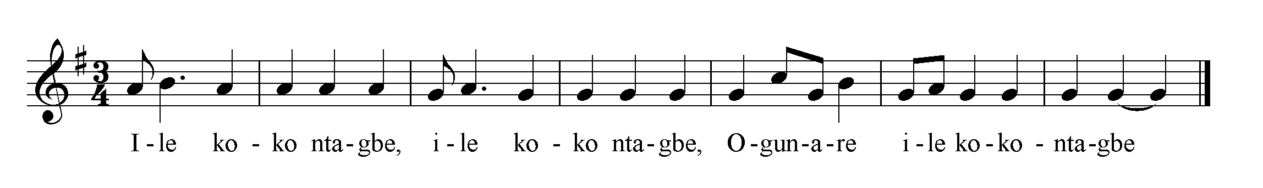
Interpretation of Yoruba Text in the Staff above
Ogunare, you will safely get home.
Orin Oro: Oro Festival Song
‘Oro’ is celebrated to ward off evil occurrences in Yoruba land. It is also to pray for bountiful harvest in the farm as well as to pray for rain and general peace of mind in the society. Oro songs are meant to invoke oro spirit and serve to regulate good conduct. The initiated members of the group, who remain anonymous, have a well organized network of songs about the major happenings in the society. Music is very important activity of the cults. Each song is clearly distinguished from each other, and every member of the group usually participates in the chorus rendition. Besides, in order to keep the identity of members, both oro and ‘majowu’(oro’s wife) with all devotees usually alter their voices during rendition in the responses. These acts of keeping their identity through voice gag usually lead to call and response hush tone musical form. The following musical example was recorded at Ipaja village,Yewa in Ogun State.
Musical Example 2
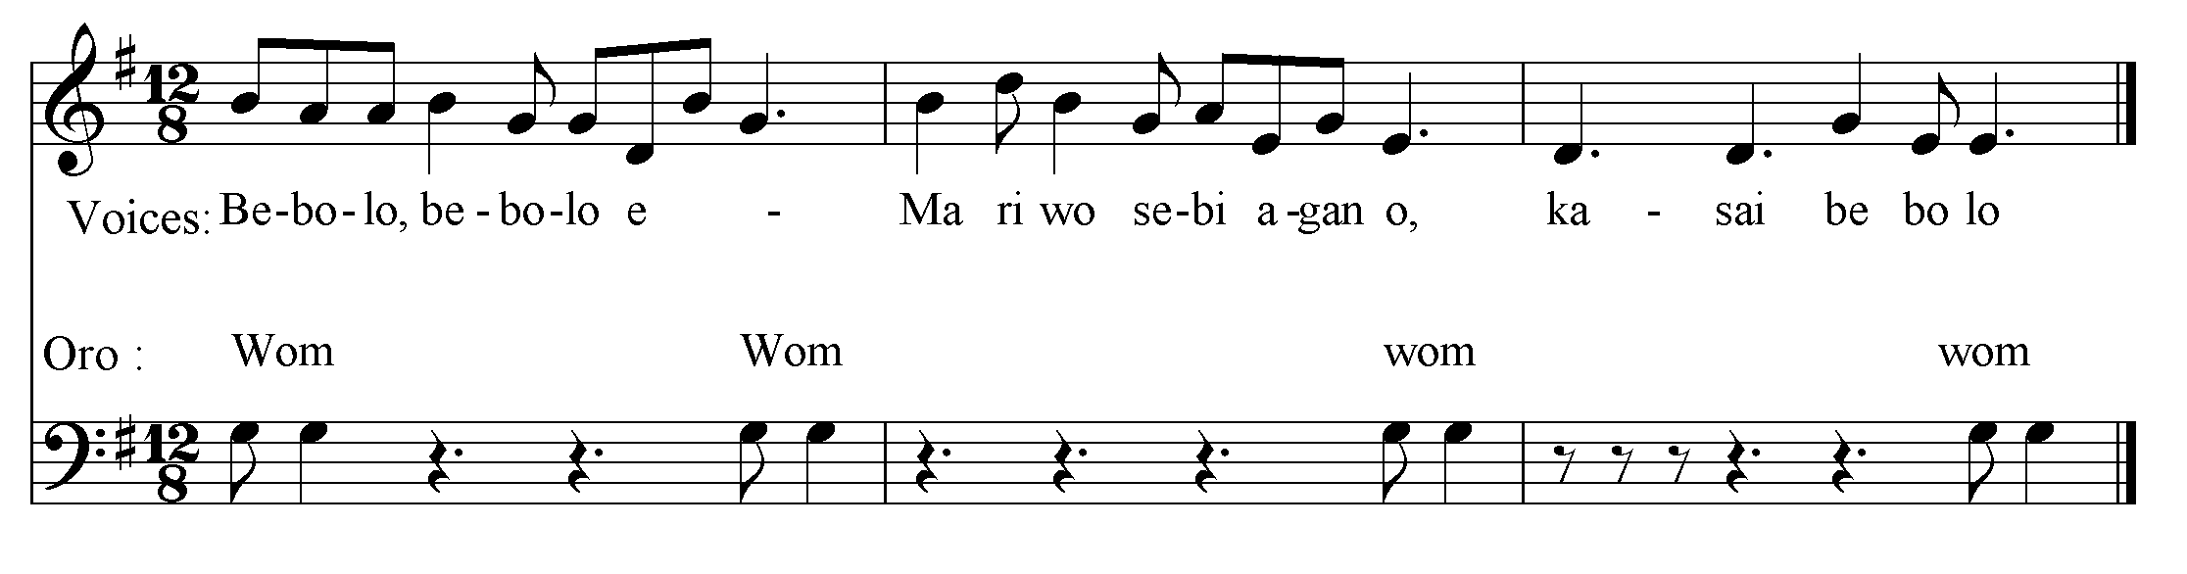
Evil depart with the sacrifice, evil depart with the sacrifice.

Music is an important aspect of Oro cultural festival in which the young oro cult members engaged in chanting and dancing across the village. The songs have very high moral messages and at the same time entertaining.
Oro Worship Graph of Interpolation Form
MC MC
MC MC
MC MC
SW SW
SW SW
MYSTIC CHORAL
SPOKEN WORD
PERCUSSION

Ekun Iyawo (Bride Cry)
Marriage is an important aspect of Yoruba life and music serves as spices in the ceremony. Bridal cry is a musical form used by the bride to express the joy and love of marriage. The cry is usually accompanied with elder’s prayers and praises to the new wife. In a typical traditional Yoruba marriage ceremony, bridal cry (Ekun iyawo) is an important aspect of the marriage. It is compulsory for every bride to perform the bridal cry a day prior to her departure to the bridegroom house. The main purpose of the cry is as follow; request for prayer, to thank her parents, to bid her parents and well wishers farewell, to express the fear of unknown and to assure her parents of keeping her virginity. This is the only Yoruba musical rendition where joy is mixed with sorrow in performance context. The following song (subject to variation) , is a typical Yoruba bride cry music.
Musical Example 3
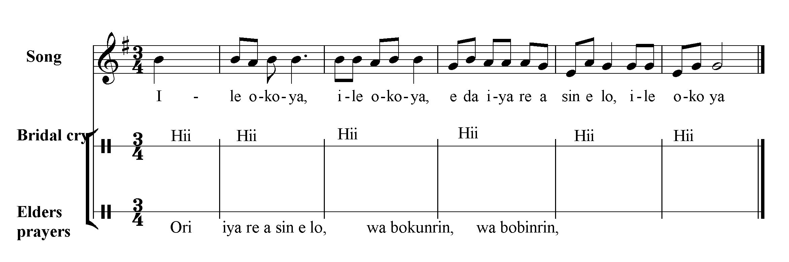
It is time for marriage; your ancestors will follow you

Lineal Recitative / Bride cry and Prayer Forms
Chorus
Bride cry | Hii hii hii hii hiii hiii hiii hi hi hi hiiii
Prayer | p p p p p p p p p p p p

Ere Osupa: Moonlight Song
Yoruba children love to turn any physical movement, object, or environmental circumstances into play song. The children usually make references to circumstances like birth, animals, weather and even their parents. The following musical example (subject to variation) is a Yoruba children play song.
Musical Example 4
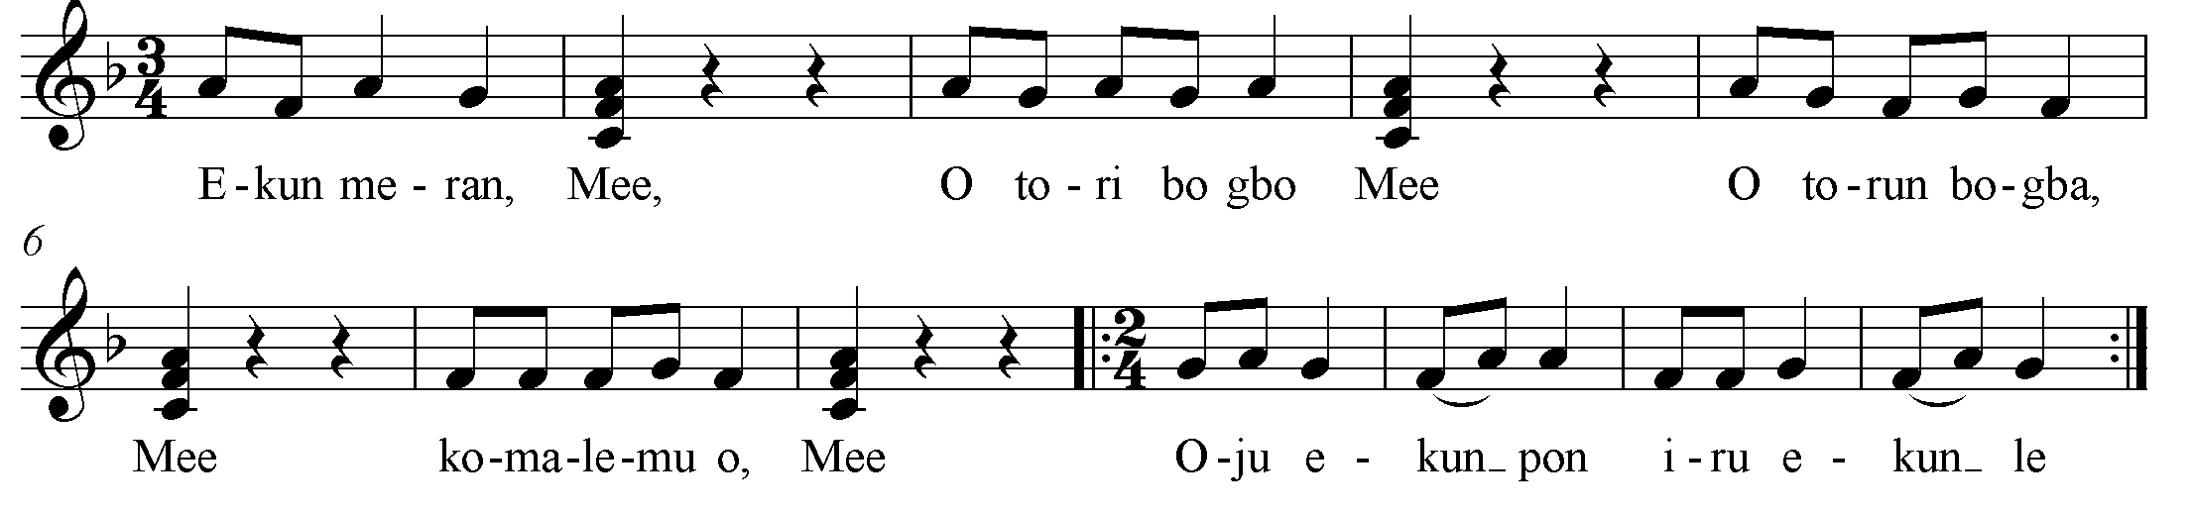

A tiger chases a goat … mee
The goat enters the bush … mee
Later, the goat enters the garden … mee
Tiger keeps chasing the goat … mee
Tiger could not succeed … mee
The tiger is disappointed … mee
The children form a circle; two children represent a tiger and a goat. They run to chase each other in and out of the circle. The circle gives way at interval for the goat to escape and enter the circle at will. The song stops when the tiger catches the goat. The song can be repeated with different set of children representing tiger and goat at other rounds. The song is a Yoruba children game song which may be repeated as many times as possible. In the above game song, the children form a circle, with one of them acting as the lion (B in the circle) chasing a goat (A in the circle), the play must as well go–round.
Children Game Song (Round / Circle Form)
A
A
A
A
A
B
B
B
B
B

The several repetitions give ‘round’ form while the response ‘mee’ (goat) gives the nonsense syllable form. Round Musical Form/Nonsense Syllable musical forms are also found in the moonlight story song. The moonlight story or folktale is usually led by an elderly man with little children forming his congregation. Usually, in order to spice the moonlight story songs are added. This leisure kind of relaxation among the Yoruba people usually results in ‘song call’ and ‘nonsense syllable response’ musical forms.

STORY
CHORUS
CHORUS
CHORUS
STORY
STORY

Analysis
Form constitutes a major aspect of traditional music compositions that already exist in all the elements of Yoruba music. These qualities are largely attributable to the closeness between the arts of music and its usefulness. In consequence, the following are the varieties of Yoruba musical forms and the performance contexts that determine their forms.
Performance Contexts | Poetic Genres | Musical Forms
Orin Igbal: Burial Procession | Song Lyrics | Incantation/Dirge Response forms
Orin Oro (Oro Song) | Recitative Poetry | A mystic-weird choral song interpolate with spoken word.
Ekun Iyawo (Bride Cry) | Recitative Poetry | Lineal Recitation/Bridal Cry Forms
Ere Osupa (Moonlight play) | Myth, Riddles, Folktale | A – B Forms, Round/Circle Forms.

The above is the summary of performance contexts, poetic genres and the Yoruba musical forms. However, Ekwueme (2001:19) opined that; the limitation imposed by this form of music by its repetitive and monotonous nature is obvious… the limitation in structural organization imposed by the strict call and response form would make it virtually impossible for a composer today to create a reasonably artistic piece of music for contemporary international consumption.
Meanwhile, a deliberate creative effort to develop the folksong is required for the realization of art music suitable for contemplative purposes. This new approach should make use of such musical dynamism like, fugal form, organum, counterpoint, polyphony, suite, hocket, ostinato, canon, rondo and other harmonic principles. The following table presents a deliberate exploitation of Iyere Ifa symphonic plan”. Iyere Ifa is a Yoruba religious chant usually performed by the worshippers of Ifa or Orunmila. The form or organization of iyere ifa is in five categories thus: solo or monodic chant of signature tune, praise and native air. The punctuations of iyere literary corpus with musical accompaniments naturally gives birth to anecdotal/rhapsodic forms. This interesting if a form may be artistically composed for new strength and academic dynamism as follows:
Movements | Forms Categories of Form | Proposed Art | Dynamic Forms
Movement 1 | Solo or monodic chant of signature tune | (Solo) (24) bars solo recital
Movement 2 | Praise poetry | (16 bars) solo praise with background chorus of ‘nonsense syllable’
Movement 3 | Recitation of Ife Corpus | (16 bars) Duet – Mixed Ifa recitative with solo rendition (call and answer form).
Movement 4 | Choral recitative | (24 bars) 3 part music – Solo obligato, Chant, chorus
Movement 5 | Native Air | (32 bars) Four part Choral with parallel harmony, counterpoint, ostinato, imitation

One of the major contributions of this study is the detail research into the nitty–gritty of the intricacies of Yoruba traditional musical forms. What is needed is a creative continuum of the above traditional song forms with deliberate development into the art form. This in essence will make the art music composition culturally relevant and also meet the international standard. According to Agu (2010) pragmatics is very essential in African music practice and performance. It knowledge enables one to be at home with the various sonic musical sounds, symbols and vocal expressions … with this knowledge , music is fully laid bare before the listener with the appropriate cultural and socio-environmental background.
The main thrust of this research is found in the foregoing submissions of the renowned scholar. Therefore with the above listed traditional musical forms, the art music composition is set to be culturally relevant. The listed forms are the traditional Yoruba musical form derives from performance context, which may be useful for the Nigeria art music composers. The indigenization of art musical forms could help to pacify the yearnings, aspirations and sensibility of the masses musically and the art music compositions will be culturally relevant.
Conclusion
This study has discussed the major aspects of Yoruba traditional musical forms from the highlights of performance context as factor that give birth to musical forms. The study established the concept of performance practice as an important revelation of Yoruba musical form and pointer to the ‘meaning’ of Yoruba traditional music. Yoruba music is meaningful when it refers to things outside itself, evoking association, social events and connotations relative to the world of ideas, emphatics, and physical activities. On the other hand, an appreciation and articulation of the order of the forms makes it possible to have a deeper understanding of Yoruba traditional music.

References
Agu, D (2009): Learning and Practicing African Music in the Global Context: A Survey of Meki Nzewis Approach.
___ (2010): Foundations of Pragmatics: The Primacy of Language in African Music Theory, Practice and Education, in the Journal of The Association of Nigerian Musicologist, No 4, 2010
Akpabot, S.E. (1986): Foundation of Nigeria Traditional Music, Ibadan: Spectrum Books Ltd. p. 1
____ (1998): Form, Function and Style m African Music, Lagos: Macmillan Nig.
Publishers Ltd. Pp. 13 - 16.
Awolalu, O. (1979): Yoruba· Beliefs and Sacrificial Rites, African Heritage, London Longman.
Davies, W. (1999): Theories of Art from a Companion to Aesthetics, David S. Copper, Ed. Oxford, Blackwell Press. http://www.rowan. ed/phi1osop/clowney
/ Aesthetics/theoriest +of+. p. 2.
Grove's Dictionary of Music and Musician (1939): (5th edition), ed. Eric B10m. New York: St. Martin's Press, Inc., Vol. Vii.
Idolor, E. (2002): Music in .the Contemporary African, in Emurobome Idolor (ed), Music in Africa Facts and Illusion, Ibadan, Stinging - Horten Publishers (Nig.) Ltd. p. 4
Kennedy, G. A. (1980): Classical Rhetoric and Its Christian and Secular Tradition from Ancient to Modern Times. Chapel Hill: U of North Carolina p. 12
Nzewi, M (1990): Ese Music Notation and Modem Concert Presentation . IwalewaHaus:Centre for Mordern African Art. P-11
Nzewi, M. (1991): Musical Practice and Creativity: An African Traditional Perspective. Bayreuth: Iwalewa - Hans, University of Bayreuth.
Qlatunji, 0.0. (1984): Features of Yo rub a Oral Poetry, Ibadan: University Press Ltd.
Schonberg, A. (1967): Style and Idea. New York: Philosophical Library.
Tracey, H. (1943): Chopi Musicians: Their Music, Poetry, and Instruments, Oxford University Press for the International African Institute, London. p. 123.

