STRUCTURAL ANALYSIS OF YORUBA TRADITIONAL MUSICAL FORMS

Olufemi Akanji Olaleye, PhD
MUSIC TECHNOLOGY DEPARTMENT
FEDERAL POLYTECHNIC ILARO
olufemi.olaleye@federalpolyilaro.edu.ng.com
08035745380

Olaleye, O.A. (2015). Structural Analysis of Traditional Yoruba Musical Forms. A Paper Presented at the Bi-ennial International Religious Studies Conference of the Religious Studies Department, Faculty of Arts, University of Ibadan, between 9th - 12th August, 2015.

Abstract
Generally, music is known to be part of history of ideas in an ever – changing conditions. Music constitutes a central part of living in any nation, hence it also witnesses several changes and metamorphosis due to the response to man’s needs. Therefore, if music must serve the purpose of mankind particularly in an ever-changing situation, this research provides us with the insight into thoughts and structure of traditional Yoruba music before the forces of change wipe the music into oblivion. This study relies on an amalgam of different ethnographic techniques to collect information. The adopted methods of data collection are unstructured oral interview, observation of Yoruba musical performances and key Informant method. The unstructured oral interview method provided first hand information and enable the respondents, most of which are illiterate, to clearly explain their views. The direct observation of Yoruba musical performances exposes the researcher to various methods of performances and the musical instruments. The necessity of ‘key Informants’ enables the researcher to have access to local people and important places and personalities in Yoruba community, and to have access to secret information that would have been kept away from the researcher. The study enhances an understanding of Yoruba traditional music from structural point of view and proper documentation and preservation. The research also provides a basis for the school music system, scientific and systematic teaching and learning, as well as for research purposes.

Keywords: Yoruba, Structures, Forms, Traditional Music, Sociological, Scientific

CITATION:
Olaleye, O.A. (2015). Structural Analysis of Traditional Yoruba Musical Forms, A Paper Presented at the Bi-ennial International Religious Studies Conference of the Religious Studies Department, Faculty of Arts, University of Ibadan, between 9th - 12th August, 2015.

Introduction
This research explores the trend in the structure of traditional Yoruba musical forms. Several theses have in no doubt been written on Yoruba music, the present study focuses on the structural formation of traditional Yoruba musical forms. The conceptual background to this study is hinged on the notion that every art is an accurate representation of social realities such as objects, events, environment, and general human behavior, hence, ‘art must depict its subject truly’ Kennedy G.A (1980). Socially, music is one of the products of high creativity among the Yoruba people and it is used to empresses’ feelings, emotions, moods, attitudes, evaluations, atmospheric qualities, their expectations, their frustrations, events and general inner quality of their life, hence Kehinde , J.O (2001) submitted that ‘Yoruba music is a dynamic phenomenon and so flexible…different styles are explored…therefore we need to investigate what had transpired in the past and what necessitate certain actions and inactions’. Therefore, the study examines the variety of traditional Yoruba music and exhumed the structure in the design and organization of the musical forms.
The preoccupation of this work is on the sociological events, which is the foundation to the evolution of Yoruba traditional musical structure and the study bridged the gap earlier created in order to arrive at the right and acceptable analysis. This is in keeping with the fact that in Yoruba tradition, music is a symbolic art through which other cultural practices are express. However, after several decades of research in Yoruba traditional music, the question of whether the study actually reflects the sociological events and circumstances of the period, which usually gives birth to the musical forms, these now poses a challenge.
An attempt is made in this study to interpret Yoruba cultural practices as factors that shape the musical structure because Huge Tracy, (1963); has demonstrated that ‘a study of song lyrics of Africans can lead to an understanding of African basic philosophical principles’. However, Woodbridge (1962) submitted that ‘we can never understand anything at all until we have discovered its origin in something which preceded it’. Therefore the need to find an acceptable solution to the lopsidedness, confusions and wrong theories, created by the separation of the sociological events, regarded as the origin of Yoruba traditional music from it analysis is yet another focus of this study. On the other hand, several works conducted in Yoruba music, in the last few decades, has expands the purview of exotic rituals associated with Yoruba music, to the detriment of its sociological principles. This fact was noted by eminent music scholars like Akpabot (1998), Mereni (2007) and especially Ekwueme, (1972) that, there is need to take a look at the music of Africa (Yoruba music included) not only to describe the exotic ritual with which music is associated … but in addition to these, to investigate the specific musical phenomenon of its principles. This research is thus in line with the submission of the aforementioned authors. The challenge, then, is first to seeks an understanding of social-cultural events about Yoruba traditional music, and second, an attempt to discover its structural analysis and principles in a concise, clear, accurate and engaging manner.
An artwork, especially music, cannot properly be appreciated or studied in isolation. Neither can stylistic evolution and trends be distinguished without a thorough understanding of individual example. Hence, the significance of the study is the application of form analysis to arrive at a deeper understanding of musical utterances and an interpretation of Yoruba traditional music, which enriches the response to it. Furthermore, the forces of change often affect the evidence of cultural music, especially if wrongly preserved or documented. Generally, music is known to be part of history of ideas in an ever – changing conditions. Music constitutes a central part of living in any nation, hence it also witnesses several changes and metamorphosis due to the response to man’s needs. Therefore, if music must serve the purpose of mankind particularly in an ever-changing situation, this research provides us with the insight into thoughts and structure of Yoruba traditional music before the forces of change wipe the music into oblivion.
The generalized nature of this problem as it relates to the present research in Yoruba traditional music is made explicit in the generally held notion that human achievements reflect or develop from the essential character of an era. This study, therefore, attempts to exhume the hiding essential character that reflects in the musicological achievements of the various traditional Yoruba musical structure. What is needed therefore, in the problem of the neglects of social structures, are interpretations and analysis based on the tradition of Yoruba people, sociological events and relationship between the Yoruba traditional musical forms, interactions and interpretation.

Theoretical Framework
The theoretical framework for this study is hinged on the Aristotle’s theory of art as an imitation of life. Aristotle, (384-322 BC) the Greek Philosopher, was the first to introduce the theory that art imitate nature and he considered the origin or evolution of art as a basis for his argument. He attributed the origin or evolution of art to the human affinity for imitation of nature. According to the theory, imitation is the primary method of learning and that it is natural that humans to take delight in works of imitation. Aristotle states (Politics 1340a 17-21) that ‘musical times and tunes provide us with images (homoiomata, likenesses) of states of character’. Therefore, Aristotle’s theories which interpret art as an attempt to provide an accurate representation of the object, social reality and experience of life are undoubtedly the core theoretical framework for this study. The very intricacies of an artworks structure achieve formal unity in individual type of art form, such as the various musical elements: rhythm, harmony, melody, counterpoint, texture, aesthetic, and instrumentation constitutes a tightly integrated whole of musical form.
Analysis of Yoruba Traditional Musical Forms
This aspect focuses on the structural analysis of Yoruba musical forms under the following musical terms; harmony, scale, texture, rhythm, melody, pitch and aesthetic. Therefore, this section is the analysis of finished piece of musical composition that gives denotative meanings of Yoruba music.

Yoruba Musical Harmony: the concept of harmony in Yoruba music is the total sound image and unsound actions in a piece of music. Pure traditional Yoruba music is always monophonic (a single part music or song which may be rendered by more than twenty peoples). The performance in unison however may be accompanied with “extemporaneous extra-tonal” sounds such as shakers, clapping, gun-shorts, purposeful shout, speech comments, trills acclamations, ululation, yodeling, and unsound body movements. This kind of harmonic organization of Yoruba music usually leads to any type of harmonization thus; song/gun-short, song/speech comments, song/bridal cry, polarity, overlapping, song/nonsense word and hocket technique harmony. The following musical examples are noted in the recorded songs: Oro Sound/Song/Shakers Harmony
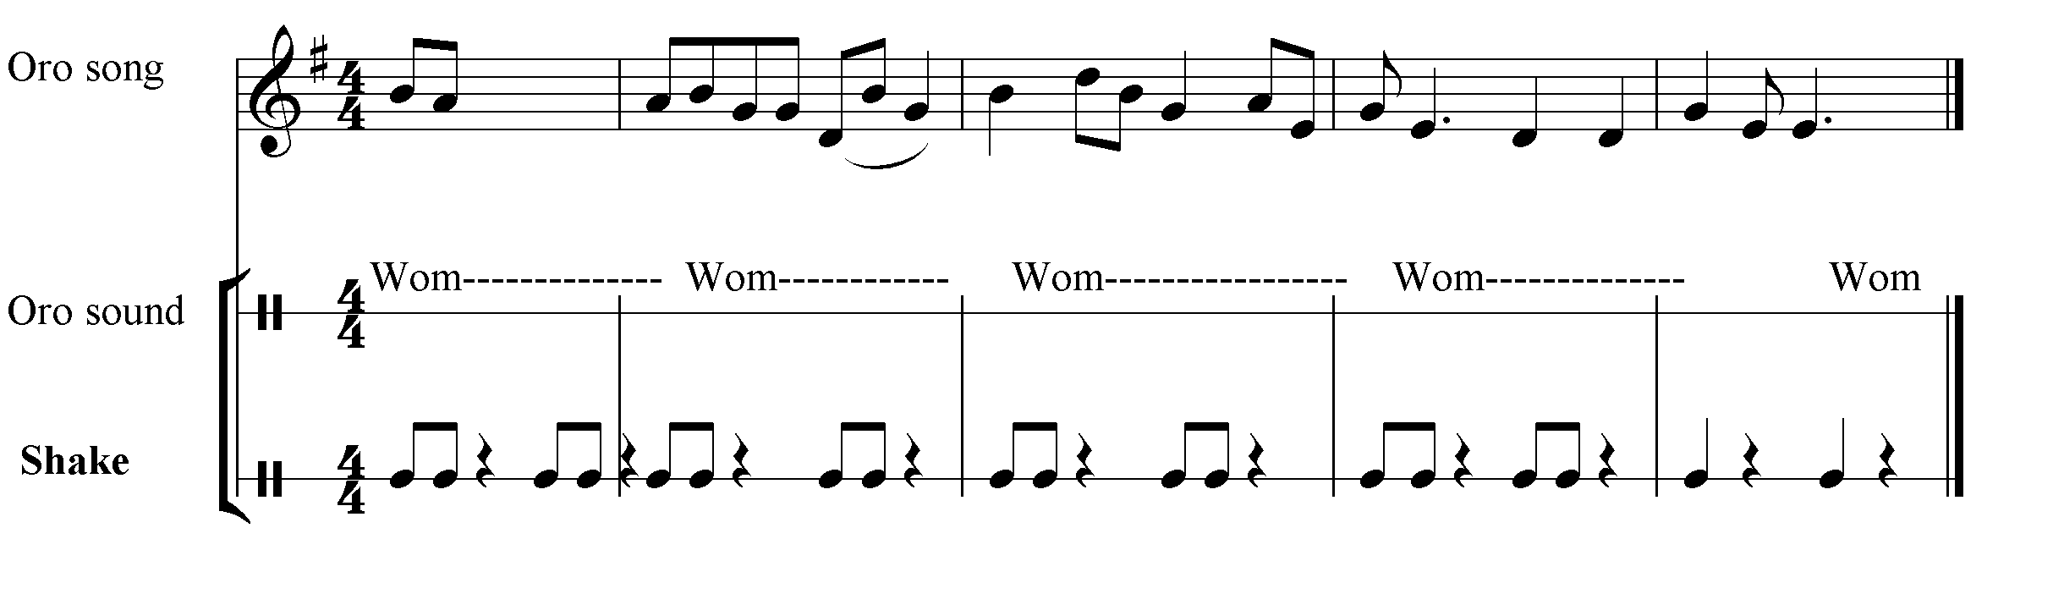
In the above musical example, the oro song is harmonized by oro sound and feet –shakers. In this regard, the concept of harmony which denotes the chord or vertical structure of a musical composition is not applicable in Yoruba traditional music.

Song/Speech Comments Harmony: Speech comments harmony is common in Yoruba song-dirge. The lead cantor in Yoruba-dirge is usually the village ‘Babalawo,’ that recites the praise name of the family lineage of the dead person. The following is a speech comments harmony used during the burial ceremony of Ogundele member of a hunters group.
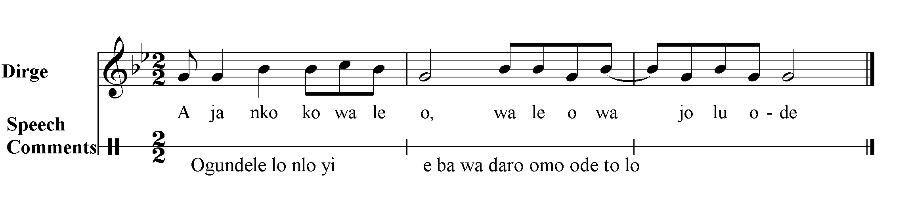
Apart from Yoruba dirge burial, these forms of harmonization are also very common in Eyo song. The Eyo recites his genealogy or family lineage to the chorus of his followers.
Song / Bridal Lamentation Harmony: In a typical traditional Yoruba marriage ceremony, bridal cry (Ekun iyawo) is an important aspect of the marriage. It is compulsory for every bride to perform the bridal cry a day prior to her departure to the bridegroom house. The main purpose of the cry is as follow; request for prayer, to thank her parents, to bid her parents and well wishers farewell, to express the fear of unknown and to assure her parent of keeping her virginity.
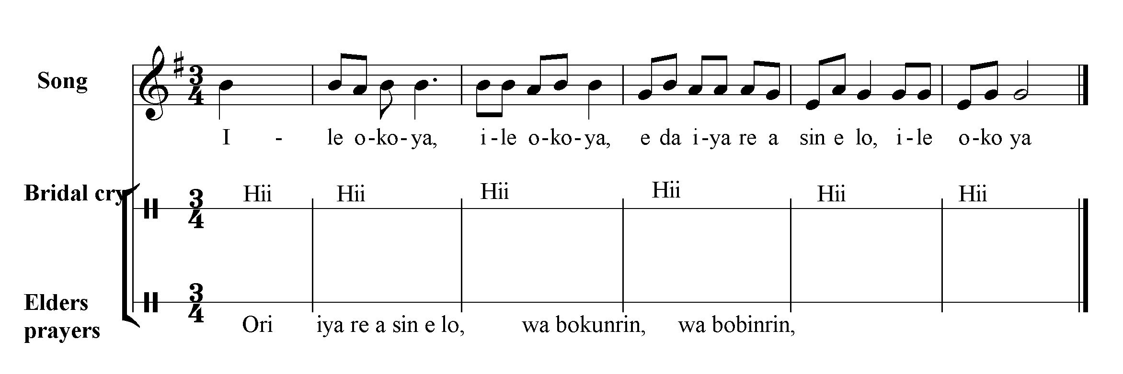
Moreover, during the brides cry, some professional mourners (Alasuta or Asukuta) may also join her in the cry. The cry is beautifully done to the song accompaniments that the audiences are usually moved to spray them money.
Song/Gun-Short Harmony: Harmony is usually achieved through several gun-shorts in music performance in Yoruba traditional music. The following musical example of Ijala hunters music are several gun-shorts used to confirm the power of “Ogun’ to pass judgment on an offender.
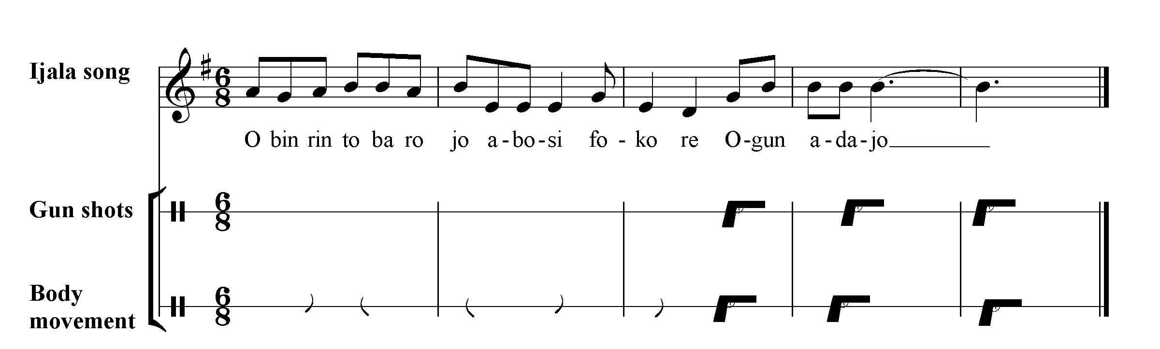

Harmony by Overlapping: As part of the technique of artistic development within the limits of a simple antiphonal form is the employment of overlapping between solo and chorus in a song. An example of an overlapping harmony is shown in, ‘Bolojo music of the Egbado, Yewa in Ogun State.
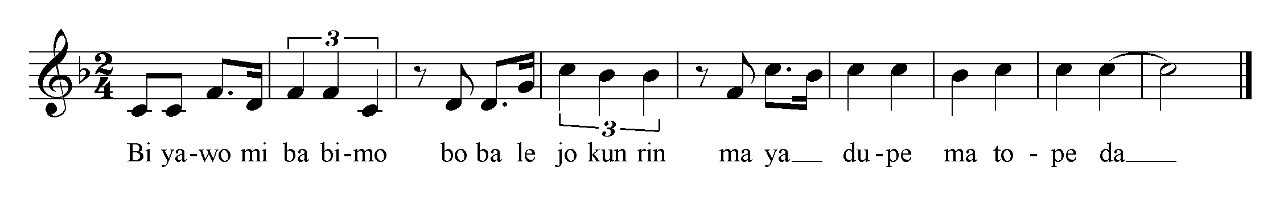
Harmony by Assumption/Internalized Tone: Harmonization is achieved through the addition of extra tones to an assumed or internalized main tone such a harmonic system is shown in the following Yoruba songs. This type of harmony was described by Akpabot (1998) as ‘very important aspect of harmony and polyphony in the music of Africa not usually acknowledge is the role of the inner voices’
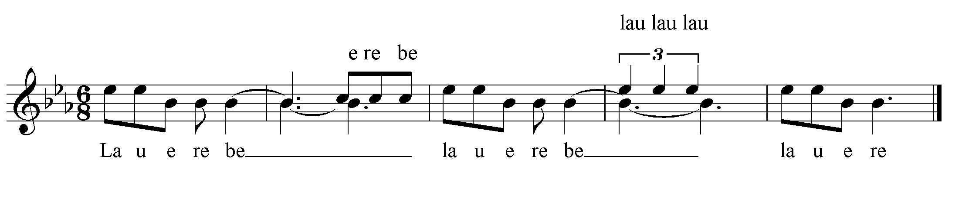
Structurally, harmony/polyphony in Yoruba music has several parts with each part having the same equal footing and importance (counter point). The concentration on polyphony is on the individual melodies as they proceed side by side and not on chords progression. Horizontal harmonic progression is the norm in Yoruba music. In choral singing, usually in the responsorial form, harmony/polyphony is achieved through the following techniques: parallelism, imitation, overlapping and contributive mechanism. Hence, from the organizational technical viewpoint, two fairly distinct principles are identifiable in the Yoruba polyphonic music: overlapping mechanism and contributive mechanism. Overlapping polyphonies are created by the overlapping mechanism – a technique whereby the response (i.e. the consequent) is made to start before the end of the antecedent musical phrase. The sort of polyphony obtained through this mechanism, is, owing to the operative modus, the mechanism itself, which foresees the contrast in temporal level between the overlapping parts. Contributive polyphonies are created by contributive techniques. It is true that all polyphonic music’s result from the contribution of two or more parts (voice or instrument): but in the category of polyphonies created by the contributive mechanism. The function of the contributing voices, often go beyond that of sheer supplying of ‘counter – melodies’ that are distinguishable and/or isolatable from a principle melody.
Harmony in Yoruba Art Music: The connectivity and interrelationship of styles, forms and general aesthetic vision between the Western and Yoruba music is not farfetched. In the following analysis, various Western harmonic techniques were used by Yoruba art musicians in their various compositions. Some of the Western harmonic techniques that were found heightened echoed in Yoruba musical forms are: polyphonic organum in 4th 5th and 8ve and polarity, hocket, contrapuntal polyphony, and homophonic parallelism
Oragnum : The various styles of the earliest kind of polyphony known as organum exist in Yoruba music. Fela Sowande’s Oyigiyigi exhibits an interesting organum:
Variation I (choir) organum in 5th
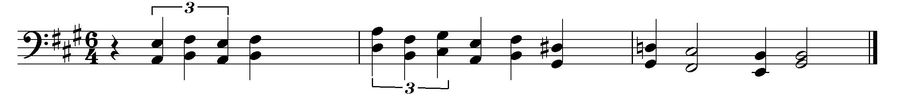
Also in a variation VI. Organum in 8^{ve}
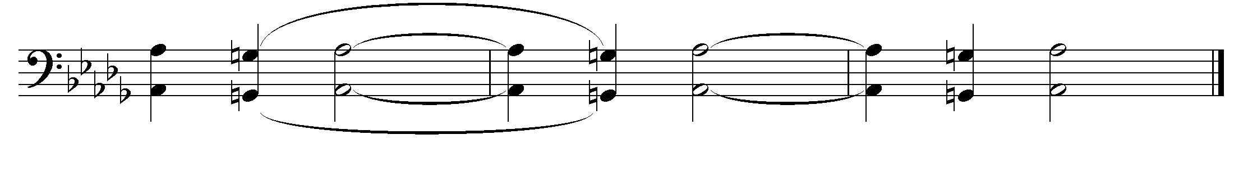
Contrapuntal Polyphony: The contrapuntal polyphonic arrangement of the main theme of the Yoruba composed music Oyigiyigi: arising out of one of many stories about Orunmila.
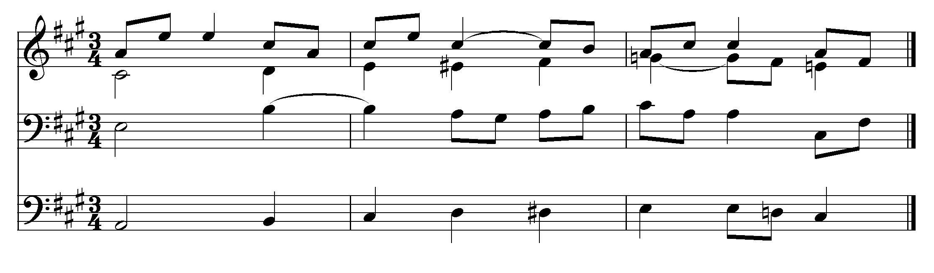
A striking feature of Yoruba art music is the application of pure western/European classical music idiom in Yoruba compositions. With several Yoruba musicologists trained in a predominantly European tradition and have chosen European idiom as the conceptual basis for much of their works. Some of their work later reflects pure European idiom such as 2 parts harmony, 3 parts harmony, 4 parts harmony, fugal techniques, counterpoint, sonata and concertos. However, an elaborate discussion on the listed European harmonic technique is beyond the purview of this paper. However, it is expedient to state that several attempts were made by Yoruba art composers to make their work relevant culturally. The uses of folk melodies are adapted to suit the Yoruba situation and Yoruba musical elements within largely Europeans forms, with the historical progression from T.K.E. Philips and Fela Sowande, who conceived their works within a predominantly western tradition. The second category are Akin Euba in the works like Dirges and Abiku, who sought a more ‘Yoru-centric’ approach in approach in their bid to evolve an original tradition of modern Yoruba art music.

Popular Yoruba Music Harmony: Popular Yoruba music includes were, waka, apala, awurebe, fuji, highlife. Harmony is synonymous to polyphony and usually derived from overlapping and contributive mechanism as discussed earlier. However, response mechanism which gives rise to call and answer polyphony, antiphonal polyphony and ordinary homophonic choruses (which normally start with a cue from a cantor or a group of individual) are only peculiar to popular Yoruba music. Ordinarily, a typical Yoruba traditional music will only achieved harmony through overlapping mechanism and contributive mechanism. The peculiarity of response mechanism in popular Yoruba music may be due to Arab and European influence on Yoruba music. In all the songs that were recorded, harmony only appears scantily and not because of the activity of lead cantor and the chorus response. Besides, clear two parts singing is common in Yoruba popular music such as fuji, highlife were and apala. The technique evolves a monophonic lead cantor with two parts response at the chorus. However, the current study by Steven Olusoji has expanded the musicological study of Yoruba popular music. In his current study Olusoji S. (2010) with the title ‘Nigeria dances for piano, volume 1 were notated for the piano instrument.
Yoruba Musical Texture: Texture is one of basis unit that influenced the form of Yoruba music. The most far-reaching influence is exerted by the verbal texts to which songs are set. The Yoruba’s deliberately treat songs as though they were speech utterances in Yoruba chants: rara, ijala, iyere ifa and esa. This is made clear in the following ijala chant form.
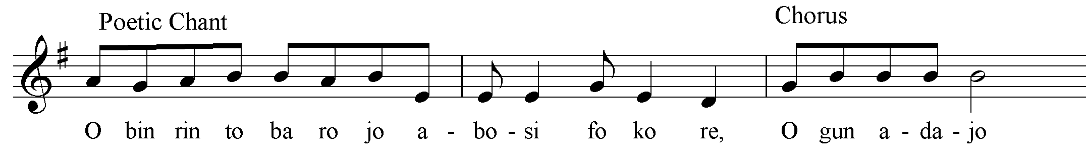
In the above musical example, speaking and singing are integrated. The song begins with a spoken call and the response followed in a singing form. To probe further deeply, Yoruba language is a tonal language in which the inflexion of words determines their meaning. Yoruba languages are inflectionary in character producing high, medium and low tones. There are three main tones in Yoruba language. They are represented graphically as follows:
Low tone ‘do’ musically
Mid tone mi (no mark) mid
High tone ‘re’ musically
Hence, a disyllabic morpheme like /oko/ gives completely different words, each with its own meaning, depending on the relative pitch (or tone) at which each of the syllables is sounded.
Word | Pitch sound | Musical sound | Resultant meaning
Oko | High-high tone | Re re | Husband
Oko | High-low tone | Re do | Motor car
Oko | Low-low tone | Do do | Sword
Oko | High-mid tone | Re mi | Hoe
Oko | Low-high tone | Do re | Writer

The above analysis simply means that one cannot compose a melodic line arbitrarily merely as an aesthetically beautiful sequence of tones, if it is intended to be sung to Yoruba words. Any melodic line must be controlled – to some extent determined –by the contour – tonal rise and fall – of the words.
Yoruba Musical Rhythms: Broadly, rhythm can be defined as the organization of music in respect of time. It is the regular or irregular recurrence of groups and motion in relation to each other; these relations being in respect of pulse, metre, stress, duration, accent, pitch, contour and design; functions within the architectural structure of the artistic whole. Akpabot, S. (1998). Specifically, three types of rhythms are identified in Yoruba song movement, such as free rhythm, regular rhythm, and mixture of free and regular rhythms. Free rhythm is the movement of tone in song melody without any regular beat or pulse. This is used mainly in incantation, chant, solo laments or dirge. The Yoruba hunters’ dirge (iremoje in the song notation) is a good example of irregular free rhythm.

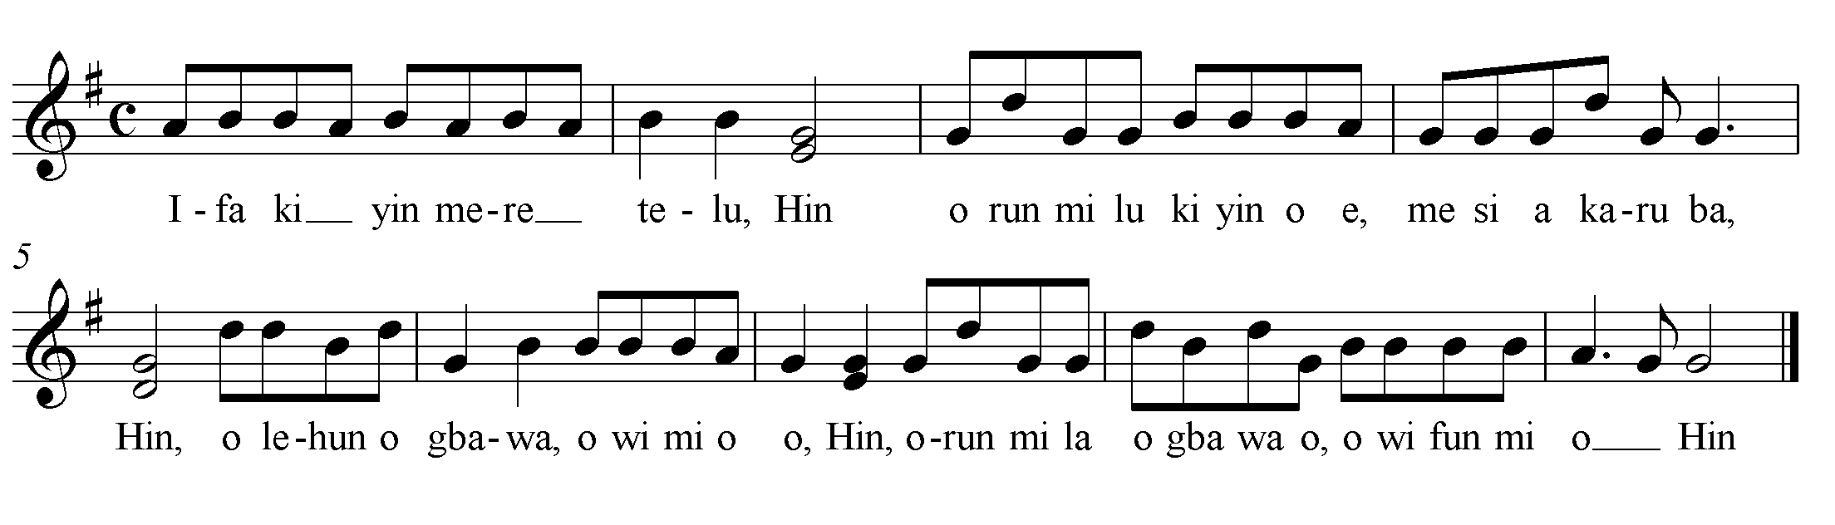
Regular Rhythm: Apart from the three main types of rhythms identified in Yoruba music, there are other inherent rhythms operating within the mixture of the three rhythms. A diagrammatic representation of rhythms types in Yoruba music will give a concise and straightforward explanation on the subject.

Yoruba Rhythms can be

Regular
or
Strict
Irregular
or
Free

Mixed, Cross, Clash, Poly
Bell rhythms or Drum rhythm
Speech or melodic rhythms
Percussive or instrumental rhythms
Regulator

Iambic short long ( _)
Trochaic long short )(_
Spondee long long (_ _)

Bell rhythms or big drum rhythms (not in all cases) serve as the regulator to all other rhythms in performance. Yoruba bell rhythm or ‘konkolo’ rhythms are made up of three rhythms modes: the iambic, trochaic and the spondee. However, the iambic mode is more common in speech or melodic rhythm; this was in consonant to the speech tone of Yoruba language.
A – gba O mo ko yo mo-wa
Ni – bo O-hun I-wo E-mi
Je – wo Mo-yo Mo-yo I-wo

Ki ni mo se - what did I do?
However, the instrument uses iambic (since they imitates human tones) and other variants rhythms. This explains how accompanying musicians without any rehearsal whatever, are able to pick up the rhythms from the built in speech rhythms. The following is a traditional Yoruba hymn mostly in iambic movement.
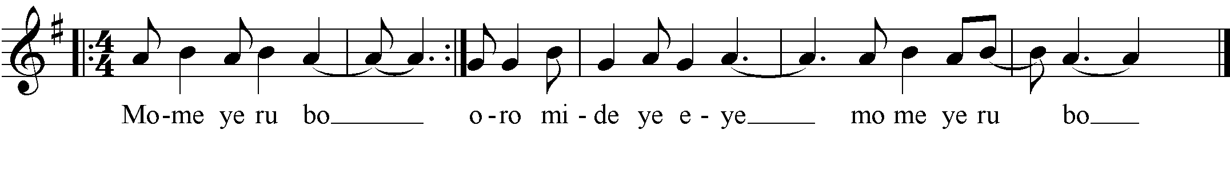
Some general rules arising out of speech rhythm maybe outline as guiding factors in rhythm of Yoruba song as follows:
- When two successive syllables are sung to the same pitch (or pitch not above a ‘second’), the second syllable generally has the longer duration.
- When two syllables are on the same pitch, the elision generally occurs on the second.
- Disyllabic spondee words share equal duration per syllable.
The above general rules are clearly seen in the following song:
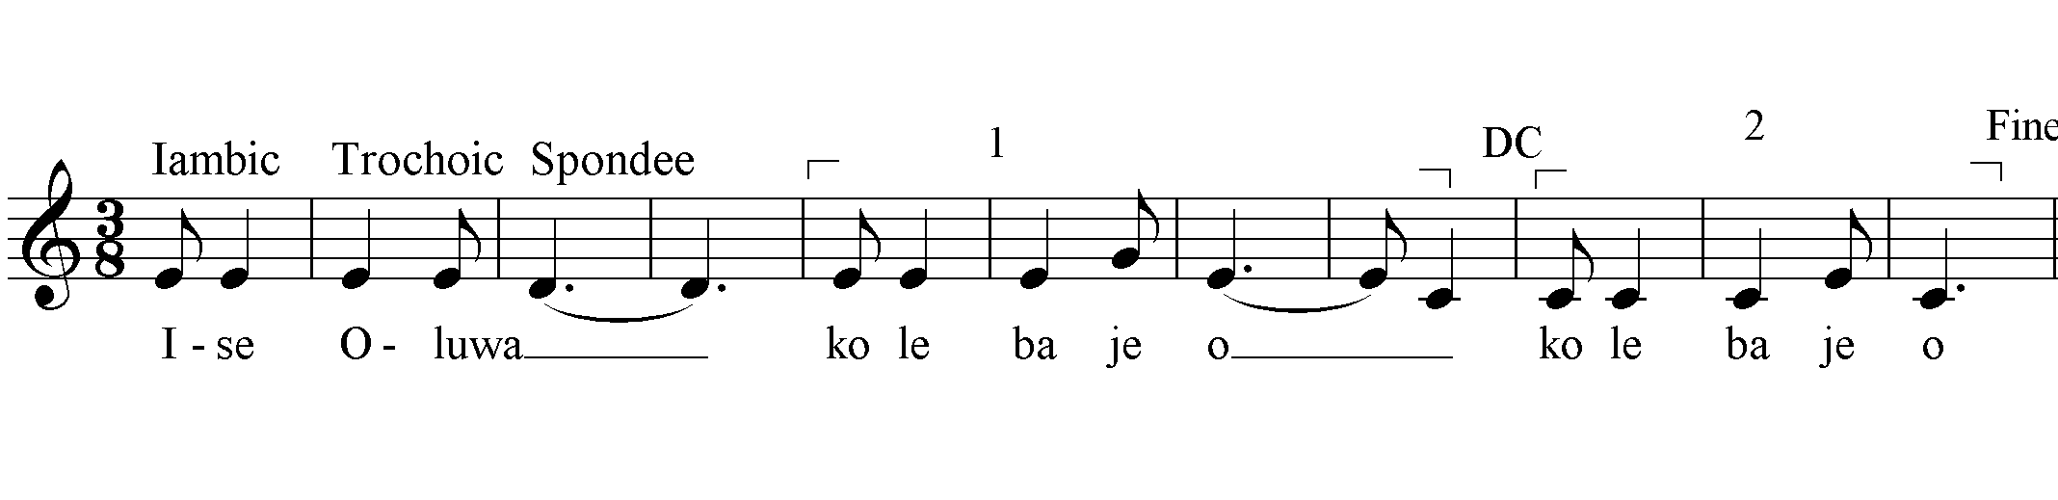
Yoruba Musical ‘Aesthetic’: Aesthetic question are present in almost all types of musicological writing. They arise when musicologists discuses the role of music in a social milieu or the impact of personal environment of individual musical development, or liken music to other arts. Traditional music is usually realized within the context of social events. Yoruba traditional performing arts tend to exist as a multiple arts complex, with music forming the core of their complex. With music are dance, poetry, wrestling, acrobatic, story-telling and puppetry, drama, and visual arts.
Aesthetic in Costume: Apart from having strong links with other performing arts, music is also closely associated with the visual arts. For example, in Yoruba music performance, one is likely to see a display of the most splendid costume on those important occasions when music is performed. Special masks are always on display in most of Yoruba music performances for deities.
Aesthetic in Number Symbolism: Legend has it that Obatala, the Yoruba god of creation had four wives who serenaded him every night singing and clapping their hands in rhythm. The god decided that it would be good idea to teach them how to reproduce these rhythms on a drum so he had four drums made and named them after his wives – Iya Nla, Iya Agan, Afere and Keke. These have remained to this day; and in any music for the worship of Obatala only these four drums are used.
Aesthetic in Sound: In Yoruba settlement, ‘Gbedu’ drum when sounded indicates the passing on of a chief or the king. It may also be used to invites the elders for a special meeting. Gong musical instruments are used to pass messages to the people. Iya Ilu (Taking Drum) is used to eulogize the virtues of an important person in Yoruba community.
Aesthetic in Musical Symbol: When a town crier put a gong on his head across the village in Yorubaland, it is an indication of a bad occurrence. Also, gudugudu musical instrument is placed in the shrine of drummers. The drummers appease the drum before embarking on their itinerants’ journey.
Aesthetic in Instruments: Art materials such images, masks, costumes and other paraphernalia gave form to the supernatural and the invisible. The fearful ‘Oro mask, for example, was carved to instill fear in the minds of men and should not be seen by feminine gender.
Aesthetic in Song Text: In Yoruba music, ritual songs are used for ancestral gods, secular songs texts for regulating social conduct, philosophical song for moral and spiritual well-being, protest song for expression of displeasure, history are also preserved in song, and various songs are used to accompany daily activities, play, work and game song.
Aesthetic in Philosophical Songs Philosophical songs are used in Ifa divination to achieve some spiritual purposes. Ifa is the Yoruba words of wisdom. Besides, proverbial songs are used to pass an indirect message to the listener.

In almost every discussion of Yoruba musical instruments, the rhythms of the drum and gong always take the central stage. The rhythms of all other instruments in an ensemble will, on closer examination are found to be either founded on the rhythms of these two instruments or adapted from them. The changes which a master-drummer or a gong player can ring or beat from his instrument are many and varied but there are certain rhythm patterns that recur again and again and tend to provide standard rhythms as notated are as follows;

Drum Rhythms
The bigger a drum is, the more it is able to talk and therefore the more involved its rhythmic patterns. The bata drum ensemble consists of Iya-ilu bata (mother drum), omele ako (male drum), omele abo (female drum) and kudu (child drum). The pitch of sound of a member of drum family ranges from low to high. The following rhythms represent an average movement of Yoruba instrument

Gong Rhythms
The gong rhythm is very important to the drum or other instrumental ensemble. It serves as accompaniment in instrumental ensemble instead of clapping or to punctuate incantations at a ritual ceremony. It can safely be said that most gong rhythms are in variants thus. The standard drum ensemble of four players comprises a soloist known as mother drum (Iya ilu in Yoruba) and another three sets of drums. The accent of a drum orchestra is strictly on rhythm producing polyrhythms which are a great feature of Yoruba music. With the exception of the lead drummer who is able to produce gradations of tone. (Speech surrogate), all other drums play strictly unvaried rhythmic patterns: High pitched drum, Medium pitched drum, Gududugu, Iyailu.
Conclusion
This study has dwelt extensively on the structural analysis of the various Yoruba traditional music. Analysis, taken as general sense, embraces a large number of diverse activities. Some of these are mutually exclusive: they represent fundamentally different views of the nature of music, music’s role in human life, and role of the human intellect with regard to music. This study however, centers on the musical structures such as harmony, interval, rhythm, aesthetic and scales and seeks to define its constituent elements and how they operate. The primary impulse of analysis is an empirical one: to get to grips with something on its own terms. However, music is not measurable in terms of liquid or a solid substance for chemical analysis .Therefore, the subject of a musical analysis has to be determined. Hence, the determinant subject in this analysis includes: the sound-image that the score project and the sound-image as recorded by the researcher at the time of performance, as well as the interpretative performance base on life performance and recorded with actions .The itemized analytical elements serve as operational tools that illuminates the anatomy of Yoruba musical forms.

References
Akpabot, S.E. (1986): Foundation of Nigeria Traditional Music, Ibadan: Spectrum Books Ltd.
Akpabot, S.E. (1998): Form, Function and Style in African Music, Lagos: Macmillan Nig. Publishers Ltd.
Ekwueme, Laz (1975) “Structural Levels of Rhythm and Form in African Music. African Music 5 (4).
Ekwueme, Laz E.N. (2004): Essays on African and African-American Music and Culture. Lagos: Lenaus Publishers Ltd.
Kehinde, J.O. (2003): African Music, Arts and Folklores: Nigerian Examples, Satellite Press, Imo, Abeokuta.
Kennedy, G. A. (1980): Classical Rhetoric and Its Christian and Secular Tradition from Ancient to Modern Times. Chapel Hill: U of North Carolina P.
Mereni, A. (2004): Theory of African Music: Polyphonic Types and Usages, Apex Books Ltd. Yaba Lagos.
Mereni, A. (2004): Theory of African Music: Tone System and Melody, Apex Books Ltd. Yaba, Lagos.
Mereni, A. (2007). Nigerian/African Musicology in the Global Context, Paper Presented at Delta State University, Abraka.
Tracey, H. (1948): Chopi Musicians: Their Music, Poetry, and Instruments, Oxford University Press for the International African Institute, London.
Vidal, T. (1986): “The Westernization of African Music: A Study of Yoruba Liturgical Church Music” Ife: Annals of the Institute of Cultural Studies, Ile-Ife: University of Ife Press Limited.
Wande, A. (1968): Yoruba Oral Tradition, Department of African Languages and Literature, Univeristy of Ife, Ile-Ife and Olatunde, O.O. (1996). The Yoruba History, Culture and Langauges, F.J. Odunjo, Memorial Lectures.
Waterman R.A., William R.B. (1949:21): African and New World Negro Folklore; in Dictionary of Folklore, Mythology and Legend, ed. Maria Leach, New York: Funk and Wagnalls.
Woodbridge, J. (1937): The Technique of Theory Construction in International Encyclopedia of Unified Science, Vol. 2, No. 5. Chicago: University Press.

