A Comparative Analysis of the Academic Performance of Male and Female Students in the Polytechnic
¹Sekinat Olubunmi Olagoke-Salami and ² Gbemisola Ajoke Akinola
¹Department of Estate Management and Valuation, Federal Polytechnic Ilaro, Ogun State. seqeenaholagoke@gmail.com
²Department of Quantity Surveying, Federal Polytechnic Ilaro, Ogun State.
akinolagbemisola14@gmail.com
ABSTRACT
The study carried out a comparative analysis of the academic performance of male and female student in the polytechnic using Federal polytechnic Ilaro as a case study. Particularly Estate management and valuation students and Quantity Surveying students form the basis of this study. The comparism was done using the mean cumulative grade point average of final year student result for a period of four consecutive academic sessions. It was discovered that male student performed better in Estate management and valuation department whereas female student that studied Quantity surveying performed better than their male counterpart. A further analysis was carried out to determine factors influencing academic performance of polytechnic students. A structured questionnaire in Likert scale was administered on final year students of the two departments under review, Eighty (83) questionnaires was administered on the students to harvest their perspective. The responses were further collated, analyzed with SPSS software, processed with Mean method and presented in tables. The study revealed that complex course content, mode of subject delivery and financial problems top the list amongst 18 variables examined. Suggestions were proffered on what could be done to improve academic performance of all gender components.
KEYWORDS: Academic performance, Gender, Polytechnic, Student.
- INTRODUCTION
Education is a process designed to inculcate the knowledge, skills and attitudes necessary to enable individuals to cope effectively with their environment (Umar, Yagana wali, Ali & Mohammed, 2015), it ensures the acquisition of knowledge and skills that enable individuals to increase their productivity and quality of life (Farooq, Chaudhry, Shafiq & Berhanu, 2011).
Human activities evolve around education especially in this era of technology and globalization, people are now are of the advantages and importance of education, this is evident in the increasing number of students seeking admission into tertiary institutions. Gender plays a crucial role in the numbers of students who choose and are admitted into some course of study especially science based department. It is believed that male students perform well academically in science oriented courses than female students (Adigun, Onihunwa, Irunokhai, Sada & Adesina, 2015).
There are different factors affecting the academic performance of students, these ranges from individual and household characteristics such as motivation from the family and environment provided to student, student’s ability and the quality of education obtained (Faisal, Shinwari , & Hussain, 2017). Johnson and Elder, (2004) identified student factors, family factors, school factors and peer factors affecting academic performance of the students. Farooq et al (2011) identified age, gender, geographical belongingness, ethnicity, marital status, socio economic status, parent’s education level, parental profession, language, income and religious affiliations as factors affecting student’s academic performance.
Voyer and voyer (2014) revealed that females performed better than their male counterparts while Awofala (2011) and Oluwalogbohunmi (2014) disclosed that male students performed better than females. It is against this background that the study set out to carry out comparative analysis of the academic performance of male and female student in the polytechnics.

  - MALE AND FEMALE STUDENT ACADEMIC PERFORMANCE
Students’ academic performance plays an important role in producing the best quality graduates who will become great leader and manpower for the country as well as for the country’s economic and social development (Humaida, 2017).
Juma and Simatwa (2014) strongly believed that gender is a major factor influencing students’ academic performance. Female students lag behind their male counterparts because of family and social cultural obligations such as domestic chores which place undue pressure on females, and, consequently, on their academic resilience and achievement.
Another major factor considered by scholars which affects academic performance is the learning environment. According to Faisal et al (2017) learning cannot occur without physical and psychosocial safety and security in the classroom, in the school and schoolyard, and on the way to and from school as this requires that safe, secure, private and sanitary facilities are available and accessible, with separate provision for girls and boys. It also requires policies and procedures to protect girls and boys from intimidation, harassment, sexual abuse and other forms of physical or mental violence.
Amusan, Tunji-Olayeni, and Adedeji (2016) laid emphasis on learning environment as an important aspect of knowledge acquisition. Learning environment was categorized into three: the natural learning environment, virtual learning environment and E-learning environment. Beyond the social structure learning environment have effect on pattern and extent of knowledge impartation.
- RESEARCH METHODOLOGY
The study adopted a survey research design which involves analysis of both secondary and primary data. Secondary data analysis entails collection and analysis of final year results of the two departments for a period of four consecutive academic sessions.
The primary data involves the use of questionnaire to solicit information from final year students (ND II and HND II) of Estate Management and Valuation Department and Quantity Surveying Department on factors influencing students’ academic performance in the polytechnic. A purposive sampling technique is suitable in this regard. This research uses the Krejcie and Morgan (1970) table of determining sample size from the population with 95% confidence level, 5% margin error and a population of 104 students, the table gave a sample size of 83 students. This is represented in Table 1.
Table 1: Sample size
Department | Population | Sample | Percentage
Estate Management & Valuation | 36 | 29 | 34.6
Quantity Surveying | 68 | 54 | 65.4
Total | 104 | 83 | 100
Source: Authors’ field survey, 2019.
The analysis is confined to simple percentage, frequency distribution and mean.

- RESULT AND DISCUSSION
3.1 Male and Female Academic Performance between 2014/2015 and 2017/2018 Academic Session.
This analysis was carried out using the mean Cumulative Grade Point Averages (C.G.P.A) of the Final year (ND II and HND II) students in Estate Management and Valuation Department as well as Quantity Surveying Department between 2014/2015 and 2017/2018 academic session. The result of this analysis is presented in figure 1.
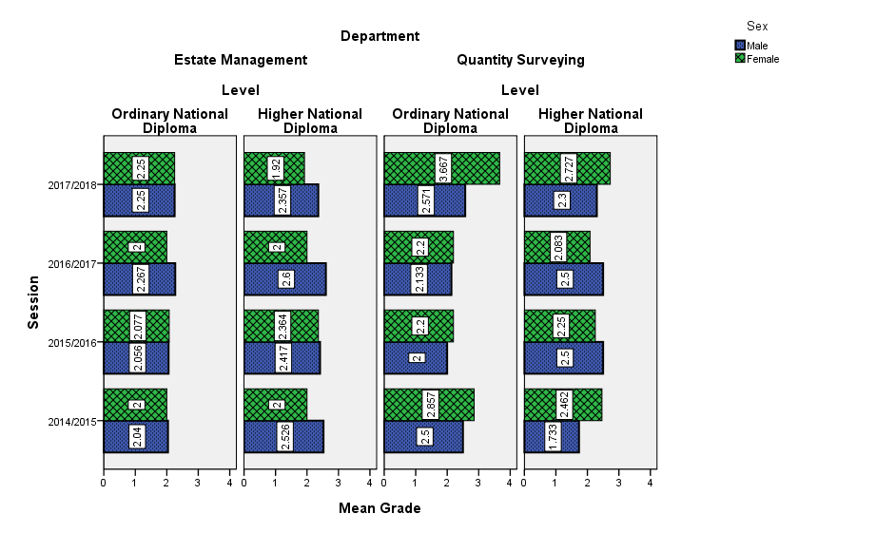
Figure 1: Male and Female Academic Performance between 2014/2015 and 2017/2018 academic sessions.
Data from Estate Management and Valuation Department shows both male and female as having about the same mean C.G.P.A at Ordinary National Diploma level. However, at Higher National Diploma level, the result shows that the male students perform better than their female counter part over the whole period.
For Quantity Surveying department, at Ordinary National Diploma Level, the result shows that female students performed better than male students for all the period assessed. At Higher National Diploma level, the female student performed well above male student in 2014/2015 and 2017/2018 academic sessions while male students took upper hand in 2015/2026 and 2016/2017 academic sessions.
  - Factors Influencing Students’ Academic Performance
Structured questionnaires were distributed to final year students in Estate management and valuation department as well as Quantity Surveying department based on the sample size earlier determined. Their perceptions were sort on 18 variable representing factors influencing students’ academic performance in the polytechnic. A scale of 1 to 5 was adopted for questionnaire calibration, with 1 indicating strongly disagree (SD) 2 being disagree (D) 3 being neither agree nor disagree (N), 4 being agree (A) and 5 being strongly agree (SA). Their response was processed using mean. The result is as presented in table 2.
The result in Table 2 shows that complex course content with mean index value (4.10) was ranked first, followed closely by mode of subject delivery (4.08) and financial problems (4.07). However age difference (2.23), external interference (3.06) and poor learning environment (3.11) were the three least factors respectively. It is not surprising that complex course content ranked highest in this research as polytechnic students have only four years duration to study what their university counterparts will study for five years coupled with extensive practical. Likewise mode of subject delivery because of the work load on lecturers to cover the syllabus they tend to brush through the contents in order to be able to meet up. It is also a general believe that polytechnics are for the poor or middle class, that explains why financial problems is surfacing as a major factor affecting students performance.

Table 2: Factors influencing students’ academic performance
Factors influencing academic performance | Mean | Rank
Complex Course Content | 4.10 | 1
Mode of subject delivery | 4.08 | 2
Financial Problem | 4.07 | 3
Complex curriculum | 3.99 | 4
Educational background | 3.98 | 5
Lack of Basic Study Materials | 3.93 | 6
Psychological problem | 3.92 | 7
Family problem | 3.77 | 8
Course dissatisfaction | 3.71 | 9
Teachers challenge | 3.63 | 10
Emotional disturbance | 3.59 | 11
Intelligence Quotient | 3.55 | 12
Attention to details | 3.51 | 13
Emotional Maturity | 3.48 | 14
Social Engagement | 3.13 | 15
Poor learning Environment | 3.11 | 16
External interference | 3.06 | 17
Age Difference | 2.23 | 18

Findings of this study is in clear disparity with findings of Amusan et.al.(2016), this shows that there is clear difference between factors influencing academic performance of polytechnic students and that of university students.
- CONCLUSION AND RECOMMENDATION
From the result, it was discovered that male students that studied Estate management and valuation performed a little better than their female counterpart however, the opposite is the case for male student that studied Quantity surveying between the periods considered as female students performed better.
The study also revealed major factors that influence academic performance of polytechnic students as complex course content, mode of subject delivery, financial problems amongst others. In the light of the discoveries of this research, the recommends demystifying complex course content/curriculum for easy understanding of students. Polytechnics lectures are admonished to ensure adequate and thorough lecture delivery. Furthermore, trainings should be conducted for lecturers from time to time and a system of monitoring how lecturers deliver their lectures should be put in place and enforced in the polytechnics. It is also advised that parents should endeavor to give their children adequate financial backings in order to improve their academic performance.
REFERENCES
Adigun J., Onihunwa J., Irunokhai E., Sada Y. & Adesina O. (2015). Effect of Gender on Students’ Academic Performance in Computer Studies in Secondary Schools in New Bussa, Borgu Local Government of Niger State. Journal of Education and Practice. ISSN 2222-1735 (Paper) ISSN 2222-288X (Online) Vol.6, No.33, 2015.

Amusan, L., Tunji-Olayeni, P., & Adedeji., A.(2016) Gender based competitive performance in built environment technical related courses in a tertiary institution: Covenant University case study. Proceedings of INTED 2016 conference 7th-9th March 2016, Valencia, Spain.
Awofala A. O (2011). Is Gender a Factor in Mathematics Performance among Nigerian Senior Secondary Students with varying School Organization and Location?. Mathematics Trends Technol. 2(3): 17-21.
Faisal R., Shinwari L., Hussain S. (2017). Academic Performance of Male in Comparison with Female Undergraduate Medical Students in Pharmacology Examinations. Journal of the Pakistan Medical Association. February, 2017.
Farooq, M. S, Chaudhry, A. H, Shafiq M, & Berhanu, G (2011). Factors affecting Students’ Quality of Academic Performance; A case of Secondary School Level, Journal of Quality and Technological Management. 7(2): 1-14.
Humaida, I. (2017). Self- efficacy, positive thinking, Gender differences as predictors of Academic Achievement in Al Jouf University Students Saudi Arabia. International Journal of Psychology and Behavioural Sciences P-ISSN: 2163-1948 e-ISSN: 2163-1956 2017; 7(6): 143-151.
Juma L.S.& Simatwa E. M.(2014). Impact of Cultural Factors on Girl Student’s Achievement in Secondary Schools in Kenya: A Case Study of Kisumu East District. International Research Journals 5(6); 166-178.
Krejcie, R. V., & Morgan, D. W. (1970). Determining sample size for research activities. Educational and psychological measurement, 30(3), 607-610.
Oluwalogbohunmi, M. F (2014). Gender Issues in Classroom Interaction and Students’ Achievement in Social Studies. Int.. Innovat. Res.Dev. (5): 742-745.
Umar G., Yagana wali S. B., Ali K.. & Mohammed W. B. (2015) .Gender Difference in Students’ Academic Performance in Colleges of Education in Borno State, Nigeria: Implications for Counselling. Journal of Education and Practice ISSN 2222-1735 (Paper) ISSN 2222-288X (Online) Vol.6, No.32, 2015
Voyer D & Voyer S. D (2014). Gender Differences in Scholastic Achievement: A Meta – Analysis. Psychol. Bull. 140 (4): 1174-1204: doi. Org/ 10.1037/a0036620.

